Writing Home Learning for Year 2
Look at this picture of The Magic Tree:
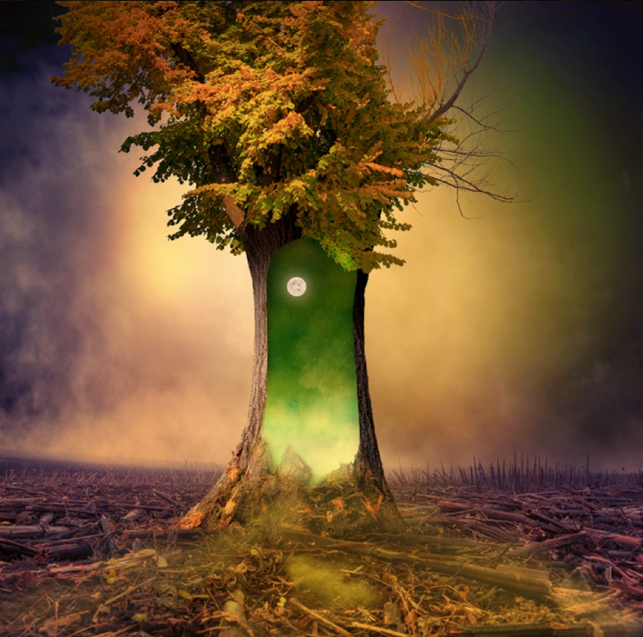
The tree was all that remained. A solitary figure, it stood there with destruction surrounding it. The bark had begun to peel away, one piece at a time, joining the wreckage of other trees that lay scattered across the scorched earth. This tree was different from the other trees. It contained magic. It contained hope…

Task 1:

Discussion time with an adult!
What do you think has caused the destruction all around the tree?
Why has this one tree survived?
If you walked through the portal, what would happen to you? What would you see?
If this portal to another world, would you go through it or stay on Earth, even if you had no idea what could happen?

Is it good to take risks? Are some risks riskier than others?

