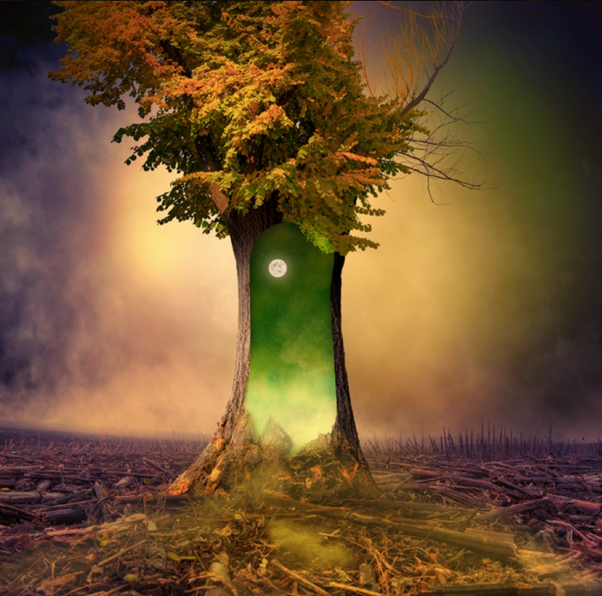
Task 2:

The Magic Tree - Perfect picture!
Imagine you have just walked through the open portal and into the world inside the tree. Draw/describe what you can see. Use adjectives!

