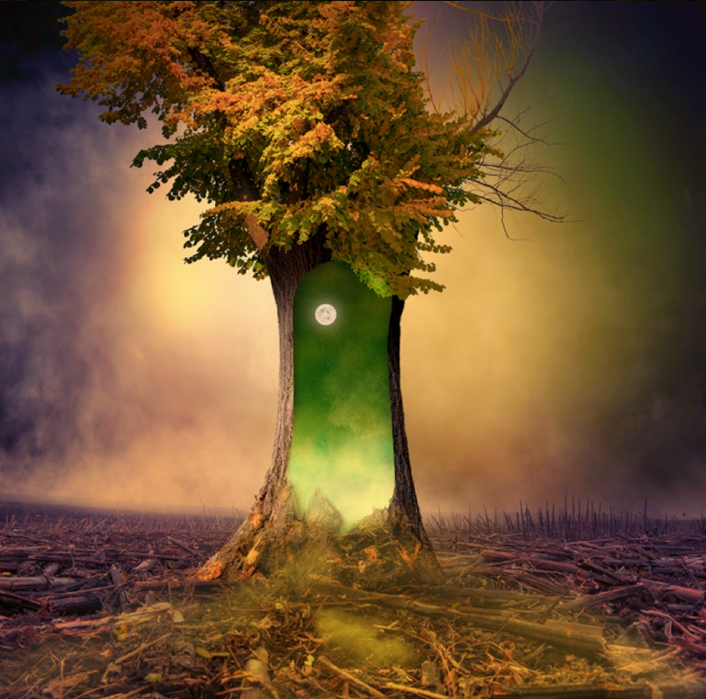

Task 3:

The Magic Tree
Can you continue the story? What is so different about this tree? What has happened to the other trees around it? Who discovers it? What happens to them? Do they end up in another world? How do they get home?
You could make your story into a mini book with illustrations… Be creative!

