Salt dough dinosaur fossils
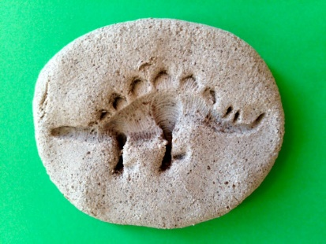
What you will need

- A spoon
- A bowl
- 1 cup of salt
- ¾ cups of warm water
- 2 cups of plain flour

Optional
- Items around the house that you could use to make a pattern such as a fork or cookie cutters
- Paints for after the fossil is dry
- Soil or coffee grounds if you want to make it look like a stone

Make sure you wash your hands really well before and afterwards and that you have a grown up to help you make the dough. Disclaimer although the salt dough has salt, water and flour in it, please do not eat it as it could give you a poorly tummy.

Method
In the bowl put the flour and salt in and mix, slowly add the water and mix together until it becomes a dough mixture. Once you have done this, take some and make it rock shaped flattening out slightly. Finally using a fork or a cookie cutter begin to make shapes in the dough.

(You might want to make dinosaur footprints using your fingers and thumbs).When you have finished creating the fossil, you can either let them airdry (wait 24 hours at least) or oven bake them on 100 Degrees Celsius for 2 to 3 hours (remember a low heat is best).

Salt dough dinosaur fossils activity continued….

Extra tip

Before drying the fossils, if you want to hang them using string/wool, make you that you put a hole though the top of your fossil, you can do this with your fingers or with a pen/pencil.

