Read the information below and then answer the questions written.

Scientists believe dinosaurs’ are a group of reptiles that roamed the land for over 140 million years (more than 160 million years in some parts of the world) close to the start of the Triassic time period. Dinosaurs also lived through the Jurassic time period and became extinct at the end of the Cretaceous time period; these three time periods are called the Mesozoic Era. Dinosaurs were herbivores, omnivores or carnivores, this meant that dinosaurs ate tough vegetation (herbivores), meat (carnivores) or both such as insects, eggs and plants (omnivores). we can still see evidence today of how they lived (through fossils and bones) and what they might have looked like/behaved when they roamed the earth. The closest living ancestors to the dinosaurs that we can see today are birds

The first dinosaur fossil was discovered in England in 1676, however it wasn’t until 1824 that it was given a name of Megalosaurus (meaning terrible lizard in Greek) by a fossil hunter called William Buckland. In 1842 an anatomist, (someone who studies anatomy of animal bodies and other living things) called Richard Owen, studied fossils and grouped three of these historic animals together, to create the name we now know as the dinosaur (Dinosauria). Today we have scientists called palaeontologists who study the remains of fossilised organisms including plants and animals.

Some dinosaurs have been made famous in films (night at the museum, Jurassic park) and books (The Dinosaurs Diary by Julia Donaldson). Some of the more well-known dinosaurs’ are the Tyrannosaurus rex (T-rex) (carnivore), Stegosaurus (herbivore), Velociraptor (carnivore), Chirostenotes (omnivore) and Pterodactyl (carnivore).

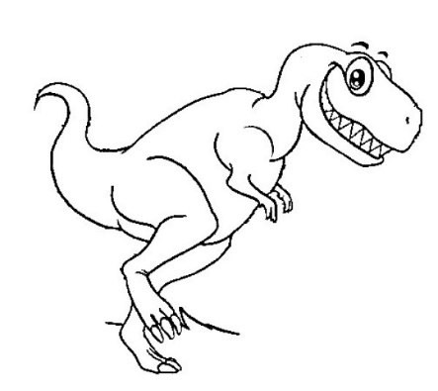
Something to think about
This Photo by Unknown Author is licensed under CC BY
Can you name any more dinosaurs?
How do we know what they might have looked like/behaved?

Questions
- What were dinosaurs?
- What three time periods did dinosaurs’ live in?
- What year was the first dinosaur fossil discovered?
- Who was William Buckland?
- What does the name Megalosaurus mean?
- Who was Richard Owen and what is he famous for?
- Who are palaeontologists’ and what do they study?
- Can you name 3 of the dinosaurs listed and what they might have eaten?

Further challenges this week

- Check out the natural history museum website for more information and facts on dinosaurs. You might like to try to find out which dinosaur you might be! https://www.nhm.ac.uk/discover/what-dinosaur-are-you.html

- Create your own dinosaur, you could make a 3d dinosaur using things you might find around your house such as plastic bottles and tubs

