Hi all and welcome to this week’s art lesson! This week we will be looking at drawing a flower.

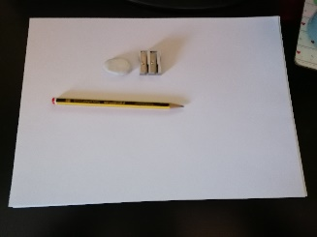
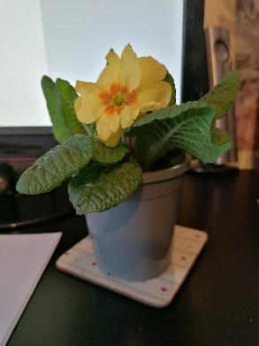
Tools needed:
- Plain paper
- A pencil (for drawing and shading)
- An eraser
- A pencil sharpener
- A flat surface such as a table, book or desk
- Flowers either in front of you or on a photo/picture.

Step one

Draw a small circle in the paper.
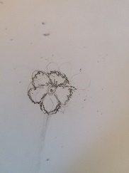
Step two

Draw semi circles around the outside of the circle, remember to leave a gap inside the petals for your shading at the end!

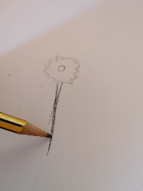
Step three

Draw a line going downwards, then shade in to make your stem.

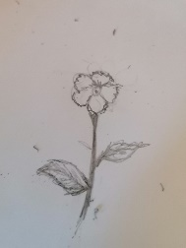
Step four

Draw on your leaves, making sure you include any detail you see.
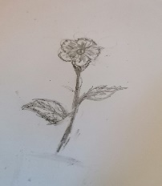
Step five

Start to shade in your flower; for example, look at where the petals might be slightly darker, do the leaves need to be shaded in?

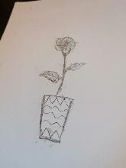
Step six

Draw a pot for your flower. You might want to draw a pattern or colour the pot in your favourite colours.

Further challenge
Our further challenges for this week are to label the flower you have drawn, and to use your imagination to create a new flower. To help you with the second further challenge you might want to think about the following:
- What might your flower look like?
- Can your flower do anything? For example, does it have special powers? If so, what might these look like?
- How does your flower feel when you touch it?
- Does your flower have a name?

