Tuesday 7th April 2020
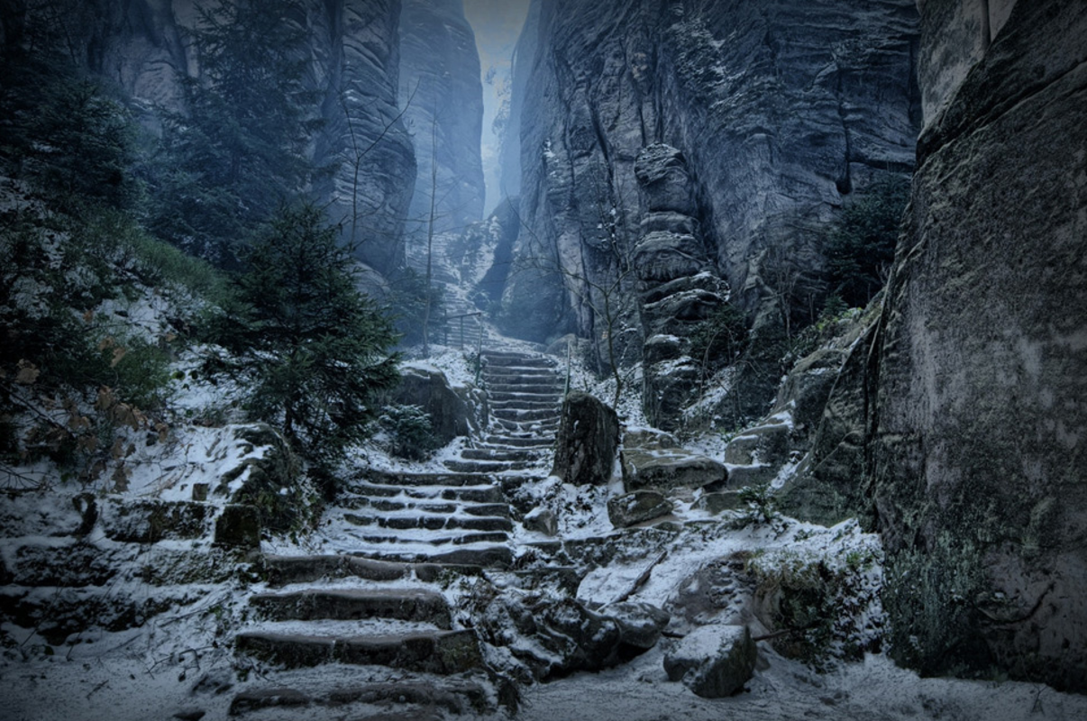
Writing:

Look at this picture- what can you see? What is it? How many adjectives can you think of to describe it? If one of the words that you think of is dark, can you think of a different word for it?
Read this story starter and think of how you could continue the story using it. What happens next?

The mountain of High Hrothgar had stood proudly for thousands of years, casting a solemn shadow for miles around.
Few dared to venture close to its base, let alone scale its heights, fearing what awaited at the summit. For one brave adventurer, the folk lore surrounding the mysteries of High Hrothgar provided an opportunity just too tempting to resist. Some called him courageous, others foolish, but it mattered not to him now.
Bracing himself against the torrent of icy wind that rushed towards him down the narrow pass, the lone figure prepared himself for the challenge ahead. He took a deep breath, feeling the frozen air rush into his lungs, and took a bold step onto the path to High Hrothgar…

Things to remember to include.
Full stops and capital letters (don’t forget to use capital letters for proper nouns not just at the beginning of a sentence)
Neat handwriting
Fronted adverbials
Interesting vocabulary.

