Wednesday 8th April
Writing
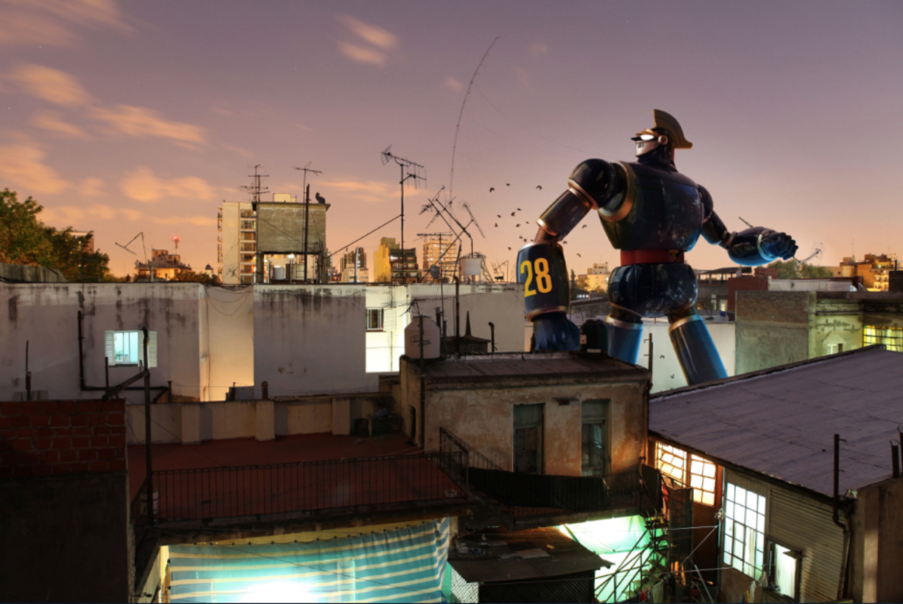

Question time!
Look at this picture and think about these questions.
- Who/what is Number 28? What is his mission? Where has he come from? Who is he speaking to?
- Do robots have feelings? Will there be robots around in the future?
- If we all had a personal robot that belonged to us, would this be a good thing or a bad thing?
- Does a robot need to eat food, or do they need fuel?
- What is the difference between fuel and food?

Sentence challenge!
- Can you write a sentence that uses an apostrophe for omission?
- E.g. cannot = can’t I have = I’ve he will= he’ll she is= she’s we have= we’ve will not = won’t
- Can you write a sentence that uses an apostrophe for possession?
- E..g. The robot’s suit Number 28’s head

