Dinosaur Feet
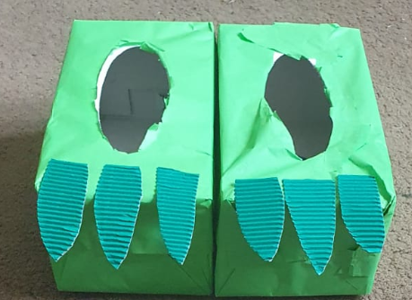
You will need
2 cardboard boxes- I used tissue boxes.
Green paper
Paint/pens to decorate
Card for the toes.
Method
- Cover your boxes with paper or paint them the colour you want.
- Next cut out 6 triangles out of the cardboard and stick them to the top of the boxes to make toes.
- Finally put your dinosaur feet on and do the dinosaur stomp.

