Paper Plate Dinosaur
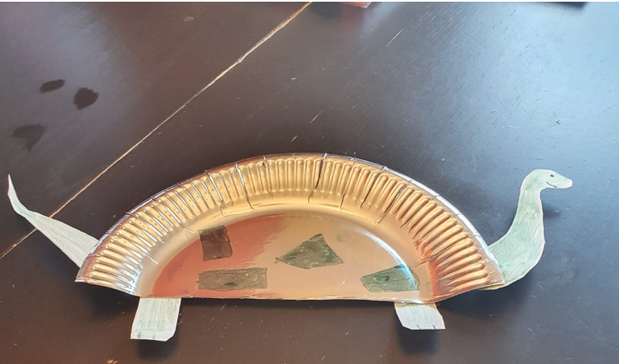
You will need
Paper plate
Colouring pens/pencils
Paper dinosaur head, feet and tail,
Scissors
Glue/Sellotape.

First cut the paper plate in half for the dinosaur body.
Next draw a head and feet from the paper and stick to the plate with Sellotape or glue.
Finally use pencils/pens to draw an eye, a smile on spots on to your dinosaur body.

