SCIENCE POLICY

January 2020

Review Date: Spring Term 2021
Contents

- Science at Firs
- FIRSY Foundation
- SEND and Higher Ability
- How Science is Taught
- Cornerstones and Science
- Two year overview (including cross-curricular links)
- Knowledge Retention
- Assessment
- Investigation Ideas
- Progression through experiments
- Sentence stems
- Concept Cartoons
- Examples of differentiation
- Science and Careers
- Monitoring
- Continual Professional Development

Science:
At Firs Primary School, we recognise the importance of Science in every aspect of daily life and how the elements in Science contribute to many career paths.

At Firs Primary School, as well as following the National Curriculum, in our lessons and extra-curricular activities we:

- Allow children to undertake scientific enquiries to help them answer scientific questions about the world around them.

- Equip children with the scientific knowledge to understand the uses and implications of science today.

- Teach the children to use a range of methods to communicate their scientific information and present it in a systematic and scientific manner including diagrams, graphs, tables and charts.

- Develop the children’s enthusiasm and enjoyment of scientific learning and discovery.

We endeavour to ensure that the Science Curriculum we provide will give children the confidence and motivation to continue to further develop their skills into the next stage of their education and life experiences.

What are the aims for your Subject?
National Curriculum:
The national curriculum for science aims to ensure that all pupils:
Develop scientific knowledge and conceptual understanding through the specific disciplines of biology, chemistry and physics.
Develop understanding of the nature, processes and methods of science through different types of science enquiries that help them to answer scientific questions about the world around them.
Are equipped with the scientific knowledge required to understand the uses and implications of science, today and for the future.
How do we tailor it to the needs of our pupils?
Vocabulary
For each science unit, key vocabulary is identified and is split in to three sections: tier 1, tier 2 and tier 3.
Throughout the unit, it is expected that children build a good understanding of these key words and can use them in context. We have also planned for progressive vocabulary within the element of “Working Scientifically.”
Cultural Capital
We build cultural capital by providing opportunities for children to experience science beyond the classroom, linking closely with businesses and providing hooks and memorable experiences linking to science where appropriate.
Oracy
Children have opportunities to develop oracy skills through practical activities and scientific investigations. The ‘Speakwell Toolkit’ can be used to support lessons when children are predicting/hypothesising and concluding. Concept cartoons are also used to initiate discussion and to develop a mastery level of vocabulary that children also practise in other subject such as maths.
Other Opportunities
Children have the opportunity to take part in a STEAM club ‘Destination Imagination’ whereby children have the opportunity to work scientifically outside of the classroom, with other children and in different settings. Children have also previously taken part in the “Big Bang Fair” where they have had the chance to work scientifically in a group to develop a design to meet set criteria.

Science
Firsy Foundation
Intent

Implementation
How EYFS, KS1 and KS2 Develop throughout Schooling:
The EYFS “Development Matters” grids have been linked clearly to the KS1 National Curriculum to map progression. This shows what knowledge from “Understanding of the World” for a “Good Level of Development” (GLD) child should have when they enter KS1.
As we follow the National Curriculum, we know that there is progress and coverage across the school. This can be seen in more detail in the whole school overview and the topic booklets for each half term.
Assessment
Assessment for learning is carried out throughout every lesson by the teaching using key questioning. At the end of every lesson self-assessment and teacher-assessment is completed to assess whether each individual child has met the required learning objective by achieving the success criteria. This can then be used to tailor and support future learning such as follow-up interventions or addressing the objective in another context. End of unit assessment (attainment) is monitored across the school using the assessment sheets provided within the topic booklets.
Retention and Adaptation
To monitor retention in 2020, pre-unit quizzes have been introduced to assess prior knowledge of pupils and to allow teachers to identify the required starting points.
SEND and disadvantaged children receive a broad and balanced curriculum through tailored visual resources, practical activities and scaffolded support.
Knowledge of Staff
Teachers receive appropriate CPD when needed, this may be done in house by members of the STEM team or they are done outside of school from external providers. STEM team to keep a look out for course opportunities– this should ensure that all members of staff, including support staff, have a good understanding of the science curriculum. The topic booklets provide clear guidance of what must be taught in that unit and are provided to staff with enough time to do any self-study or ask support from other members of staff.
Timetable and Rationale
Science, where possible is linked to the topic of that half term. Through mapping the national curriculum, science isn’t taught every half term. Science is taught progressively through the topics and half term, not through “science weeks” although this may be used as an opportunity to extend their learning further, past the national curriculum or complete more complex projects.
Timetabling is flexible throughout the school and therefore science may not always be taught in the same slot. This ensures that interventions or other opportunities such as family learning, boxing for well-being do not replace the learning of science for some pupils. Science may also be taught in the morning or the afternoon and this is carefully planned for and decided by the teacher.
How it is Taught
Teaching science can be done practically or through written work. A minimum of 1 practical lesson per unit must be taught – this could be an investigation or it might be and interactive task to support the children’s learning e.g. melting chocolate for states of matter.
We are maintaining links with businesses to provide children with opportunities to see science in the real world and to boost the profile of science.

Impact
Monitoring
Progress and attainment are monitored through book scrutinies, lesson visits, pupil voice and teacher voice. The assessments from the topic booklets are also shared at the end of every half-term throughout the school.
Retention
Pupil voice allows for the retention of knowledge to be checked by the STEM team, as well as the pre-unit quizzes by the class teacher which is recorded in books and can be monitored in book scrutinies. Some elements of science such as adaptation and habitats is also re-visited in other curriculum areas such as geography.

SEND and Higher Ability
SEND
For all pupils who are on the SEND register at Firs they will have an personalised plan. This will either be a IPM (Individual Provision Map) or MEP (Multi Element Plan). Within the plan the children will have personalised targets are provisions that are put in place to support the child in meeting targets. If the target links to science or foundation subjects, the provisions maybe techniques that are put in place to include children in whole class learning or interventions that support the children’s learning outside of the science lesson time.
In science most SEND children will follow the same lesson structure as others. Where written work may not be appropriate for that child, practical learning may take place and images or a description placed in their child’s book for evidence. Cognitive overload is also taken to into account, so the child can take focus on that specific learning objective such as a scribe may be used so a child does not also have to concentrate on their phonetic sounds. All SEND children will be exposed to age-related objectives but how they attempt those objectives will differ as the class teacher scaffolds the learning for their needs.

High Attaining Pupils
Stretch and challenge will be evident for the pupils in a variety of different ways:
- Teacher questionning either during the whole class input or 1:1
- Expectations of vocabulary used within the lesson
- Expectations of using mastery language within their answers (either written or orally): prove it, explain it, convince me
- Orange bubbles for further challenge in response to their current work or after the lesson has ended (purple pen of progress)

How Science is taught at Firs Primary School
Early Years
In EYFS Science is taught in a variety of different ways including: exploration through continuous provision and teacher led sessions. Some science objectives will be in the continuous provision for a set length of time (eg during the topic) others will be able to be accessed throughout the year such as the construction area and the garden.

During continuous provision, members of staff have a good understanding of the Early Years Framework and will ask carefully thought out questions to probe children’s understanding and develop their learning.

Understanding the World - Science

Intent |  | Foundation Stage | Year 1
Working scientifically | Asking questions | - Comments and asks questions about aspects of their familiar world such as the place where they live or the natural world. | - ask simple questions and recognise that they can be answered in different ways
Implementation

Intent | Foundation Stage | Year 1
Plants | - Looks closely at and talks about change, e.g. plants  - They make basic observations of plants.  - They make observations of plants and explain why some things occur and talk about changes.  - Children know that the environment and living things are influenced by human activity. | Pupils should be taught to:  - identify and name a variety of common wild and garden plants, including deciduous and evergreen trees  - identify and describe the basic structure of a variety of common flowering plants, including trees
Implementation
- UTW inputs
- Are Carrots Orange Cornerstones topic
- Gardening provision
- Enhanced resources

Intent | Foundation Stage | Year 1
Animals including humans | - Looks closely at and talks about change, e.g. animals  - They make basic observations of animals.  - Children know about similarities and differences in relation to living things.  - They make observations of animals and explain why some things occur, and talk about changes.  - Children know that the environment and living things are influenced by human activity. | Pupils should be taught to:  - identify and name a variety of common animals including fish, amphibians, reptiles, birds and mammals  - identify and name a variety of common animals that are carnivores, herbivores and omnivores  - describe and compare the structure of a variety of common animals (fish, amphibians, reptiles, birds and mammals, including pets)  - identify, name, draw and label the basic parts of the human body and say which part of the body is associated with each sense
Implementation
- UTW inputs
- Why do Zebras have strips Cornerstones topic
- Bug hotel provision
- Enhanced resources

Intent | Foundation Stage | Year 1
Seasonal change | - Looks closely at and talks about change, e.g. seasons  - They talk about the features of their own immediate environment.  - They talk about how environments might vary from one another. | Pupils should be taught to:  - observe changes across the four seasons  - observe and describe weather associated with the seasons and how day length varies
Implementation
- UTW inputs
- Daily discussion during the morning register
- Gardening provision
- Enhanced resources

Intent | Foundation Stage | Year 1
Materials | - Looks closely at and talks about change, e.g. objects  - Children know about similarities and differences in relation to materials.  - They know the properties of some materials and can suggest some of the purposes they are used for. | Everyday Materials  Pupils should be taught to:  - distinguish between an object and the material from which it is made  - identify and name a variety of everyday materials, including wood, plastic, glass, metal, water, and rock  - describe the simple physical properties of a variety of everyday materials  - compare and group together a variety of everyday materials on the basis of their simple physical properties
Implementation
- UTW inputs
- Will you read me a story Cornerstones topic - 3 Pigs house materials
- Are we there yet Cornerstones topic – Materials for transport
- Construction provision
- Creative area provision
- Water play - Floating and sinking
- Enhanced resources

Key Stage 1 and 2

At Firs Primary School, in KS1 and 2 the quantity of Science that is taught links to the topic and unit being taught, and how the class teacher thinks the objectives will be best met by the children to allow for good progress and knowledge retention. For some topics this may be one Science lesson a week, or may be through a block Science week.

Cornerstones and Science
Our topics run in a two year cycle due to use teaching in some mixed year groups across the school. To initially plan our topics within school we follow the Cornerstones curriculum. However, not all of the topics fit in with the areas of science, so for some topics science may be taught discreetly.

Cornerstones recommends ideas for science lessons within each stage of the curriculum: Engage, Develop, Innovate, and Express. We then use those ideas and sometimes extend them further to ensure we are covering all of the necessary areas of the National Curriculum.

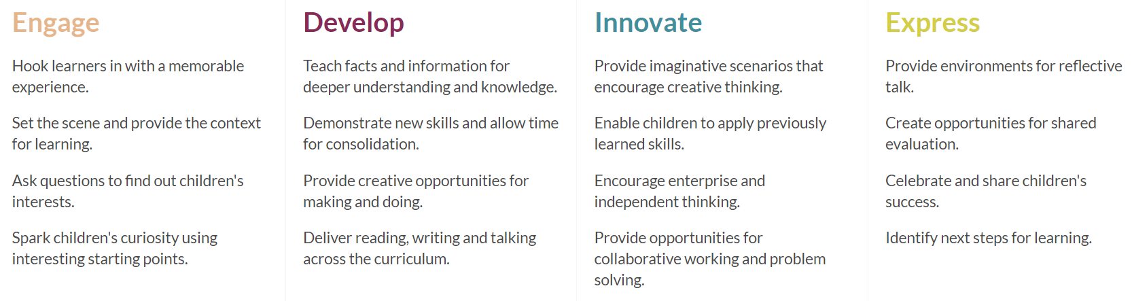

In Cornerstones the topics are planned to meet the National Curriculum objectives for each specific year groups. This, with the two-year cycle, helps ensure that science is progressive throughout the school. Our science curriculum ensures that every “Forever Firs” has every chance to succeed in science and is taught every National Curriculum objective in a meaningful and memorable way.

Two Year Overview
A | Autumn 1 | Autumn 2 | Spring 1 | Spring 2 | Summer 1 | Summer 2
EYFS | Will you read me a story?  Changes around us -  signs of Autumn /  changes in the season.  Introduce computer  Software. | What happens when I fall asleep?  Weather / Seasons  Light and Dark (daytime / night-time - link to day / night animals. | Are we there yet?  Weather / Seasons  Light and Dark (daytime / night-time - link to day / night animals. | Do Dragons exist?  Making observations  Signs of Spring  Planting flowers | Are carrots orange?  Planting vegetables in the garden  Growing investigation  (changes) | Why do ladybirds have spots?  How have we  changed?  Journey through  school.  Signs of summer
Cross Curricular Links
Year 1 & 2 | The Enchanted Woodland  Year 1 Plants  Identify and name a variety of common wild and garden plants, including deciduous and evergreen trees.  Identify and describe the basic structure of a variety of common flowering plants, including trees.  Year 2 Living Things and their Habitats (Part)  Identify that most living things live in habitats to which they are suited and describe how different habitats provide for the basic needs of different kinds of animals and plants, and how they depend on each other.  Identify and name a variety of plants and animals in their habitats, including microhabitats. | Moon Zoom!  Year 1 Seasonal Change  Observe changes across the four seasons.  Observe and describe weather associated with the seasons and how day length varies.  Year 2  None | Muck, Mess and Mixtures  Year 1 Animals Including Humans (Part)  Identify, name, draw and label the basic parts of the human body and say which part of the body is associated with each sense.  Year 2 Animals Including Humans  Notice that animals, including humans, have offspring which grow into adults.  Find out about and describe the basic needs of animals, including humans, for survival (water, food and air).  Describe the importance for humans of exercise, eating the right amounts of different types of food, and hygiene. | Rio De Vida  Year 1 Animals Including Humans (Part)  Identify and name a variety of common animals including fish, amphibians, reptiles, birds and mammals.  Identify and name a variety of common animals that are carnivores, herbivores and omnivores Science - key stages 1 and 2 8 Statutory requirements.  Describe and compare the structure of a variety of common animals (fish, amphibians, reptiles, birds and mammals, including pets).  Year 2 Living Things and their Habitats  Explore and compare the differences between things that are living, dead, and things that have never been alive.  Describe how animals obtain their food from plants and other animals, using the idea of a simple food chain, and identify and name different sources of food. | Street Detectives  Year 1 Materials  Distinguish between an object and the material from which it is made.  Identify and name a variety of everyday materials, including wood, plastic, glass, metal, water, and rock.  Describe the simple physical properties of a variety of everyday materials.  Compare and group together a variety of everyday materials on the basis of their simple physical properties.  Year 2 Uses of Everyday Materials  Identify and compare the suitability of a variety of everyday materials, including wood, metal, plastic, glass, brick, rock, paper and cardboard for particular uses.  Find out how the shapes of solid objects made from some materials can be changed by squashing, bending, twisting and stretching. | Land Ahoy!  Year 1 Materials (Continued)  Distinguish between an object and the material from which it is made.  Identify and name a variety of everyday materials, including wood, plastic, glass, metal, water, and rock.  Describe the simple physical properties of a variety of everyday materials.  Compare and group together a variety of everyday materials on the basis of their simple physical properties.  Year 2 Uses of Everyday Materials (Continued)  Identify and compare the suitability of a variety of everyday materials, including wood, metal, plastic, glass, brick, rock, paper and cardboard for particular uses.  Find out how the shapes of solid objects made from some materials can be changed by squashing, bending, twisting and stretching.
Cross Curricular Links | EYFS planting area  Plants around the school | Geography  Identify seasonal and daily weather patterns in the United Kingdom and the location of hot and cold areas of the world in relation to the Equator and the North and South Poles. | PSHE & PE; Healthy Eating and Exercise;  Design and Technology:  Use the basic principles of a healthy and varied diet to prepare dishes. |  | Design and Technology  Build structures, exploring how they can be made stronger, stiffer and more stable. | Design and Technology  Build structures, exploring how they can be made stronger, stiffer and more stable.
Year 3 & 4 | God and Mortals  Year 4: Electricity  Identify common appliances that run on electricity.  Construct a simple series electrical circuit, identifying and naming its basic parts, including cells, wires, bulbs, switches and buzzers.  Identify whether or not a lamp will light in a simple series circuit, based on whether or not the lamp is part of a complete loop with a battery.  Recognise that a switch opens and closes a circuit and associate this with whether or not a lamp lights in a simple series circuit.  Recognise some common conductors and insulators, and associate metals with being good conductors. | Urban Pioneers  Year 3: Plants (Discreet)  Identify and describe the functions of different parts of flowering plants: roots, stem/trunk, leaves and flowers.  Explore the requirements of plants for life and growth (air, light, water, nutrients from soil, and room to grow) and how they vary from plant to plant.  Investigate the way in which water is transported within plants.  Explore the part that flowers play in the life cycle of flowering plants, including pollination, seed formation and seed dispersal. | I am Warrior  None | Predator  Year 4: Living things and their Habitats  Recognise that living things can be grouped in a variety of ways.  Explore and use classification keys to help group, identify and name a variety of living things in their local and wider environment.  Recognise that environments can change and that this can sometimes pose dangers to living things. | . Playlist  Year 4: Sound  Identify how sounds are made, associating some of them with something vibrating.  Recognise that vibrations from sounds travel through a medium to the ear.  Find patterns between the pitch of a sound and features of the object that produced it.  Find patterns between the volume of a sound and the strength of the vibrations that produced it.  Recognise that sounds get fainter as the distance from the sound source increases. | Tribal Tales  Year 3: Light (Taught both years)  Recognise that they need light in order to see things and that dark is the absence of light.  Notice that light is reflected from surfaces.  Recognise that light from the sun can be dangerous and that there are ways to protect their eyes.  Recognise that shadows are formed when the light from a light source is blocked by an opaque object.  fFnd patterns in the way that the size of shadows change.
Cross Curricular Links | Design and Technology  Understand and use electrical systems in their products [for example, series circuits incorporating switches, bulbs, buzzers and motors]. |  |  | Geography - Physical Geography, including:  Climate zones, biomes and vegetation belts, volcanoes and earthquakes, and the water cycle.  Human Geography, including:  Types of settlement and land use, economic activity, including trade links, and the distribution of natural resources, including energy, food, minerals and water.
Year 5 & 6 | A Child’s War  Discreet: Year 5: Forces  explain that unsupported objects fall towards the Earth because of the force of gravity acting between the Earth and the falling object  identify the effects of air resistance, water resistance and friction, that act between moving surfaces  recognise that some mechanisms, including levers, pulleys and gears, allow a smaller force to have a greater effect. | Hola Mexico!  None | Frozen Kingdom  Year 6: Living Things and their Habitats  describe how living things are classified into broad groups according to common observable characteristics and based on similarities and differences, including microorganisms, plants and animals  give reasons for classifying plants and animals based on specific characteristics. | Revolution  None | Blood Heart  Discreet: Year 6: Animals including Humans  identify and name the main parts of the human circulatory system, and describe the functions of the heart, blood vessels and blood  recognise the impact of diet, exercise, drugs and lifestyle on the way their bodies function  describe the ways in which nutrients and water are transported within animals, including humans. | Darwin’s Delights  Year 6: Evolution and Inheritance  recognise that living things have changed over time and that fossils provide information about living things that inhabited the Earth millions of years ago  recognise that living things produce offspring of the same kind, but normally offspring vary and are not identical to their parents  identify how animals and plants are adapted to suit their environment in different ways and that adaptation may lead to evolution.
Cross Curricular Links | Design and Technology  Understand and use mechanical systems in their products [for example, gears, pulleys, cams, levers and linkages].  Apply their understanding of how to strengthen, stiffen and reinforce more complex structures. |  | Geography -  Physical Geography, including:  Climate zones, biomes and vegetation belts, rivers, mountains, volcanoes and earthquakes, and the water cycle. |  | Design and Technology  Understand and apply the principles of a healthy and varied diet.  PSHE & PE - Healthy Eating & Exercise | RE: Beliefs about evolutiona and creation stories

B | Autumn 1 | Autumn 2 | Spring 1 | Spring 2 | Summer 1 | Summer 2
EYFS | Will you read me a story? | Are we there yet? | Did Dragons exist? | Why are carrots orange? | Why do zebras have stripes? | What is a rock pool?
Cross Curricular Links

Year 1 & 2 | Bright Lights, Big City  Year 1 Materials  Distinguish between an object and the material from which it is made.  Identify and name a variety of everyday materials, including wood, plastic, glass, metal, water, and rock.  Describe the simple physical properties of a variety of everyday materials.  Compare and group together a variety of everyday materials on the basis of their simple physical properties.  Year 2 Uses of Everyday Materials  Identify and compare the suitability of a variety of everyday materials, including wood, metal, plastic, glass, brick, rock, paper and cardboard for particular uses.  Find out how the shapes of solid objects made from some materials can be changed by squashing, bending, twisting and stretching. | Superheroes  Year 1 Animals Including Humans (Part)  Identify, name, draw and label the basic parts of the human body and say which part of the body is associated with each sense.  Year 2 Animals Inlcuding Humans  Notice that animals, including humans, have offspring which grow into adults.  Find out about and describe the basic needs of animals, including humans, for survival (water, food and air).  Describe the importance for humans of exercise, eating the right amounts of different types of food, and hygiene. | Paws, Claws and Whiskers  Year 1 Animals Including Humans (Part)  Identify and name a variety of common animals including fish, amphibians, reptiles, birds and mammals.  Identify and name a variety of common animals that are carnivores, herbivores and omnivores Science - key stages 1 and 2 8  Statutory requirements  Describe and compare the structure of a variety of common animals (fish, amphibians, reptiles, birds and mammals, including pets).  Year 2 Living Things and their Habitats  Describe how animals obtain their food from plants and other animals, using the idea of a simple food chain, and identify and name different sources of food. | Scented Garden  Year 1 Seasonal Change  Observe changes across the four seasons.  Observe and describe weather associated with the seasons and how day length varies.  Year 1 Plants  Identify and name a variety of common wild and garden plants, including deciduous and evergreen trees.  Identify and describe the basic structure of a variety of common flowering plants, including trees.  Year 2 Living Things and their Habitats (Part)  Identify that most living things live in habitats to which they are suited and describe how different habitats provide for the basic needs of different kinds of animals and plants, and how they depend on each other  identify and name a variety of plants and animals in their habitats, including microhabitats. | Dinosaurs  Year 1 None  Year 2 Living Things and their Habitats  Explore and compare the differences between things that are living, dead, and things that have never been alive. | Towers, Tunnels and Turrets  Year 1 Materials (continued)  Distinguish between an object and the material from which it is made  identify and name a variety of everyday materials, including wood, plastic, glass, metal, water, and rock.  Describe the simple physical properties of a variety of everyday materials.  Compare and group together a variety of everyday materials on the basis of their simple physical properties.  Year 2 Uses of Everyday Materials (Continued)  Identify and compare the suitability of a variety of everyday materials, including wood, metal, plastic, glass, brick, rock, paper and cardboard for particular uses.  Find out how the shapes of solid objects made from some materials can be changed by squashing, bending, twisting and stretching.
Cross Curricular Links | Design and Technology  Select from and use a range of tools and equipment to perform practical tasks [for example, cutting, shaping, joining and finishing].  Select from and use a wide range of materials and components, including construction materials, textiles and ingredients, according to their characteristics  build structures, exploring how they can be made stronger, stiffer and more stable. | PSHE: Body Changes  Design and Technology  Use the basic principles of a healthy and varied diet to prepare dishes. | Design and Technology  Use the basic principles of a healthy and varied diet to prepare dishes  understand where food comes from. | Geography  Identify seasonal and daily weather patterns in the United Kingdom and the location of hot and cold areas of the world in relation to the Equator and the North and South Poles.  Use basic geographical vocabulary to refer to:  key physical features, including: beach, cliff, coast, forest, hill, mountain, sea, ocean, river, soil, valley, vegetation, season and weather  key human features, including: city, town, village, factory, farm, house, office, port, harbour and shop.
Year 1 & 2 | Bright Lights, Big City  Year 1 Materials  Distinguish between an object and the material from which it is made.  Identify and name a variety of everyday materials, including wood, plastic, glass, metal, water, and rock.  Describe the simple physical properties of a variety of everyday materials.  Compare and group together a variety of everyday materials on the basis of their simple physical properties.  Year 2 Uses of Everyday Materials  Identify and compare the suitability of a variety of everyday materials, including wood, metal, plastic, glass, brick, rock, paper and cardboard for particular uses.  Find out how the shapes of solid objects made from some materials can be changed by squashing, bending, twisting and stretching. | Superheroes  Year 1 Animals Including Humans (Part)  Identify, name, draw and label the basic parts of the human body and say which part of the body is associated with each sense.  Year 2 Animals Inlcuding Humans  Notice that animals, including humans, have offspring which grow into adults.  Find out about and describe the basic needs of animals, including humans, for survival (water, food and air).  Describe the importance for humans of exercise, eating the right amounts of different types of food, and hygiene. | Paws, Claws and Whiskers  Year 1 Animals Including Humans (Part)  Identify and name a variety of common animals including fish, amphibians, reptiles, birds and mammals  identify and name a variety of common animals that are carnivores, herbivores and omnivores Science - Key Stages 1 and 2-8.  Statutory Requirements  Describe and compare the structure of a variety of common animals (fish, amphibians, reptiles, birds and mammals, including pets).  Year 2 Living Things and their Habitats  Describe how animals obtain their food from plants and other animals, using the idea of a simple food chain, and identify and name different sources of food. | Scented Garden  Year 1 Seasonal Change  Observe changes across the four seasons  observe and describe weather associated with the seasons and how day length varies.  Year 1 Plants  Identify and name a variety of common wild and garden plants, including deciduous and evergreen trees.  Identify and describe the basic structure of a variety of common flowering plants, including trees.  Year 2 Living Things and their Habitats (Part)  Identify that most living things live in habitats to which they are suited and describe how different habitats provide for the basic needs of different kinds of animals and plants, and how they depend on each other.  Identify and name a variety of plants and animals in their habitats, including microhabitats | Dinosaurs  Year 1 None  Year 2 Living Things and their Habitats  Explore and compare the differences between things that are living, dead, and things that have never been alive. | Towers, Tunnels and Turrets  Year 1 Materials (Continued)  Distinguish between an object and the material from which it is made  identify and name a variety of everyday materials, including wood, plastic, glass, metal, water, and rock.  Describe the simple physical properties of a variety of everyday materials.  Compare and group together a variety of everyday materials on the basis of their simple physical properties.  Year 2 Uses of Everyday Materials (Continued)  Identify and compare the suitability of a variety of everyday materials, including wood, metal, plastic, glass, brick, rock, paper and cardboard for particular uses.  Find out how the shapes of solid objects made from some materials can be changed by squashing, bending, twisting and stretching.
Cross Curricular Links | Design and Technology  Select from and use a range of tools and equipment to perform practical tasks [for example, cutting, shaping, joining and finishing].  Select from and use a wide range of materials and components, including construction materials, textiles and ingredients, according to their characteristics.  Build structures, exploring how they can be made stronger, stiffer and more stable. | PSHE: Body Changes  Design and Technology  Use the basic principles of a healthy and varied diet to prepare dishes | Design and Technology  Use the basic principles of a healthy and varied diet to prepare dishes  understand where food comes from. | Geography  Identify seasonal and daily weather patterns in the United Kingdom and the location of hot and cold areas of the world in relation to the Equator and the North and South Poles.  Use basic geographical vocabulary to refer to:  key physical features, including: beach, cliff, coast, forest, hill, mountain, sea, ocean, river, soil, valley, vegetation, season and weather.  Key human features, including: city, town, village, factory, farm, house, office, port, harbour and shop.

Year 3 & 4 | Heroes & Villains  Year 3: Light (Taught both years)  Recognise that they need light in order to see things and that dark is the absence of light.  Notice that light is reflected from surfaces.  Recognise that light from the sun can be dangerous and that there are ways to protect their eyes.  Recognise that shadows are formed when the light from a light source is blocked by an opaque object.  Find patterns in the way that the size of shadows change. | Tremors  Year 3: Rocks  Compare and group together different kinds of rocks on the basis of their appearance and simple physical properties.  Describe in simple terms how fossils are formed when things that have lived are trapped within rock.  Recognise that soils are made from rocks and organic matter.  Year 4: States of Matter  Compare and group materials together, according to whether they are solids, liquids or gases.  Observe that some materials change state when they are heated or cooled, and measure or research the temperature at which this happens in degrees Celsius (°C).  Identify the part played by evaporation and condensation in the water cycle and associate the rate of evaporation with temperature. | Traiders & Raiders  None | Burps, bottoms & bile  Year 4: Animals  Including humans  describe the simple functions of the basic parts of the digestive system in humans.  Identify the different types of teeth in humans and their simple functions.  Construct and interpret a variety of food chains, identifying producers, predators and prey. | Mighty Metals  Year 3: Forces and Magnets  Compare how things move on different surfaces.  Notice that some forces need contact between two objects, but magnetic forces can act at a distance.  Observe how magnets attract or repel each other and attract some materials and not others.  Compare and group together a variety of everyday materials on the basis of whether they are attracted to a magnet, and identify some magnetic materials  Describe magnets as having two poles.  Predict whether two magnets will attract or repel each other, depending on which poles are facing. | Blue Abyss  All living things.
Cross Curricular Links |  | Geography -  Physical Geography, including:  Climate zones, biomes and vegetation belts, rivers, mountains, volcanoes and earthquakes, and the water cycle.  Use maps, atlases, globes and digital/computer mapping to locate countries and describe features studied. | Design and Technology  Prepare and cook a variety of predominantly savoury dishes using a range of cooking techniques.  Understand seasonality, and know where and how a variety of ingredients are grown, reared, caught and processed. | Design and Technology  Understand and apply the principles of a healthy and varied diet. | Design and Technology  Understand and use mechanical systems in their products [for example, gears, pulleys, cams, levers and linkages].
Year 5 & 6 | Off with her head!  Discreet: Year 6: Light  Recognise that light appears to travel in straight lines.  Use the idea that light travels in straight lines to explain that objects are seen because they give out or reflect light into the eye.  Explain that we see things because light travels from light sources to our eyes or from light sources to objects and then to our eyes.  Use the idea that light travels in straight lines to explain why shadows have the same shape as the objects that cast them. | Stargazers  Year 5: Earth and Space  Describe the movement of the Earth, and other planets, relative to the Sun in the solar system.  Describe the movement of the Moon relative to the Earth.  Describe the Sun, Earth and Moon as approximately spherical bodie.  Use the idea of the Earth’s rotation to explain day and night and the apparent movement of the sun across the sky. | Alchemy Island  Year 5: Properties and Changes of Materials  Compare and group together everyday materials on the basis of their properties, including their hardness, solubility, transparency, conductivity (electrical and thermal), and response to magnets.  Know that some materials will dissolve in liquid to form a solution, and describe how to recover a substance from a solution.  Use knowledge of solids, liquids and gases to decide how mixtures might be separated, including through filtering, sieving and evaporating.  Give reasons, based on evidence from comparative and fair tests, for the particular uses of everyday materials, including metals, wood and plastic.  Demonstrate that dissolving, mixing and changes of state are reversible changes.  Discreet: Year 6: Electricity  Associate the brightness of a lamp or the volume of a buzzer with the number and voltage of cells used in the circuit.  Compare and give reasons for variations in how components function, including the brightness of bulbs, the loudness of buzzers and the on/off position of switches.  Use recognised symbols when representing a simple circuit in a diagram.  explain that some changes result in the formation of new materials, and that this kind of change is not usually reversible, including changes associated with burning and the action of acid on bicarbonate of soda. | Pharaohs  None | Time Traveller  Year 5: Living things and their Habitats  Year 5: Animals, including Humans  Describe the changes as humans develop to old age.  Describe the differences in the life cycles of a mammal, an amphibian, an insect and a bird.  Describe the life process of reproduction in some plants and animals. | Peasants, Princes and Pestilence  None
Cross Curricular links |  | Geography -  Physical Geography, including: Climate Zones  Design and Technology  Understand seasonality, and know where and how a variety of ingredients are grown, reared, caught and processed. | Design and Tecnology  Select from and use a wider range of materials and components, including construction materials, textiles and ingredients, according to their functional properties and aesthetic qualities.  Design and Tecnology  understand and use electrical systems in their products [for example, series circuits incorporating switches, bulbs, buzzers and motors]. |  | PSHE: Body Changes

Knowledge Retention
Science is a progressive subject, developing knowledge on different areas of biology and physics in each year group taught. By following the National Curriculum, we can ensure that our science lessons enable the pupils to make good progress in science. However as not all elements of science are taught every year due to the two year cycle it is necessary to ensure that we can assess whether children have retained what they have taught previously. This is done through a pre-unit quiz. This also enables us to identify starting points for new pupils (both direct entrants and pupils from other schools) and allow us to plan effective lessons to meet the needs of the pupils.

The pre-unit quiz is done at the start of each half term and is evidenced in books. The questions link to the previous year groups learning objective (or ELG). If the area of science has not been taught before, the pre-unit quiz will assess children’s understanding of key vocabulary. The pre-unit quiz might involve circling pictures, multiple choice or writing short answers.

Examples
Year 3/4 Cycle A - Summer 2 - Animals Including Humans

Year 1 Objectives | Year 2 Objectives
♣ identify and name a variety of common animals including fish, amphibians, reptiles, birds and mammals  ♣ identify and name a variety of common animals that are carnivores, herbivores and omnivores  ♣ describe and compare the structure of a variety of common animals (fish, amphibians, reptiles, birds and mammals, including pets)  ♣ identify, name, draw and label the basic parts of the human body and say which part of the body is associated with each sense. | ♣ notice that animals, including humans, have offspring which grow into adults  ♣ find out about and describe the basic needs of animals, including humans, for survival (water, food and air)  ♣ describe the importance for humans of exercise, eating the right amounts of different types of food, and hygiene.

Date
Subject/s | Science
Pre-unit Quiz
Area | Animals, including humans
Circle the amphibian

What is a carnivore?
- An animal that only eats plants
- An animal that only eats meat
- An animal that eats meat and plants
Circle the things that keep us healthy
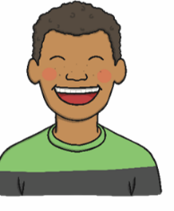
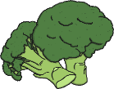
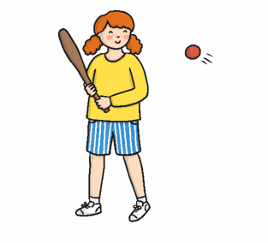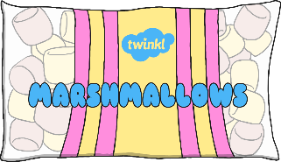
Exercise Sweets Fruit and vegetables Being happy
What are the 5 senses?
Label the Body Parts
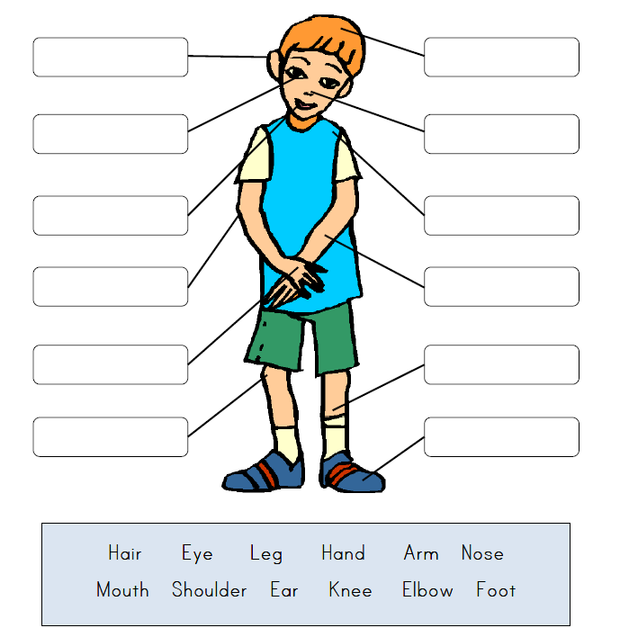

Year 5/6 Cycle B - Autumn 1 – Light

Year 1 Objectives | Year 2 Objectives | Year 3 Objectives | Year 4 Objectives
- recognise that they need light in order to see things and that dark is the absence of light
- notice that light is reflected from surfaces
- recognise that light from the sun can be dangerous and that there are ways to protect their eyes
- recognise that shadows are formed when the light from a light source is blocked by an opaque object
- find patterns in the way that the size of shadows change.

Date
Subject/s | Science
Pre-unit Quiz
Area | Light
What is dark?
- When everything is black
- When it is night time
- When there is no light
What does ‘reflect’ mean?
- When it is really bright
- When light is bounced off an object
- When light is taken in
Explain 1 negative and 1 positive of the sun

Why are shadows created?

What does opaque mean?
- You can see through it
- You can’t see through it
- You can see through it a little bit

Assessment
At the end of every half term when science is taught, the teacher will assess their class against the NC and progression guidance for that unit of science. The teacher may choose to use additional materials to aid their teacher assessment such as end of unit tests, KWL grids etc. but assessment will be primarily from work that is done in class.

The teacher will assess each individual child under 4 headings:

Children working below ARE | Children working towards ARE | Children working at  ARE | Children working above ARE

Investigation Ideas
When teaching Science at Firs Primary School, we aim to make the subject as exciting as possible to get the children enthusiastic about science. We aim to do at least one practical activity or experiment for every unit of science taught. Below are some examples of what could be done in each unit. The activities may link to the cornerstones topic or may be discreetly linked to the area of science. There will be evidence of the activities taking place either through photographs and a short description or a write up of the experiment.

All the curriculum in EYFS will be taught practically. This will be in taught sessions as well as access to materials within the continuous provision.

Cycle A
Year 1/2
Autumn 1: Enchanted Woodland | Plants  Are all leaves the same?  Collect a variety of leaves and discuss whether or not they are the same- think about size, texture etc.  Make predictions and suggestions about whether or not they think leaves are the same.  Children to describe and draw them.
Autumn 2:  Moon Zoom | Seasonal Changes  How wild is the wind?  Discuss with the children what they know about wind and how what causes it is.  Children to create a wind diary over a week to measure the direction and force of the wind.
Spring 1: Mucks, Mess and Mixtures | Animals including humans.  Children to have a visit from a pet owner to discuss what they have to do to look after a pet.
Spring 2: Rio de Vida | Animals, including Humans
Summer 1: Street Detectives | Everyday materials  The Billy Goats Gruff  - Children to design a material to build a bridge.  - Which will be the strongest? Build a variety of bridges from various materials and find out which is the strongest by putting on a weight/ object to see if it holds.
Summer 2: Land Ahoy! | Everyday materials  Waterproofing coins  https://www.science-sparks.com/protect-the-pirate-coins-waterproofing-activity/

Cycle B
Year 1/2
Autumn 1: Bright Lights, Big City | Materials  Protect the egg - discuss with the children what happens to eggs if you drop them on the floor?  Provide children with a variety of materials for them to cover the egg in.  Make a prediction as to which material would be the best to cover the egg with to stop it from breaking.  Cover the egg with various materials and the drop them from a set height and observe what happens.
Autumn 2:  Superheroes | Working scientifically  Traction man experiments
Spring 1:  Paws, Claws and Whiskers | Animals including humans
Spring 2:  Scented Garden | Working scientifically  Observe and record the growth of plants as they change over time and setting up comparative tests to show what plants need to stay healthy.
Summer 1:  Dinosaurs | Animals, including humans
Summer 2:  Towers, Tunnels and Turrets | Plants  Colour changing plants  Put some white flowers into water with some food colouring. See what happens to the petals as the water travels up the stem.

Cycle A
Year 3/4
Autumn 1: Gods and Mortals | Electricity (Y4)  Does the circuit have to be complete in order to work?  Children to create a circuit
Autumn 2: Urban Pioneers | Plants (Y3)  Room for Growth  Investigate how competition for resources affects growth.  Plant seeds and place them in a variety of settings e.g. with light, without light, with water, without water and observe what happens to them. Children to make predictions etc. about these based upon what they know about plants already.
Spring 1: I am Warrior | None
Spring 2: Predator | Living things and their habitats (Y4)  Children to visit a local park/nature reserve or pond. What living this can they see? How can they document it?
Summer 1: Playlist | Sound (Y4)  How does sound travel along a piece of string on a cup phone?  Experiment using cup phones- does the string have to be straight in order for it to work?
Summer 2: Tribal Tales | Light (Y3)  Football Shadows- make shadow patterns using a pencil and a torch- PP to support what to do.  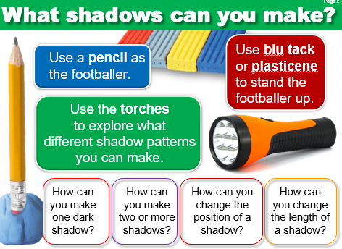

Cycle B
Year 3/4
Autumn 1: Hero or Villain |  | Light (Y3)  Which material is the most reflective? Have a range of materials and make a predictions as to which will be the most reflective.
Autumn 2: Tremors |  | Rocks (Y3)  Testing rocks for suitability  Provide a variety of rocks for the children and get them to carry out permeability and scratch tests to see which rock would be most suitable to use for a statue. (i.e. which rock was least permeable and hardest).  States of matter (Y4)  Film canister rockets - do this outside!  https://www.youtube.com/watch?v=PVDWq5CeE-g
Spring 1: Traders and Raders |  | None
Spring 2: Burps, Bottoms and Bile |  | Animals including humans (Y4)  Show the digestive system using food and a pair of tights.  https://www.stem.org.uk/resources/elibrary/resource/35396/digestive-system-experiment
Summer 1: Mighty Metals |  | Forces and magnets (Y3)  Investigate how magnetic forces work through different materials.
Summer 2: Blue Abyss |  | Living things
Cycle A
Year 5/6
Autumn 1:  A Child’s War | Forces (Y5)  Slipping and sliding- testing Friction  https://www.science-sparks.com/slipping-and-sliding/
Autumn 2: Hola Mexico! | None
Spring 1: Frozen Kingdom | Living things and their habitats (Y6)
Spring 2: Revolution | None
Summer 1: Blood Heart | Animals including humans (Y6)  Dissecting a sheep heart.
Summer 2: Darwin’s Delights | Evolution and inheritance (Y6)  Investigating the best beak - to understand why birds have different beaks  https://www.stem.org.uk/resources/elibrary/resource/33665/education-pack-seeds-and-fruits-adaptation  https://www.tes.com/teaching-resource/bird-beaks-6267561

Cycle B
Year 5/6
Autumn 1: Off With Her Head! | Light (Y6)  Investigation refection using a glass and arrow on paper https://www.youtube.com/watch?v=G303o8pJzls  Investigate reflection using a periscope
Autumn 2: Stargazers | Earth and Space (Y5)  Model how the earth orbits in the sun and the moon orbits the earth to investigate why night and day occur and why the moon changes shapes. Use torches, lego and balls/globe for children to have a go.  https://www.bbc.co.uk/bitesize/clips/zkynvcw  https://www.bbc.co.uk/bitesize/clips/z3jd7ty
Spring 1: Alchemy Island | Properties and changes of materials (Y5)  Make your own butter  https://www.science-sparks.com/making-butter/  Electricity (Y6)  Work scientifically whilst designing and making a set of traffic lights https://www.sfi.ie/site-files/primary-science/media/pdfs/col/dpsm_traffic_lights_activity.pdf
Spring 2: Pharaohs | None
Sumer 1: Peasants, Princes and Pestilence | None
Summer 2: Time Traveller | Living things and their Habitats. Animals, including humans (Y5)  To grow new plants from different parts of the parent plant, for example, seeds, stem and root cuttings, tubers, bulbs.  Observe changes in an animal over a period of time (for example, by hatching and rearing chicks), comparing how different animals reproduce and grow.

Progression through Experiments
As children take part in different experiments and investigate key questions, they will begin to record what they have done.
In each year group children will be expected to write up their experiment under the subheadings below and using the key vocabulary.
Differentiation: For ‘not there yet’ classes, children will still be expected to write up their experiments and use the required vocabulary for their age group, but this may be scaffolded using STEM sentences or providing the children with images to circle.

 | National Curriculum | Subheadings | Key Vocabulary
EYFS | In EYFS, teachers will model the scientific vocabulary that the children will be exposed to in year 1 and begin to expect the children to reuse it in context. Evidence can be seen in the whole class topic book.
Year 1/2 | ♣ asking simple questions and recognising that they can be answered in different ways  ♣ observing closely, using simple equipment  ♣ performing simple tests  ♣ identifying and classifying  ♣ using their observations and ideas to suggest answers to questions  ♣ gathering and recording data to help in answering questions. | - Question  - What I think will happen  - What we did  - Result  - What I found out  - What I know now (Linked to what they have learnt. I can now say…  - E.g. In an investigation on insulating materials. I know the best material to make a lunch box out of is….. | - Results  - Tables
Year 3/4 | ♣asking relevant questions and using different types of scientific enquiries to answer them  ♣ setting up simple practical enquiries, comparative and fair tests  ♣ making systematic and careful observations and, where appropriate, taking accurate measurements using standard units, using a range of equipment, including thermometers and data loggers  ♣ gathering, recording, classifying and presenting data in a variety of ways to help in answering questions  ♣ recording findings using simple scientific language, drawings, labelled diagrams, keys, bar charts, and tables  ♣ reporting on findings from enquiries, including oral and written explanations, displays or presentations of results and conclusions  ♣ using results to draw simple conclusions, make predictions for new values, suggest improvements and raise further questions  ♣ identifying differences, similarities or changes related to simple scientific ideas and processes  ♣ using straightforward scientific evidence to answer questions or to support their findings. | - Question. What are you investigating?  - Prediction  - Equipment  - Variables  - What am I going to change?  - What am I going to keep the same?  - What am I going to measure?  - How do I know my test is fair?  - Results  - Labelled Diagram  - Conclusion  - What I’d change or do next time. | - Predict  - Equipment  - Variables  - Fair test  - Bar Charts  - Diagrams  - Tables
Year 5/6 | ♣planning different types of scientific enquiries to answer questions, including recognising and controlling variables where necessary  ♣ taking measurements, using a range of scientific equipment, with increasing accuracy and precision, taking repeat readings when appropriate  ♣ recording data and results of increasing complexity using scientific diagrams and labels, classification keys, tables, scatter graphs, bar and line graphs  ♣ using test results to make predictions to set up further comparative and fair tests  ♣ reporting and presenting findings from enquiries, including conclusions, causal relationships and explanations of and degree of trust in results, in oral and written forms such as displays and other presentations  ♣ identifying scientific evidence that has been used to support or refute ideas or arguments. | - Question. What are you investigating?  - Hypothesis.  - Prediction and Explanation  - Variables  - Independent variable (what you are changing)  - Dependent variable (what you are measuring)  - Control variable (what you are keeping the same)  - Equipment  - Method and Labelled Diagrams  - Results  - How I know my test was fair.  - Were there any anomalies? Why do you think this was?  - Conclusion | - Hypothesis  - Prediction  - Variables  - Independent  - Dependent  - Control  - Equipment  - Table  - Scatter Graph  - Line Graph  - Bar Chart  - Anomaly  - Fair Test

Sentence Stems
This technique gives students the opportunity to respond in the form of a complete sentence to effectively communicate. Sentence stems provide scaffolding to help students get started in speaking or writing without the added pressure of thinking about how to correctly formulate a response. The Teacher Toolkit: http://www.theteachertoolkit.com/index.php/tool/sentence-stems

Teachers can help students overcome this difficulty by using sentence stems. Sentence stems are a learning scaffold that can help students respond (orally and through writing) using complete sentences.
When sentence stems are used, they:; Reduce the pressure on students to think and formulate appropriate responses.; Support and improve students’ writing; and Help students to communicate effectively. Teacher Staff Development: https://k12teacherstaffdevelopment.com/tlb/using-sentence-stems-in-the-classroom/
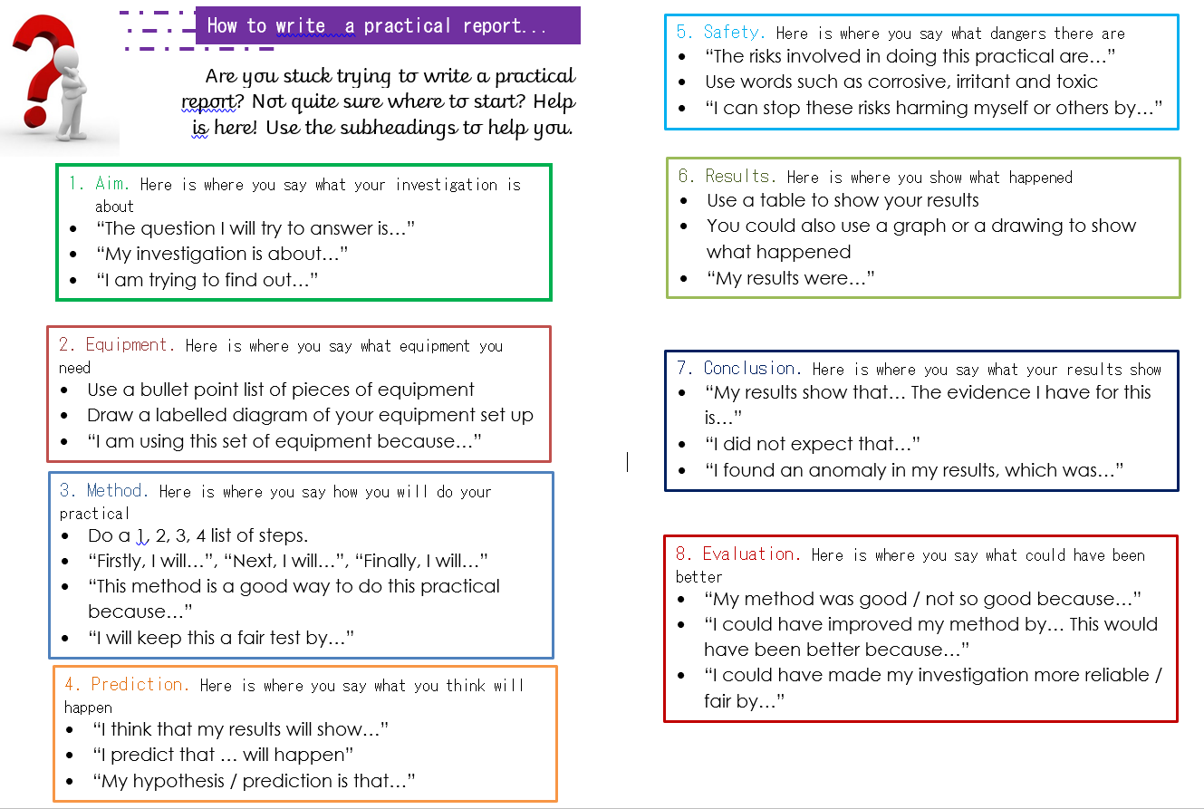
Concept Cartoons

The cartoons provoke discussion and stimulate scientific thinking. Concept Cartoon Part One can be used at the start of a topic to help the teacher and students to become aware of the range of ideas that are held within the class. This creates the circumstance where students want to find out more and provides the stimulus for investigations and other forms of enquiry.- STEM https://www.stem.org.uk/resources/elibrary/resource/26497/concept-cartoons

How to use concept cartoons: https://www.youtube.com/watch?v=9GdZfpT6BVw

KS1 Example

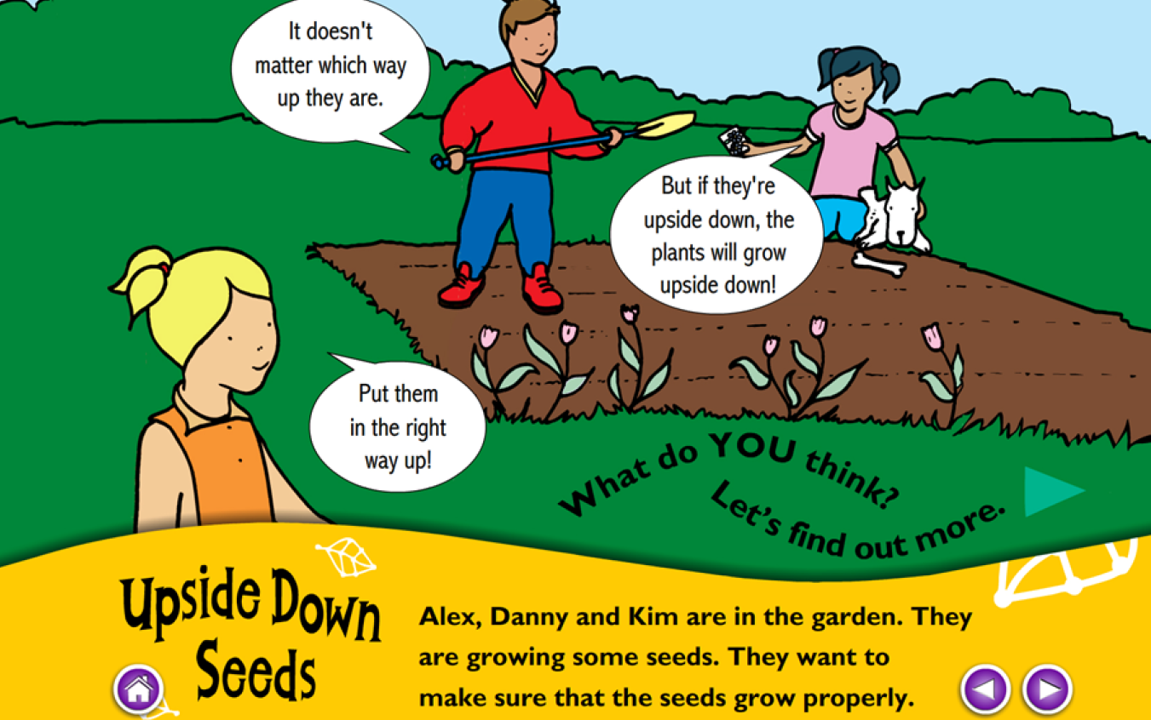

KS2 Example

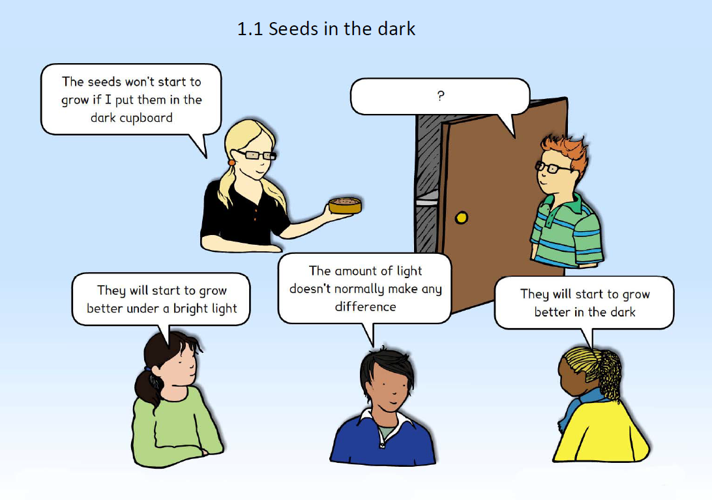

Examples of Differentiation
- Providing the children with key questions under the heading
- Giving them pictures to circle for the variables
- Key vocabulary at the top of the page
- Giving them a set layout
- Communication in Print Images to support their understanding of each part
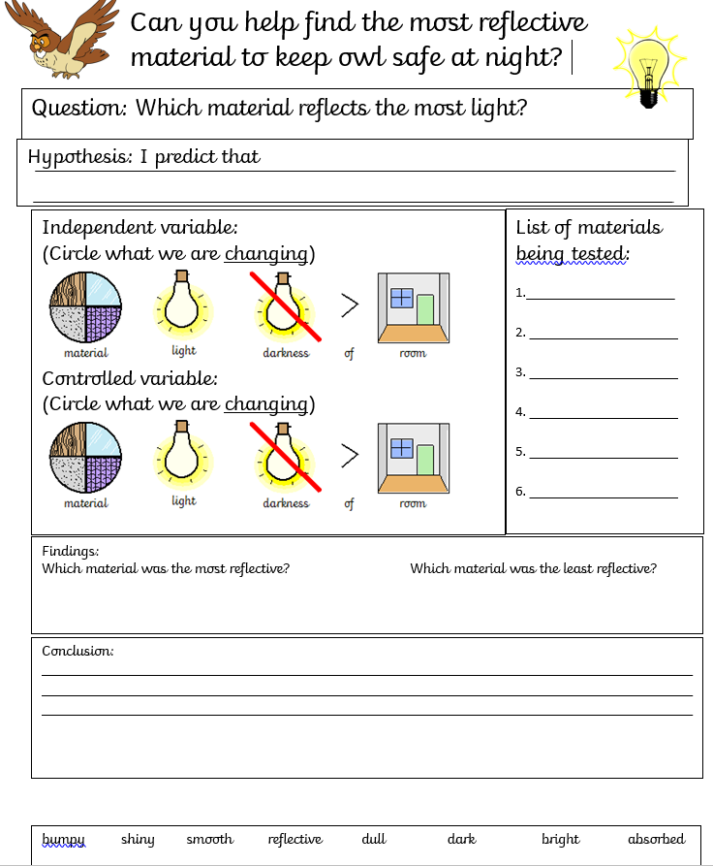
Science and Careers
To continue to raise the profile of science within the school we make links to businesses where possible to show children how science is applied in the real world.

What we’ve done Previously

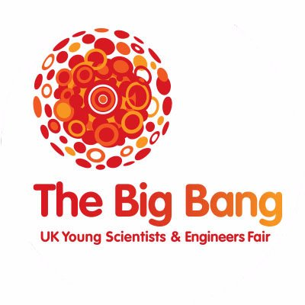 | Year 5 children have previously taken part in the ‘Big Bang Fair’ by participating with ‘Learn By Design’ to design their own products.  All of year 5/6 children in 2018 – 2019 visited The Big Bang Fair  Year 6 children will visit The Big Bang Fair in 2019 - 2020
 | Year 6 children have previously been to Toyota to learn how things are created using algorithms and conveyor belts
In 2019 – 2020 a select group of KS2 children are taking part in an extra curricular activity called ‘Destination Imagination”.
https://www.youtube.com/watch?v=FH3Vt5sH6pc

Monitoring
Monitoring is done both formally and informally throughout the year; this may be done by SLT, MLT or a member of the STEM team.

Some Examples of Monitoring:
Whole Class Topic Books
Topic Books
Displays in classrooms and in the school halls

Pupil Voice
Assessment (1/2 Termly Assessment Booklets)
Teacher Voice
Planning
Observations

Continued Professional Development
- CPD is often delivered informally, with the STEM team supporting specific members of staff as they ask questions or ask for support with planning.

- CPD is also carried out by members of the year group teams as planning is done together and PPA time is taken together to support each other.

- Any external training that members of the maths team attend will be reported back to staff where necessary and staff meetings arranged if there is a whole school initiative.

- A staff voice questionnaire is distributed to the staff at the start of the academic year to identify any need for specific CPD this can then be planned for in whole school staff meeting or support from the science lead.

