Shading | Perspective

Lockdown
Subject | Art
Learning Objective | To explore drawing using tone to create perspective
 |  | SA | TA  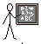
Success Criteria | I can experiment with techniques
 | I can experiment with tone
 | I can experiment with perspective
Support | Independent Adult Support ( ) Group Work
Key vocabulary: Light/dark lines Light/dark shapes Light/dark patterns Patterns Shape perspective
Technique Texture Reflection Movement Hatching Scribbling Stippling Blending Tone GradesHB, 2B, 4B Charcoal Third dimension

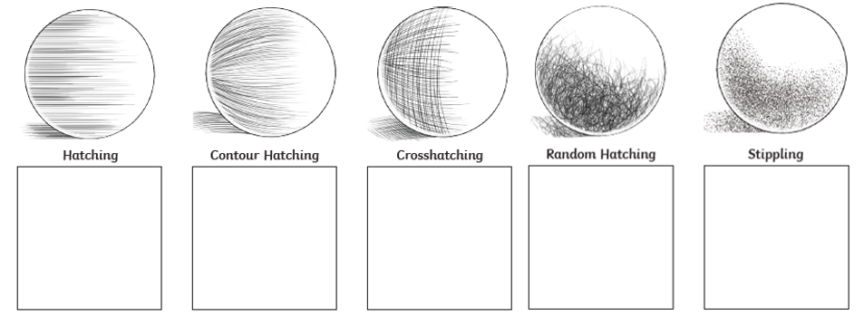

I liked …………………………………………………………………………………………………………………………............
……………………………………………………………………………………………………………………………………………..

I would improve………………………………………………………………………………………………………………………..
……………………………………………………………………………………………………………………………………………….

