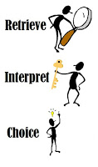

**R:**

1. Who did they call for after the little old woman?
2. Where was this character?
3. Which animals lived at the farmhouse?
4. How many characters did it take to pull out the turnip?

**I:**

1. Why do you think the turnip wouldn’t budge?
2. Why do you think the little old man invited everyone round for turnip dinner?

