Lockdown
Subject/s | English
 | Imitate
Learning Objective  . | To understand the text
 |  | SA | TA  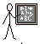
Success Criteria
 | 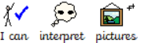
 | 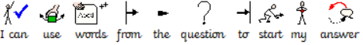
Support | Independent Adult Support ( ) Group Work
Choice:
- What choice of words does the author use to show that it is an old myth?
- Has the author only used sentences? Or have they presented the story in a different way?

Interpret
- How do you think King Theseus would feel when defeating the minotaur?

- How would Princess Ariadne feel when she realised that she had been left on the island?

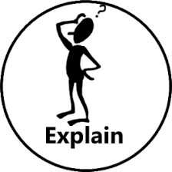
Explain
- What is a labyrinth?

- Why do you think King Aegeus send seven girls and boys instead of a weapon or adults?

