Lockdown
Subject/s | English
 | Imitate
Learning Objective  . | To understand the text
 |  | SA | TA  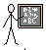
Success Criteria | I can retrieve key ideas from a text.
 | I can interpret ideas from a key text.
 | I can answer the questions using full sentences.
Support | Independent Adult Support ( ) Group Work
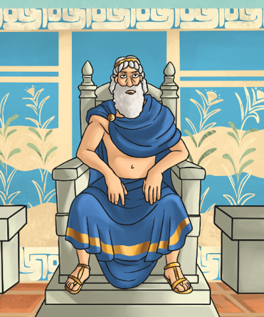
Retrieve
- Where did the story of Theseus and the Minotaur happen?

- What was the deal that King Aegeus made to prevent the attacks?

- What was sent to Crete to be eaten by the Minotaur?

- What did King Aegeus agree to do upon his return?

- Why did Daedalus give Theseus some string?

Interpret
- How do you think that the seven girls and boys were feeling? Why?

- How do you think Theseus would feel when going to defeat the Minotaur?

- How do you think King Aegus would feel when he saw the ship returning with the black sails?

