Steps to success
Lockdown work
Date | 25.1.21
Subject/s | English
Day | Imitate
Learning Objective | Short burst:  To write a setting description.
 |  | SA | 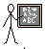  TA
Success Criteria | I can write expanded noun phrases.
 | I can use up levelled adjectives.
 | I can use alliteration.
 | I can use similes to describe.
Support | Independently Support ( ) Group work
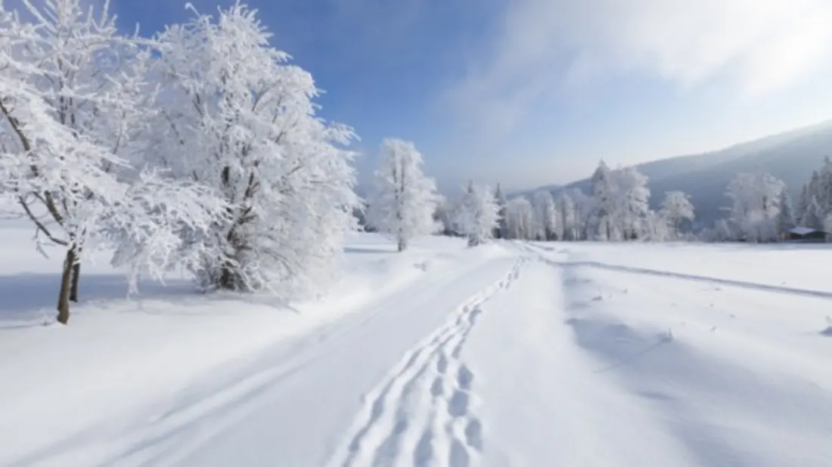

1. Try to pick out different objects from the image to describe, write 5 adjectives next to each of these.

- Trees –
- Sky –
- Weather-
- Footprints-
- Snow-
- Hills-
- Clouds-
- Road-

2. Write these adjectives in expanded noun phrases.

_________________________________________________________________________________________________________________________________________________________________________________________________________________________________________________________________________________

3. Write a simile or a metaphor to describe something from your setting.

_________________________________________________________________________________________________________________________________________________________________________________________________________________________________________________________________________________________________________________________________________________________________________________________________________________________________________________________

4. Can you think of any examples of alliteration which you could include in your writing?

___________________________________________________________________________________________________________________________________________________________________________________________________________________________________________________

5. Your turn! Write a setting description about the image above.

_____________________________________________________________________________________________________________________________________________________________________________________________________________________________________________________________________________________________________________________________________________________________________________________________________________________
__________________________________________________________________________________________________________________________________________________________________
__________________________________________________________________________________________________________________________________________________________________
__________________________________________________________________________________________________________________________________________________________________

