Steps to Success
Date
Subject/s | English
 | Innovate
Learning Objective  . | To know the features of a newspaper report
 |  | SA | TA
Success Criteria
Support | Independent Adult Support ( ) Group Work
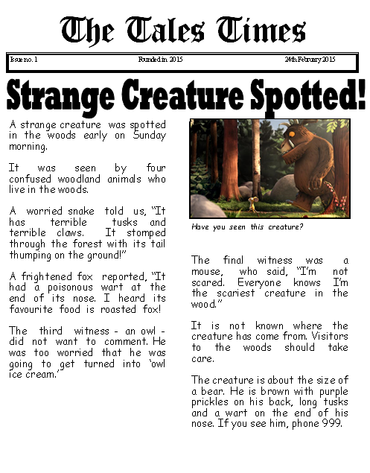
Can you find the features of the newspaper report?

