Friday 8th January 2021- RWI, English, Mathematic and Geography
Phonics- RWI groups
Miss Goodhead
https://youtu.be/_gz6lcKrWxE
https://www.youtube.com/watch?v=_B7wl3-IAAM&feature=youtu.be&safe=active
Miss Torrance
https://youtu.be/HzqroSzx93A
https://youtu.be/gxQz2C5H-ZE

Miss Howard and Mrs Thackray
https://youtu.be/4D-d_uD6ioM
https://youtu.be/uTziTaRL0hs

English
Steps to Success
Date | Friday 8th January
Subject/s | English Short Burst
Learning Objective | To describe a setting
 |  | SA | TA  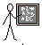
Success Criteria | 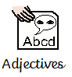  I can use in full sentences.
Support | Independent | Supported ( )  All  Most  Part

Use the adjectives from yesterday in full sentences.

Mathematic- consolidation- writing addition and subtraction sentences.

Date | 08.01.2021
Subject | Maths – consolidation.
L.O | To write the addition and subtraction sentences
 |  |  |  | 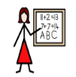
Success Criteria | I can write an addition sentence
 | I can write an subtraction sentence
Support | Independent Adult Support
Pre-task –
Write an addition and subtraction sentence.
-
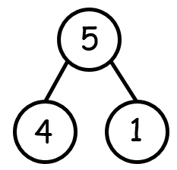
Teacher led |  | Fluency

Fluency 1
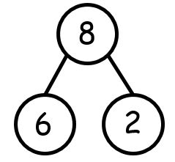 | + =  - =
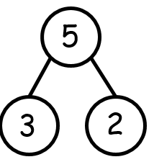 | + =  - =
 | + |  | =

 | - |  | =

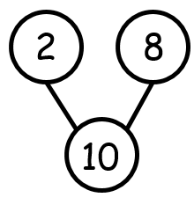 | + =  - =

Mastery glasses

Use it
Can you write the subtraction sentence?

4 + 2 = 6

Prove it
Which of these matches the addition and subtraction sentences?

4 + 5 = 12
12 - 5 = 4
4 + 5 = 11
11 - 4 = 5

Further challenge
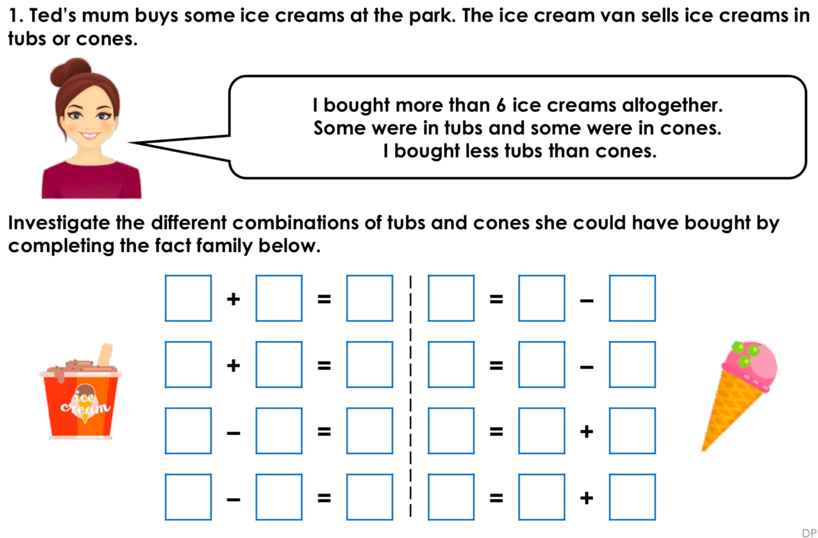

Steps to Success
Date | Friday 8th January 2021
Subject/s | Geography
Learning Objective | To recognise your local area
 |  | SA | TA
Success Criteria | 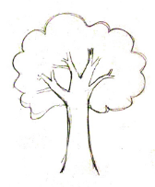  I can sketch different things that I see on my walk.
Support | Independent | Supported ( )  All  Most  Part

Listen to the geography PowerPoint online to help you called ‘week 1 Geography’ on class dojo.

