Date | 22.01.2021
Subject | Maths
L.O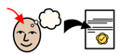 | To compare mass.
 |  |  |  | 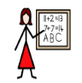
Success Criteria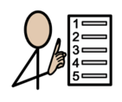 | I can say which object is heaviest or lightest.
 | I can compare objects mass.
Support | Independent Adult Support
Pre-task – Using heavier, lighter or equal, fill in the statement.
The apples weight is ______________ the banana

Teacher led |  | Fluency

Fluency 1. Fill in the statement with Lighter heavier or equal to.

Mastery glasses
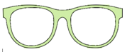 Use it
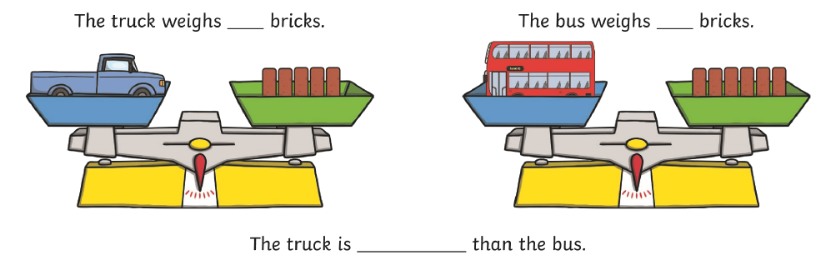

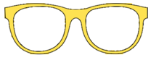Explain it
Using the 3 objects, How could I make the scales be equal?
Draw a line to each scale.
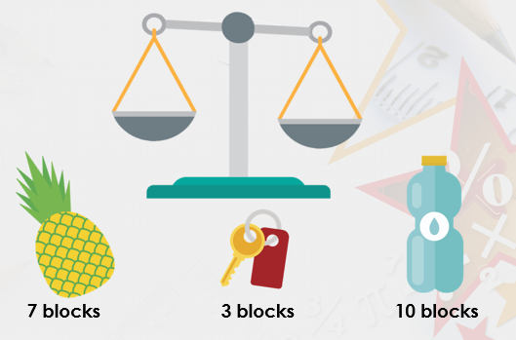

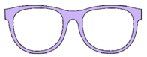Prove it
True or False.
The bottle weighs more than the pepper?
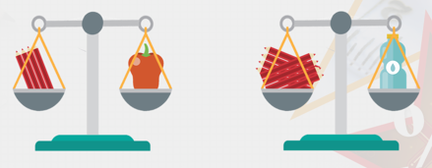

Further challenge
