History
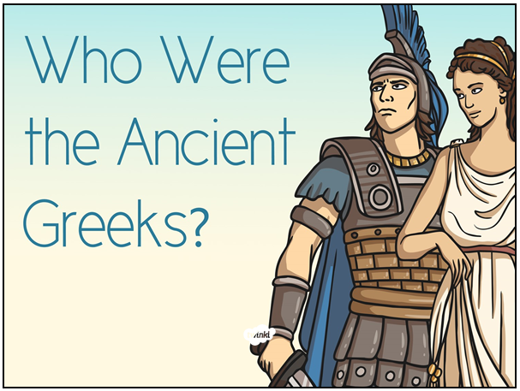

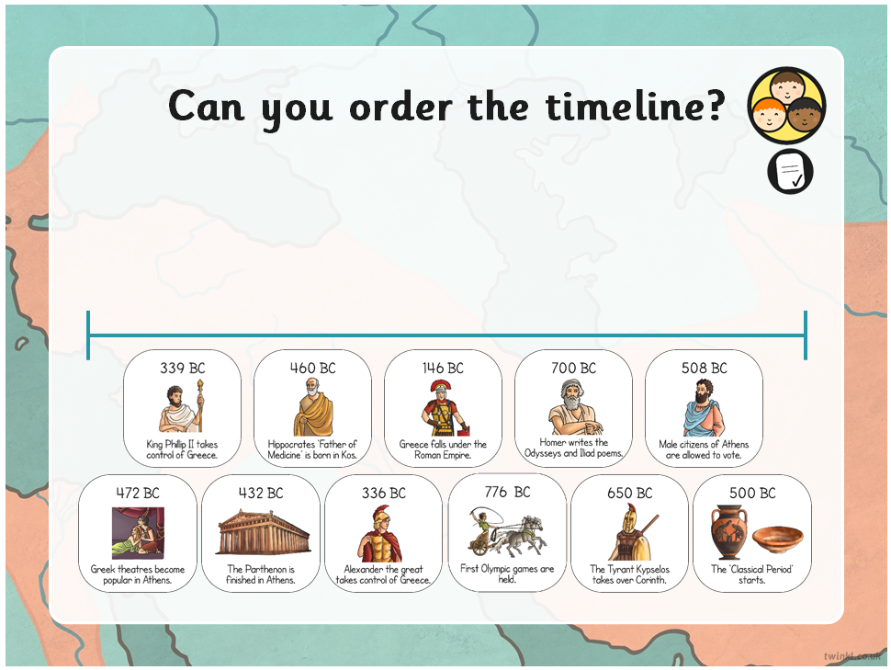

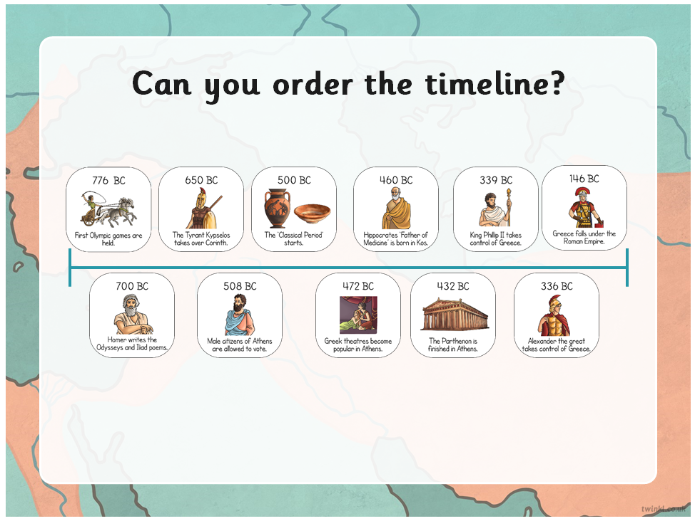

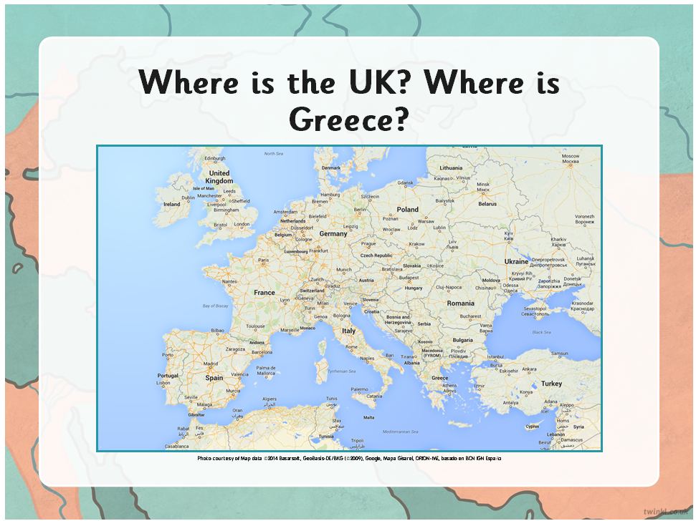

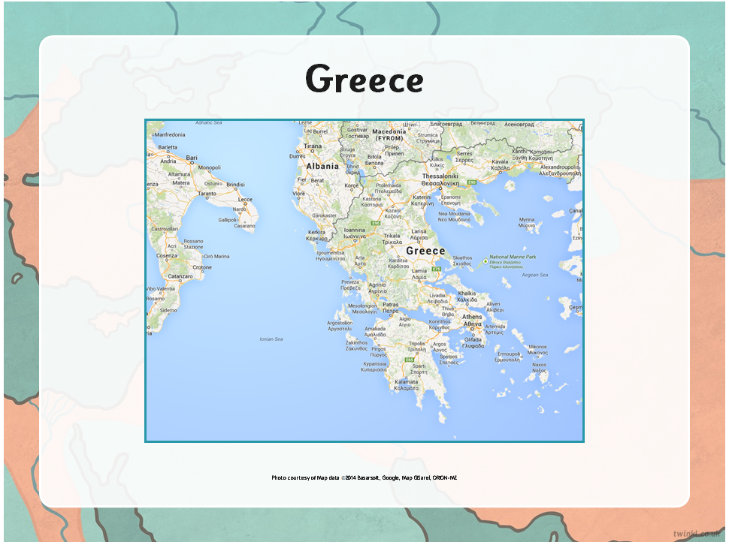

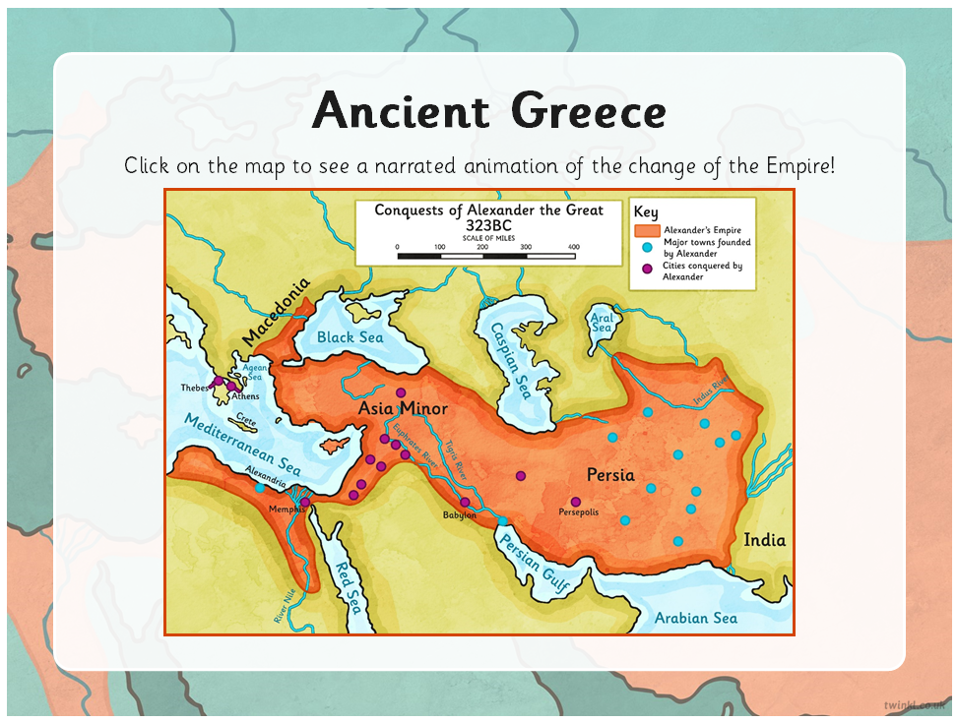

Link - https://www.the-map-as-history.com/Ancient-Greece-Hellenistic-world/Territorial-evolution

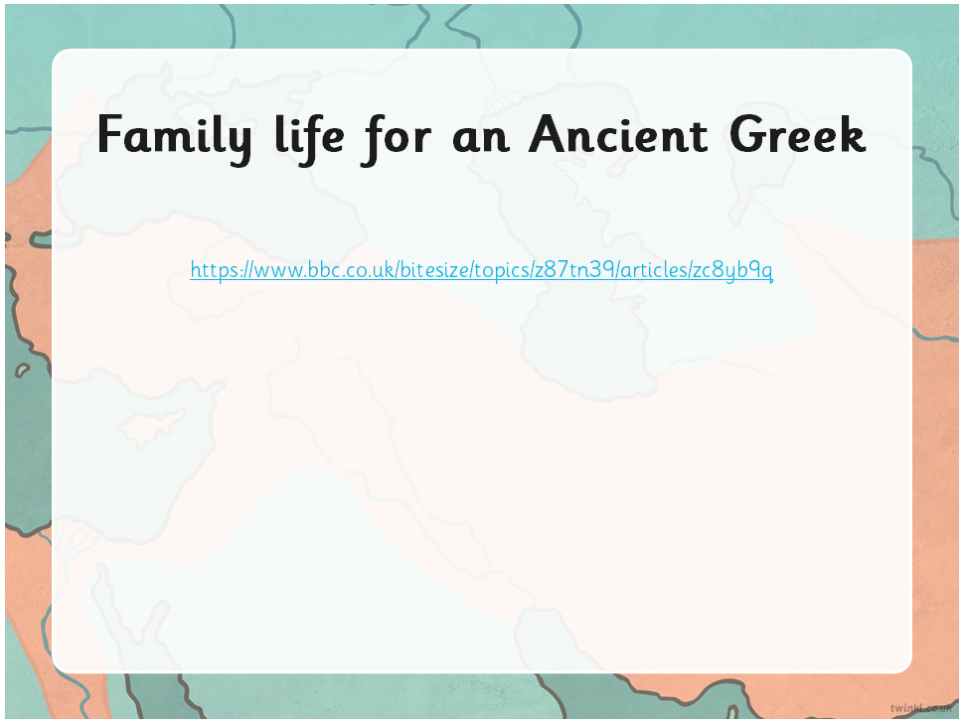

https://www.bbc.co.uk/bitesize/topics/z87tn39/articles/zc8yb9q

Steps to Success
Date | Wednesday 13th January
Subject/s | History
Learning Objective | To understand who the Ancient Greeks were and what their family life was like.
 |  | SA | TA
Success Criteria | I know who the Ancient Greeks were.
 | I know where the Ancient Greeks lived.
 | I know when the Ancient Greeks lived.
 | I know what it was like to live in an Ancient Greek family.
Support | Independent Adult Support ( ) Group Work
Where is Greece in the world?

______________________________________________________________________________

What was Greek fashion like?

What is the climate like in Greece?

____________________________________

____________________________________

____________________________________

How did the Ancient Greeks make a living?

____________________________________

____________________________________

____________________________________

What did the Greeks like to eat?

____________________________________

____________________________________

____________________________________

____________________________________

____________________________________

____________________________________

What toys did children play with?

____________________________________

____________________________________

____________________________________

What were Greek homes like?

____________________________________

____________________________________

____________________________________

____________________________________

____________________________________

____________________________________

____________________________________

+

