**Home learning pack Week commencing 25th January 2021**

When collecting next weeks work, can you bring back this pack so we can look through the work and award dojos for hard work! We have a new 'home learning' dojo for you to earn.

A new home learning Dojo has been added.

RWI and Handwriting will be posted onto Dojo and the website with the link to YouTube.

For Reading: Read one of your favourite books to you parent/carer. If you have ran out of books, log on to your myon.co.uk and find a book from there!

Ask your teacher on class dojo if you aren’t sure of your username or password.

Remember to take lots of pictures of work and upload them as portfolio on dojo so can reward you. Certificates for reaching 50 or 100 will still be awarded and send home.

Here is the timetable for the weeks work.

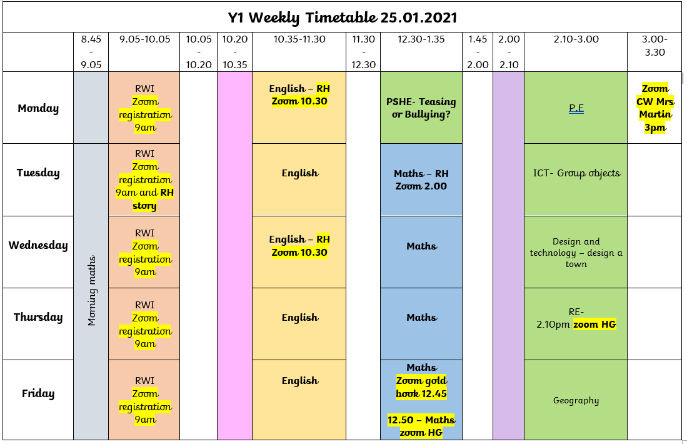

Online learning

We are arranging Zoom calls, further information will follow via Dojo when these have been organised with the time and days.

The lesson PowerPoints will be uploaded to Dojo.

The BBC are also showing live lessons from 9am-12 on CBBC. Oak National Academy has lots of online resources with the backing of the department of education. These may be useful for some online learning.

Mrs Martin would like you to join her on Zoom for an assembly today at 3pm.  
  
Topic: Collective Worship  
Time: 3.00pm  
  
Join Zoom Meeting  
<https://zoom.us/j/97938185173>  
  
Meeting ID: 979 3818 5173

**Sycamores and Palms Year 1 is inviting you to a scheduled Zoom meeting.**

**Topic: Gold Book Sycamores and Palms Year 1's Zoom Meeting**

**Time: This is a recurring meeting Meet anytime**

**12.45pm Every Friday**

**Join Zoom Meeting**

**https://zoom.us/j/96343632591?pwd=SkdwaXQ1TCtrVDZsckY1NHNqTjBpZz09**

**Meeting ID: 963 4363 2591**

**Passcode: K83GPW**

**Steps to Success**

|  |  |  |  |
| --- | --- | --- | --- |
| Date | Monday 25th January | | |
| Subject/s | English | | |
| Learning Objective | Write a journey story | | |
|  | | | |
|  | | SA | TA |
| Success Criteria | I can tick the place I chose  √ |  |  |
| I can list adjectives to describe my place |  |  |
| Support | Independent | Supported ( )  All  Most  Part | |

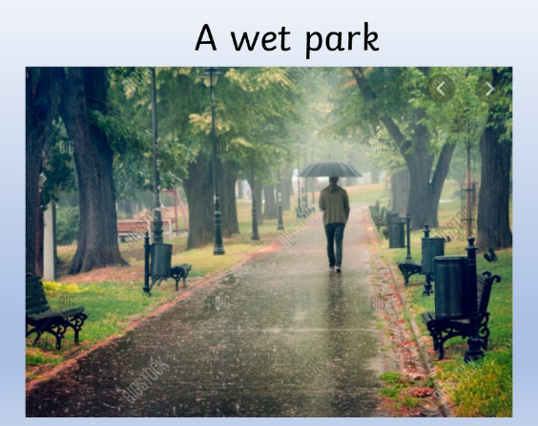

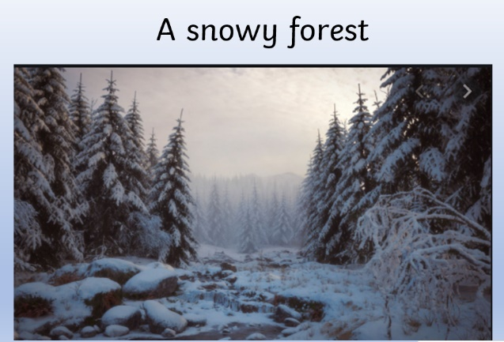

**Steps to Success**

|  |  |  |  |
| --- | --- | --- | --- |
| Date | Monday 25th January 2021 | | |
| Subject/s | PSHE | | |
| Learning Objective | To sort when someone is teasing or a bullying. | | |
|  | | | |
|  | | SA | TA |
| Success Criteria | I can say what a tease is. |  |  |
| I can say what a bully is. |  |  |
| Support | Independent | Supported ( ) | |

**Tease**

**Bully**

|  |  |
| --- | --- |
| “You have big ears! We always call Sam Big Ears!” | “You dropped the ball silly” |
| “ I am going to push you every time I see you playing football.” | “Your painting of a cat made me giggle” |
| “Jessica always pinches me when we line up for dinner” |

**Steps to Success**

|  |  |  |  |
| --- | --- | --- | --- |
| Date | Tuesday 26th January | | |
| Subject/s | English | | |
| Learning Objective | Write a journey story | | |
|  | | | |
|  | | SA | TA |
| Success Criteria | I can write a description about my place using yesterdays list. |  |  |
| Support | Independent | Supported ( )  All  Most  Part | |





|  |  |  |  |  |
| --- | --- | --- | --- | --- |
| Date | Tuesday 26th January | | | |
| Subject | Maths | | | |
|  | To investigate volume. | | | |
|  | | | | |
|  | | | 240GB SSD:Users:emmabates:Desktop:Screen Shot 2017-09-10 at 16.34.06.png | 240GB SSD:Users:emmabates:Desktop:Screen Shot 2017-09-10 at 16.34.57.png |
|  | I can use containers to show different volumes. | |  |  |
| I can say the amount the container holds. | |  |  |
| Support | Independent Adult Support | | | |
| Pre-task – Match the picture to the label. | | | | |
| Empty  Almost full  Almost empty  full | | | | |
| Teacher led | | Fluency | | |

|  |
| --- |
| Fluency 1 |
| Have four cups and using water make show.  - Empty  -Almost empty  -Half  -Almost full  -Full |

|  |
| --- |
| Mastery glasses |

|  |
| --- |
| Use it  Colour the glass in to show:  **Full Almost full Almost empty empty** |

|  |
| --- |
| A picture containing mirror  Description automatically generatedProve it |

**Steps to Success**

|  |  |  |  |
| --- | --- | --- | --- |
| Date | Tuesday 26th January | | |
| Subject/s | Computing | | |
| Learning Objective | To group objects | | |
|  | | | |
|  | | SA | TA |
| Success Criteria | I can group objects. |  |  |
| Support | Independent | Supported ( )  All  Most  Part | |

Find three things around your house that are the same colour and draw them.



|  |  |  |
| --- | --- | --- |
|  |  |  |

Find three things around your house that are the same size and draw them.

|  |  |  |
| --- | --- | --- |
|  |  |  |

**Steps to Success**

|  |  |  |  |
| --- | --- | --- | --- |
| Date | Wednesday 27th January | | |
| Subject/s | English | | |
| Learning Objective | Write a journey story | | |
|  | | | |
|  | | SA | TA |
| Success Criteria | I can write a description about my next place using yesterdays list. |  |  |
| Support | Independent | Supported ( )  All  Most  Part | |





|  |  |  |  |  |
| --- | --- | --- | --- | --- |
| Date | Wednesday 27th January | | | |
| Subject | Maths | | | |
|  | To measure | | | |
|  | | | | |
|  | | | 240GB SSD:Users:emmabates:Desktop:Screen Shot 2017-09-10 at 16.34.06.png | 240GB SSD:Users:emmabates:Desktop:Screen Shot 2017-09-10 at 16.34.57.png |
|  | I can order volumes in containers. | |  |  |
| I can say what container hold more or less. | |  |  |
| Support | Independent Adult Support | | | |
| Pre-task – choose a word to complete the sentence.. | | | | |
|  | | | | |
| Teacher led | | Fluency | | |

|  |
| --- |
| Fluency 1- order the cups from empty to full. |
| Capacity Worksheets | Teaching Resources |

|  |  |  |
| --- | --- | --- |
| Mastery glasses | | |
| Use it  Can you draw a lline on each container to show the water level? |
| Explain it.  Jack says,    Is he correct? Explain you’re answer | |

|  |
| --- |
| A picture containing mirror  Description automatically generatedProve it |

|  |
| --- |
| Further challenge |
|  |

|  |  |  |  |
| --- | --- | --- | --- |
| Date | Wednesday 19th January | | |
| Subject/s | Design and technology | | |
| Learning Objective | To design a town... | | |
|  | | | |
|  | | SA | TA |
| Success Criteria | I can design a town. |  |  |
| Support | Independent | Supported ( ) | |

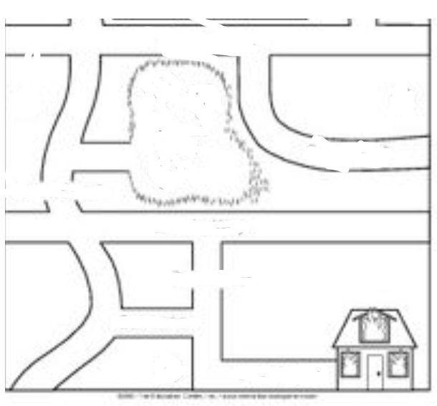

**Steps to Success**

|  |  |  |  |
| --- | --- | --- | --- |
| Date | Thursday 28th January | | |
| Subject/s | English - short burst | | |
| Learning Objective | Write a setting description | | |
|  | | | |
|  | | SA | TA |
| Success Criteria | I can draw my very own setting |  |  |
| Support | Independent | Supported ( )  All  Most  Part | |

|  |  |  |  |  |
| --- | --- | --- | --- | --- |
| Date | Thursday 28th January | | | |
| Subject | Maths | | | |
|  | To measure capacity. | | | |
|  | | | | |
|  | | | 240GB SSD:Users:emmabates:Desktop:Screen Shot 2017-09-10 at 16.34.06.png | 240GB SSD:Users:emmabates:Desktop:Screen Shot 2017-09-10 at 16.34.57.png |
|  | I can measure different containers using the same measure. | |  |  |
| I can solve problems measuring capacity. | |  |  |
| Support | Independent Adult Support | | | |
| Pre-task – | | | | |
| 5 cups fill one fishbowl.    How many cups fill 2 fishbowls. | | | | |
| Teacher led | | Fluency | | |

|  |
| --- |
| Fluency 1 How many cups does it take to filol up my container.  Choose 5 containers at home and a cup and see how many cups it takes to fill it. |
| |  |  | | --- | --- | | Container | Number of cups. | |  |  | |  |  | |  |  | |  |  | |  |  | |

|  |
| --- |
| Mastery glasses |

|  |
| --- |
| Use it |

|  |
| --- |
| A picture containing mirror  Description automatically generatedProve it  Sam pours her cups into the bottle and they fill it exactly.  She says 4 cups fills her bottle.  True or False? |

|  |
| --- |
| A close up of a logo  Description automatically generated Explain it.    Why?___________________________________________ |

|  |
| --- |
| Further challenge |
|  |

**Steps to Success**

|  |  |  |  |
| --- | --- | --- | --- |
| Date | Thursday 28th January | | |
| Subject/s | English - short burst | | |
| Learning Objective | Write a setting description | | |
|  | | | |
|  | | SA | TA |
| Success Criteria | I can match the Holy books to the correct religion |  |  |
| Support | Independent | Supported ( )  All  Most  Part | |

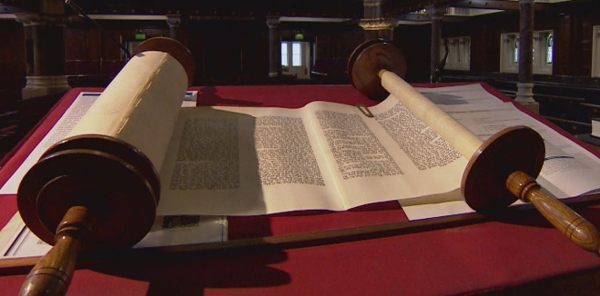

Islam

Torah

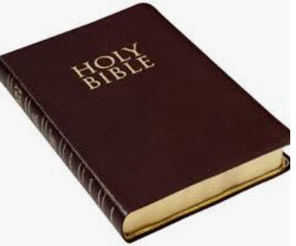

Judaism

Bible

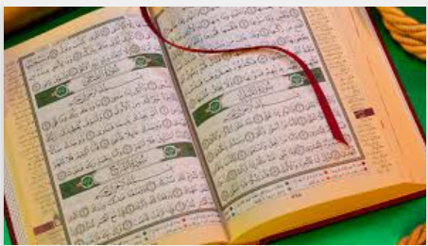

Christianity

Qur'an

**Steps to Success**

|  |  |  |  |
| --- | --- | --- | --- |
| Date | Friday 29th January | | |
| Subject/s | English - short burst | | |
| Learning Objective | Write a setting description | | |
|  | | | |
|  | | SA | TA |
| Success Criteria | I can write my very own setting description |  |  |
| Support | Independent | Supported ( )  All  Most  Part | |











|  |  |  |  |  |
| --- | --- | --- | --- | --- |
| Date | Friday 29th January | | | |
| Subject | Maths | | | |
|  | To compare capacity. | | | |
|  | | | | |
|  | | | 240GB SSD:Users:emmabates:Desktop:Screen Shot 2017-09-10 at 16.34.06.png | 240GB SSD:Users:emmabates:Desktop:Screen Shot 2017-09-10 at 16.34.57.png |
|  | I can compare containers that hold more or less. | |  |  |
| I can use < > = when comparing conainers. | |  |  |
| Support | Independent Adult Support | | | |
| Pre-task – Circle the object that had a larger capacity. | | | | |
|  | | | | |
| Teacher led | | Fluency | | |

|  |
| --- |
| Fluency 1- Using 3 different containers , We compared the capacity.  Watch Mrs Torrance go through her containers and help her order hers. |
|  |
| Fluency 2- Using more , less than and equal to fill in the missing gaps.  Then use the <>= symbols underneath. |
|  |

|  |
| --- |
| Fluency 2 : Sort by capacity.  Colour the container that holds the most yellow.  Colour the container that holds the least green. |
| Capacity - Non Standard Measurement for Kindergarten / Grade One | Capacity  worksheets, Capacity maths, Kindergarten worksheets |

|  |
| --- |
| Mastery glasses |

Use it

Can you order the containers from largest to smallest?

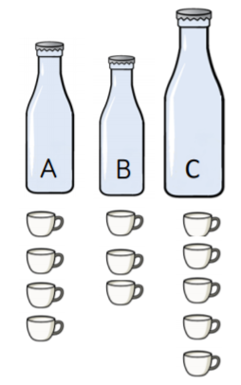

|  |
| --- |
| A picture containing mirror  Description automatically generatedProve it |

|  |
| --- |
| A close up of a logo  Description automatically generatedExplain it.  Alex has a bottle of juice. She pours three glasses of juice.    Do you agree? Explain why? |

|  |  |  |  |
| --- | --- | --- | --- |
| Date | Friday 29th January | | |
| Subject/s | Geography | | |
| Learning Objective | To use a compass | | |
|  | | | |
|  | | SA | TA |
| Success Criteria | I can say which direction the objects are In using the compass. |  |  |
| Support | Independent | Supported ( )  All  Most  Part | |

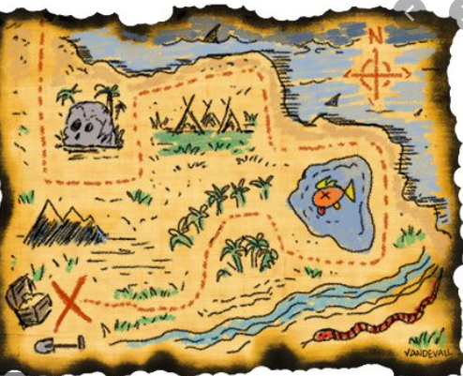

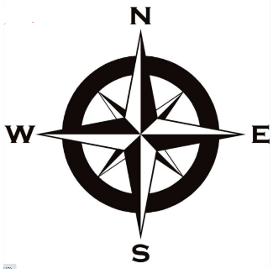



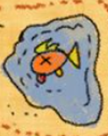

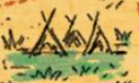

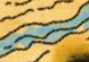

Extra Read, Write Inc work to the YouTube clips: