**Home learning pack Week commencing 11th January 2021**

When collecting next weeks work, can you bring back this pack so we can look through the work and award dojos for hard work!

A new home learning Dojo has been added.

RWI and Handwriting will be posted onto Dojo and the website with the link to YouTube.

For Reading: Read one of your favourite books to you parent/carer. If you have ran out of books, log on to your myon.co.uk and find a book from there!

Ask your teacher on class dojo if you aren’t sure of your username or password.

Remember to take lots of pictures of work and upload them as portfolio on dojo so can reward you. Certificates for reaching 50 or 100 will still be awarded and send home.

Here is the timetable for the weeks work.

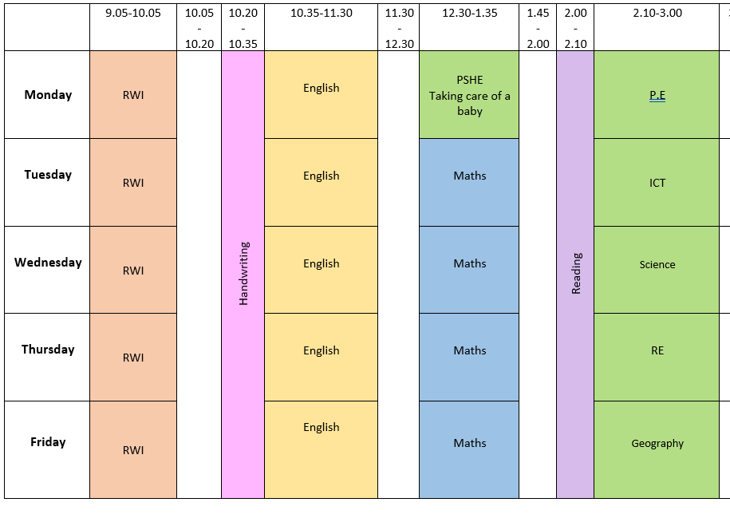

Online learning

We are arranging Zoom calls, further information will follow via Dojo when these have been organised with the time and days.

The lesson PowerPoints will be uploaded to Dojo.

The BBC are also showing live lessons from 9am-12 on CBBC. Oak National Academy has lots of online resources with the backing of the department of education. These may be useful for some online learning.

**Meerkat mail story.**

Once upon a time there was a meerkat called Sunny. Sunny lived in the Kalahari desert where it was very dry and very hot. Sunny had a large family who did everything together. They were very close.

One day Sunny was bored of his family and wanted to visit somewhere new. He packed a big suitcase and wrote his family a note. On Monday he visited uncle Bob but he didn’t fit in, it was really rocky here. The next day he visited Scratch and Mitch but he still didn’t fit in because there were ants everywhere! After that he visited Mildred and Frank but it poured with rain all the time which made Sunny sad.

Unfortunately on his next trip to visit Madagascar and it was at night. Sunny discovered that he was afraid of the dark. Sunny was scared and worried that he would never fit in anywhere.

Fortunately, Sunny decided to visit somewhere very dry and very hot where everyone is close. He decided to go home.

Finally, Sunny is happy with all his family to play with.

**Read the story Meerkat mail in your pack and answer these questions:**

**Steps to Success**

|  |  |  |  |
| --- | --- | --- | --- |
| Date | Monday 11th January | | |
| Subject/s | English ERIC | | |
| Learning Objective | To understand what we read | | |
|  | | | |
|  | | SA | TA |
| Success Criteria | I can answer retrieve questions |  |  |
| Support | Independent | Supported ( )  All  Most  Part | |

Vocabulary:

Tick the nouns

|  |
| --- |
| desert |
| beautiful |
| Visit |

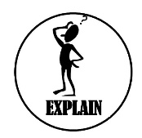



Where did sunny live? Tick the right answer.

* Rain Forest
* Kalahari desert
* Derby City

Who did he visit on Monday?

______________________________________





What was the weather like with Mildred and Frank?

___________________________________

**PSHE- Taking care of a baby.**

**Steps to Success**

|  |  |  |  |
| --- | --- | --- | --- |
| Date | Monday 11th January 2021 | | |
| Subject/s | PSHE | | |
| Learning Objective | To learn how to take care of a baby. | | |
|  | | | |
|  | | SA | TA |
| Success Criteria | I can say what a baby needs. |  |  |
| I can say what a baby doesn’t need. |  |  |
| Support | Independent | Supported ( ) | |

Babies need Babies do not need

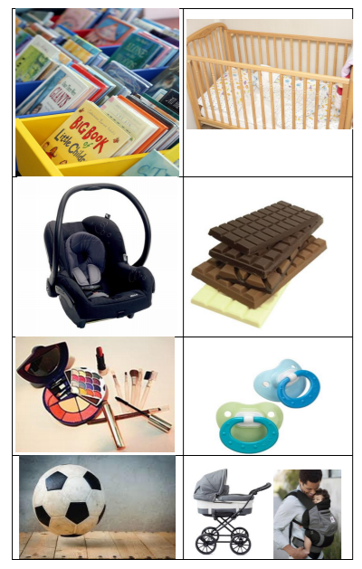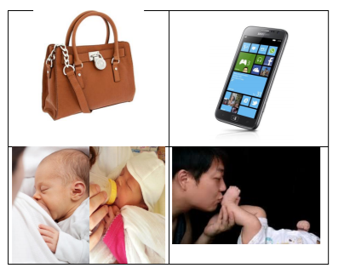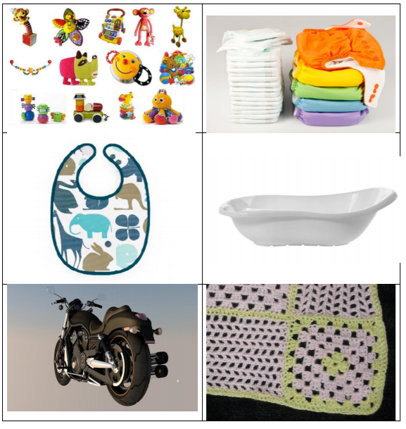

**PE- Get your heart pumping with Joe.**

PE with Joe – <https://www.youtube.com/user/thebodycoach1>

**Tuesday 12th January 2021**

**Steps to Success**

|  |  |  |  |
| --- | --- | --- | --- |
| Date | Tuesday 12th January | | |
| Subject/s | English ERIC | | |
| Learning Objective | To understand what we read | | |
|  | | | |
|  | | SA | TA |
| Success Criteria | I can answer interpret questions |  |  |
| Support | Independent | Supported ( )  All  Most  Part | |

On Monday he visited uncle Bob but he didn’t fit in, it was really rocky here. The next day he visited Scratch and Mitch but he still didn’t fit in because there were ants everywhere! After that he visited Mildred and Frank but it poured with rain all the time which made Sunny sad.

Draw a picture of what Mildred and Franks home looked like.

Draw a picture of what Uncle Bobs home looked like.

**Mathematics**

**To compare length using short, shorter, long, longer and the same language.**

|  |  |  |  |  |
| --- | --- | --- | --- | --- |
| Date | 12.01.2021 | | | |
| Subject | Maths | | | |
|  | To compare lengths of objects | | | |
|  | | | | |
|  | | | 240GB SSD:Users:emmabates:Desktop:Screen Shot 2017-09-10 at 16.34.06.png | 240GB SSD:Users:emmabates:Desktop:Screen Shot 2017-09-10 at 16.34.57.png |
|  | I can use terminology of shorter, short, long longer, tall, taller and the same. | |  |  |
| I can compare the length of objects. | |  |  |
| Support | Independent Adult Support | | | |
| Pre-task – Using the words taller and shorter, fill in the gaps. | | | | |
| The man is ___________ than the boy.  The boy is __________ than the man. | | | | |
| Teacher led | | Fluency | | |

|  |
| --- |
| Fluency 1 |
| Collect your teddies and measure them from tallest to shortest. |

|  |
| --- |
| Fluency 2 Can you cut and order the cateripillars shortest to longest. |
|  |

|  |
| --- |
| Mastery glasses |

|  |
| --- |
| Use it  Using **longer** and **shorter** in the sentence to compare the length of the pencils.    The blue pencil is _____________ than the orange pencil.  The orange pencil is _____________ than the blue pencil. |

|  |
| --- |
| A picture containing mirror  Description automatically generatedProve it    Josh says  “The second caterpillar is longer because it ends after the first one.”  How could we prove Josh wrong?  = |

|  |
| --- |
| A close up of a logo  Description automatically generatedExplain it    Explain how she could measure them? |

|  |
| --- |
| Further challenge |
| Can you write all the objects that are longer than your rubber but shorter than your pencil? |

**Steps to Success**

|  |  |  |  |
| --- | --- | --- | --- |
| Date | Tuesday 12th January | | |
| Subject/s | Computing | | |
| Learning Objective | To sort objects | | |
|  | | | |
|  | | SA | TA |
| Success Criteria | I can sort objects |  |  |
| Support | Independent | Supported ( )  All  Most  Part | |





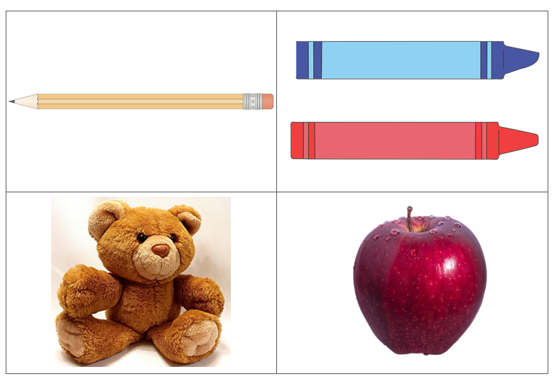

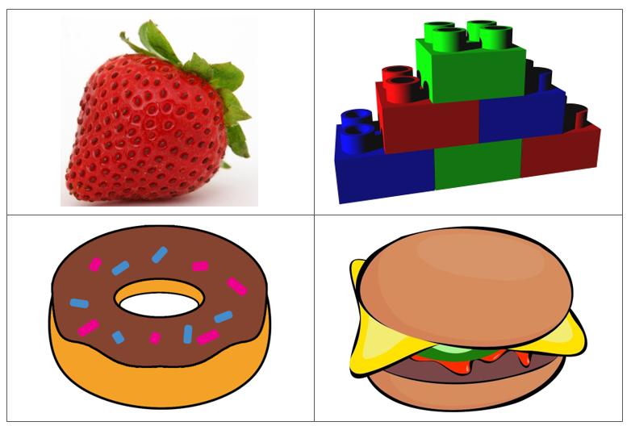

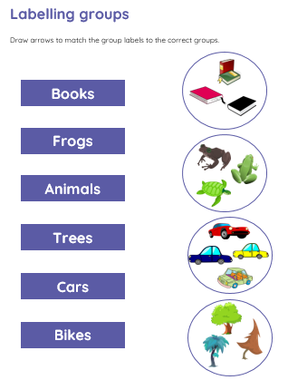

**Wednesday 13th January**

**Steps to Success**

|  |  |  |  |
| --- | --- | --- | --- |
| Date | Wednesday 13th January | | |
| Subject/s | English Short Burst | | |
| Learning Objective | To describe a setting | | |
|  | | | |
|  | | SA | TA |
| Success Criteria | I can draw where I live. |  |  |
| I can use to describe my house. |  |  |
| Support | Independent | Supported ( )  All  Most  Part | |



**Mathematics- Measuring Length**

|  |  |  |  |  |
| --- | --- | --- | --- | --- |
| Date | 13.01.2021 | | | |
| Subject | Maths | | | |
|  | To measure the length. | | | |
|  | | | | |
|  | | | 240GB SSD:Users:emmabates:Desktop:Screen Shot 2017-09-10 at 16.34.06.png | 240GB SSD:Users:emmabates:Desktop:Screen Shot 2017-09-10 at 16.34.57.png |
|  | I can measure using non-standard units. | |  |  |
| I can compare the length of objects. | |  |  |
| Support | Independent Adult Support | | | |
| Pre-task – | | | | |
| Using paper clips ( or any non-standard unit e.g. spoons, rubbers)  to measure the length of the glue stick.  The glue stick is __________ long. | | | | |
| Teacher led | | Fluency | | |

|  |  |
| --- | --- |
| Fluency 1. Draw object you find in your home and measure using your non-standard unit( spoons, rubber or thumbs) | |
| Objects | Measurement in __________ |
| Staedtler Noris 120 2B Pencil (Pack of 12) 120-2B - Office Monster |  |
| Pritt Stick | Cowling & Wilcox Ltd. |  |
|  |  |
|  |  |
|  |  |
|  |  |
|  |  |

|  |
| --- |
| Mastery glasses |

|  |
| --- |
| Use it  What is the length of the paint brush? |

|  |
| --- |
| A picture containing mirror  Description automatically generatedProve it  True or False  The length is 7 blocks long. |
| A close up of a logo  Description automatically generatedExplain it  Sam measured the length of two toys.  She says, The toys are the same length.  Do you agree with Whitney?  Explain why? | |

|  |
| --- |
| Further challenge |
| What objects are longer than your hand?  __________________________________________________________________________________________________________________ |

**Science- Learning about a plants life cylce**

**After watching the powerpoint can you write the life cycle of the plant.**

**Go for a walk In your garden or round the park see If you can spot any seeds or plants growing.**

**Steps to Success**

|  |  |  |  |
| --- | --- | --- | --- |
| Date | Wednesday 13th January | | |
| Subject/s | Science | | |
| Learning Objective | To write about the plants life cycle. | | |
|  | | | |
|  | | SA | TA |
| Success Criteria | I can name each part of the bean growing |  |  |
| I can use time adverbials  First, Next, Then, Finally |  |  |
| Support | Independent | Supported ( ) | |



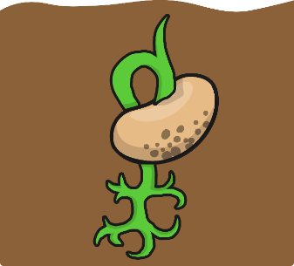

**Thursday 14th January**

**Steps to Success**

|  |  |  |  |
| --- | --- | --- | --- |
| Date | Thursday 14th January | | |
| Subject/s | English | | |
| Learning Objective | To write a journey story | | |
|  | | | |
|  | | SA | TA |
| Success Criteria | I can write the first part of the story. |  |  |
| Support | Independent | Supported ( )  All  Most  Part | |

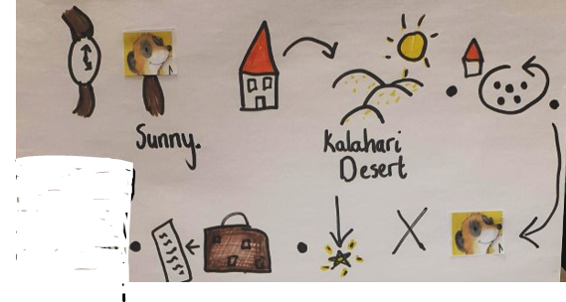



**Mathematic- Measuring Height**

|  |  |  |  |  |
| --- | --- | --- | --- | --- |
| Date | 14.01.2021 | | | |
| Subject | Maths | | | |
|  | To measure the height. | | | |
|  | | | | |
|  | | | 240GB SSD:Users:emmabates:Desktop:Screen Shot 2017-09-10 at 16.34.06.png | 240GB SSD:Users:emmabates:Desktop:Screen Shot 2017-09-10 at 16.34.57.png |
|  | I can measure the height of objects. | |  |  |
| I can use non-standardised units. | |  |  |
| Support | Independent Adult Support | | | |
| Pre-task – How tall is the lollipop? | | | | |
| The lollipop is ________________ blocks tall. | | | | |
| Teacher led | | Fluency | | |

|  |
| --- |
| Fluency 1. What is the height of the objects in cubes. |
| 1,  Pin on Kindergarten |

|  |
| --- |
| Mastery glasses |

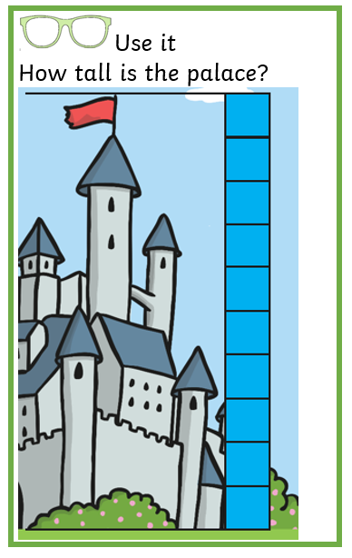

|  |
| --- |
| A picture containing mirror  Description automatically generatedProve it  True or False  The flower Is 8 cubes tall. |

|  |
| --- |
| A picture containing mirror  Description automatically generatedConvince me I'm wrong    The pencil Is 8 cm tall  What have I done wrong? |

|  |
| --- |
| A close up of a logo  Description automatically generatedExplain it  Rosie and Alex are comparing the height of Mrs Rose and Jack.  Can you improve their sentences?    Mrs Rose is __________ than Jack.  Jack is __________ that Mrs Rose. |

**Steps to Success**

|  |  |  |  |
| --- | --- | --- | --- |
| Date | Thursday 14th January | | |
| Subject/s | RE | | |
| Learning Objective | To learn from Christian sacred stories | | |
|  | | | |
|  | | SA | TA |
| Success Criteria | I can answer questions about the Christian story ‘The Lost Sheep’ |  |  |
| Support | Independent | Supported ( )  All  Most  Part | |

**Friday 15th January 2021**

**Steps to Success**

|  |  |  |  |
| --- | --- | --- | --- |
| Date | Friday 15th January | | |
| Subject/s | English | | |
| Learning Objective | To write a journey story | | |
|  | | | |
|  | | SA | TA |
| Success Criteria | I can write the final of the story. |  |  |
| Support | Independent | Supported ( )  All  Most  Part | |

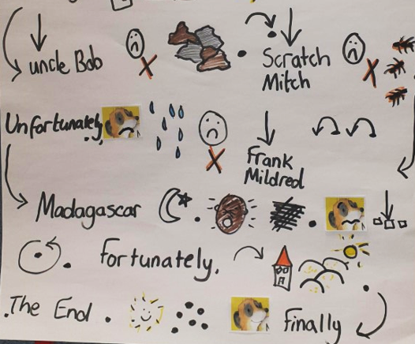





**Mathematics- Measuring using a ruler.**

|  |  |  |  |  |
| --- | --- | --- | --- | --- |
| Date | 15.01.2021 | | | |
| Subject | Maths | | | |
|  | To measure using rulers. | | | |
|  | | | | |
|  | | | 240GB SSD:Users:emmabates:Desktop:Screen Shot 2017-09-10 at 16.34.06.png | 240GB SSD:Users:emmabates:Desktop:Screen Shot 2017-09-10 at 16.34.57.png |
|  | I can measure using a ruler. | |  |  |
| I can use write the measurement using cm. | |  |  |
| Support | Independent Adult Support | | | |
| Pre-task – What is the length of the chocolate bar? | | | | |
| The chocolate bar is __________cm. | | | | |
| Teacher led | | Fluency | | |

|  |  |
| --- | --- |
| 111111111111111111111111Fluency 1.  Choose objects around your house to measure using a ruler. | |
| Object | See the source imageMeasurement (cm) |
|  |  |
|  |  |
|  |  |
|  |  |
|  |  |
|  |  |

|  |
| --- |
| Mastery glasses |

|  |
| --- |
| Use it  What Is the length of the leaf?  Measuring Objects Using a Ruler in Centimeters Worksheets | Measurement  worksheets, Mathematics worksheets, Math subtraction |

|  |
| --- |
| A close up of a logo  Description automatically generatedExplain it  Tom measures the length of the pencil.    He says    Do you agree?  I_________________because_______________________________________________________________________ |

|  |
| --- |
| Further challenge |
| Eva, Dexter and Rosie are comparing ribbons.  Dexter has lost his ribbon. He says his ribbon is shorter than rosies but longer than Eva’s  What length cound his ribbon be? |