Lockdown
Date | 12.1.2021
Subject/s | Maths
Learning Objective | To subtract a 2 digit number from a 3 digit number.
 |  | SA | TA
Success Criteria | I can use column method
 | I know I need to start at the ones column
 | I can subtract using exchanging
Support | Independent Adult Support ( )
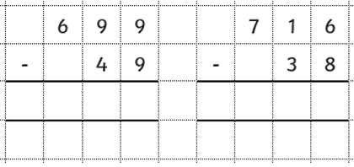
Pre- task:

If you need some extra help….

Go to this site https://whiterosemaths.com/homelearning/year-3/week-7-number-addition-subtraction-2/

Watch the video - Subtract a 2-digit number from a 3-digit number - crossing 10 or 100

Fluency:

