Lockdown
Date | 13.1.2021
Subject/s | Maths
Learning Objective | To subtract a 2 digit number from a 3 digit number
 |  | SA | 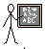  TA
Success Criteria | I can use column method
 | I know I need to start at the ones column
 | I can subtract using exchanging
Support | Independent Adult Support ( )
Pre- task:
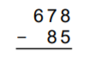

Copy these numbers into the girds below

