Lockdown
Date | 11.01.21
Subject/s | Maths
Learning Objective | To subtract a 3 digit number from a 3 digit number
 |  | SA | 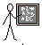  TA
Success Criteria | I can use column method
 | I know I need to start at the ones column
 | I can subtract two3 digit numbers without exchanging
Support | Independent Adult Support ( )
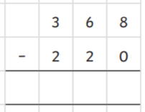
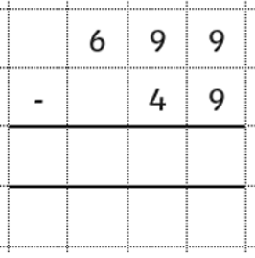
Pre- task:

Teacher led:

Fluency
