Lockdown
Date | 19.01.21
Subject/s | Maths
Learning Objective | To subtract a 4 digit number from a 4 digit number
 |  | SA | TA
Success Criteria | I can use column method
 | I know I need to start at the ones column
 | I know if I do not have enough to subtract from I need to exchange
Support | Independent Adult Support ( )
Pre- task:
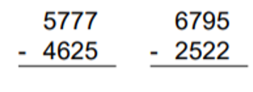

Teacher led:

