Lockdown
Subject/s | Maths
Learning Objective | To estimate and check
 |  | SA | 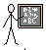  TA
Success Criteria | I can use my knowledge of addition to support my estimating
 | I can use number facts to support my estimating
 | I can choose a method to check my estimation
Support | Independent Adult Support ( )
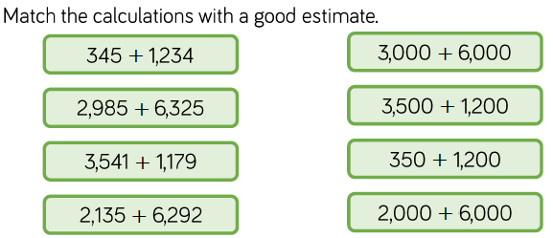
Pre- task:

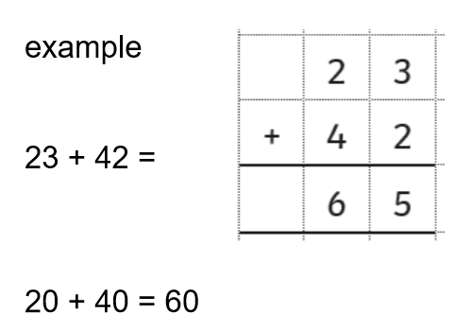

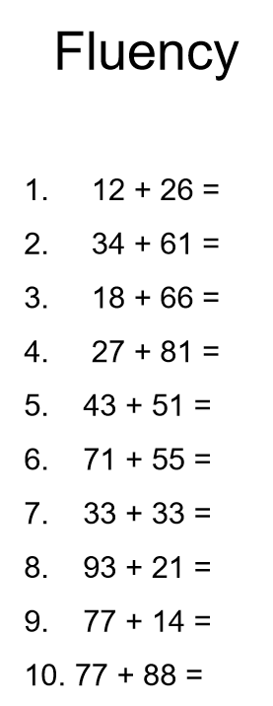
Complete these on the next page on the squared paper like the example.

