Lockdown
Date | 11.01.2021
Subject/s | Maths
Learning Objective | To subtract a 2 digit number from a 3 digit number.
 |  | SA | 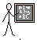  TA
Success Criteria | I can use column method
 | I know I need to start at the ones column
 | I can subtract using exchanging.
Support | Independent Adult Support ( )
Pre- task:
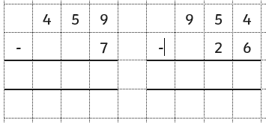

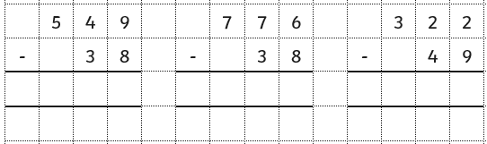
Teacher led:

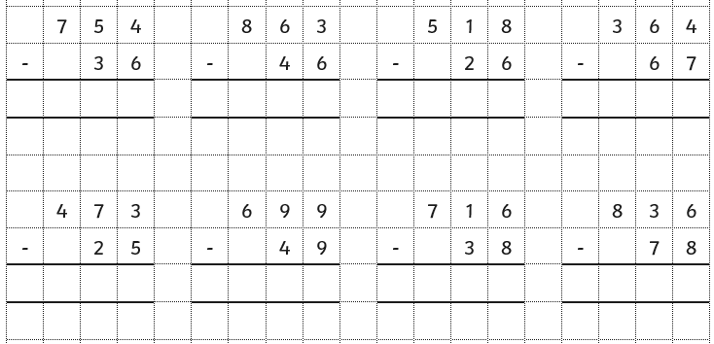
Fluency:

