Lockdown
Subject/s | Maths
Learning Objective | To estimate answer
 |  | SA | TA
Success Criteria | I can use my knowledge of addition to support my estimating
 | I can use number facts to support my estimating
 | I can make a sensible estimation
Support | Independent Adult Support ( )
Pre- task: Estimate what number you think the arrow is pointing to

100
500

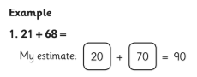

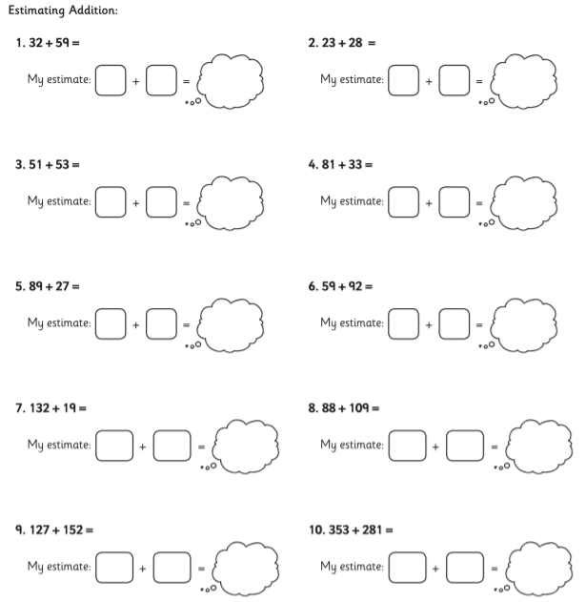

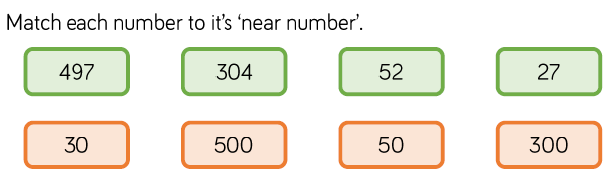

Estimate the answers to these number sentences. Write your calculations.

