Online Work Booklet for Tuesday 5th January 2021

**Phonics**- RWI groups. Children should know which group they are in for RWI, the link is a YouTube video of the phonics lesson.

**Miss Goodhead**

<https://www.youtube.com/watch?v=rsJqgWYICng>

<https://www.youtube.com/watch?v=NgAJPNs15lg&t=5s>

**Miss Torrance**

<https://youtu.be/xV-KWU5nn_c>

<https://youtu.be/_JKzUJNQUXg>

**Miss Howards and Mrs Thackray groups.**

<https://youtu.be/LS8u75kZNxQ>

<https://youtu.be/NxwLBLtqLZE>

**English**

Can you describe the picture using adjectives?

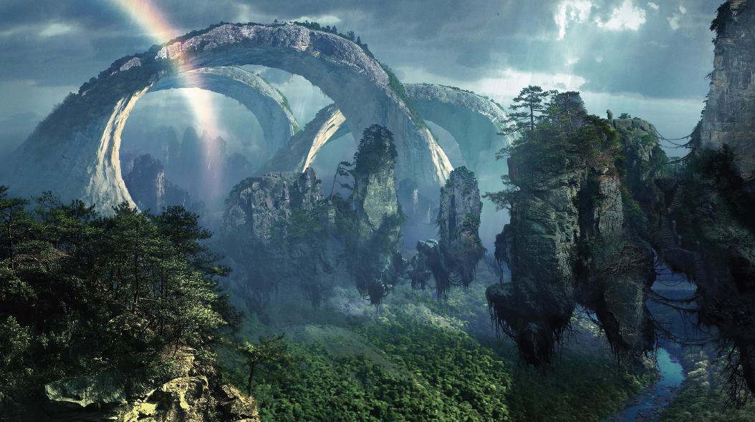Think about your senses what might you hear, touch, and see.

7

**Mathematics-** Place value to 20. Use the word mat to help you write the numbers and check they are the right way round.

|  |  |  |  |  |
| --- | --- | --- | --- | --- |
| Date | 05.01.21 | | | |
| Subject | Maths | | | |
|  | To count and write numbers to 20. | | | |
|  | | | | |
|  | | | 240GB SSD:Users:emmabates:Desktop:Screen Shot 2017-09-10 at 16.34.06.png | 240GB SSD:Users:emmabates:Desktop:Screen Shot 2017-09-10 at 16.34.57.png |
|  | I can count the objects in the image | |  |  |
| I can write the number in numerals | |  |  |
|  | |  |  |
| Support | Independent Adult Support | | | |
| Pre-task – | | | | |
| How many counters do I have? | | | | |
| Teacher led | | Fluency | | |

|  |
| --- |
| Fluency 1 |
| |  |  |  | | --- | --- | --- | |  | Numeral | Words | |  |  |  | |  |  |  | |  |  |  | |  |  |  | |  |  |  | |  |  |  | |  |  |  | |  |  |  | |
| Fluency 2 |
|  |

|  |
| --- |
| Mastery glasses |

|  |
| --- |
| A picture containing mirror  Description automatically generatedConvince me I’m wrong    This is the number 11 |

|  |
| --- |
| A picture containing mirror  Description automatically generatedProve it  A close up of a logo  Description automatically generated  I have 11 dots |

|  |
| --- |
| A close up of a logo  Description automatically generatedExplain it  A picture containing object, clock  Description automatically generated  Which number is the odd one out? |

|  |
| --- |
| Further challenge |
| Help Billy to find his ball by counting forwards through the maze from 1 to 20.  A close up of a logo  Description automatically generated  0  2  1  Then, find a different route to get from his ball to his dinner by counting backwards from 20 to 1. |