Lockdown
Date | Thursday 21st January
Subject/s | PSHE
Learning Objective | To know about dangers and risks
 |  | Self-assessment | Teacher assessment  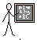
Success Criteria | 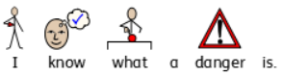
 | 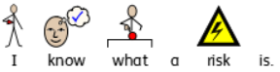
 | 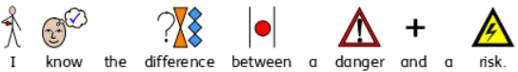
Support | Independent Adult Support ( ) Group Work

Write next to each scenario if you think the risk is worth taking or not.
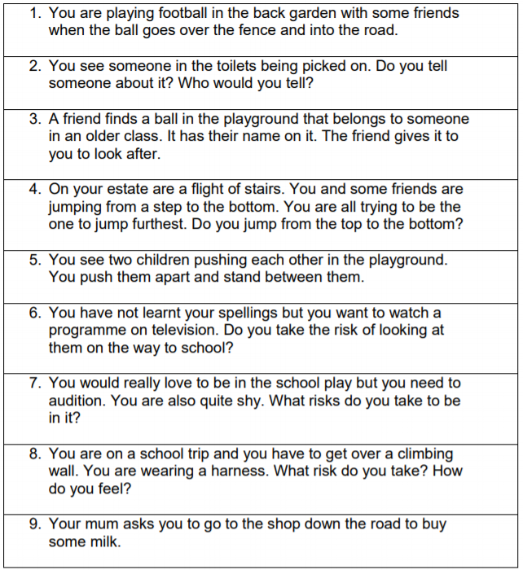

Can you write an example of a danger? _____________________________________________________________________________________________________________________________________________________________________________________________________________________

Can you write an example of a risk? ____________________________________________
_____________________________________________________________________________________________________________________________________________________________________________________________________________________

