Lockdown
Date | Thursday 14th January
Subject/s | RE
Learning Objective | Safe and unsafe situations
 |  | Self-assessment | Teacher assessment  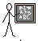
Success Criteria | 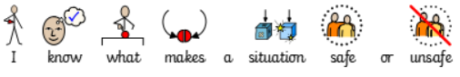
 | 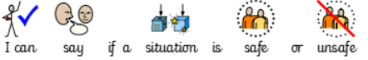
 | 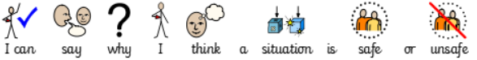
Support | Independent Adult Support ( ) Group Work

Write if you think each scenario below is safe or unsafe and why

 | Safe or unsafe? | Why do you think that?
1
2
3
4
5
6

