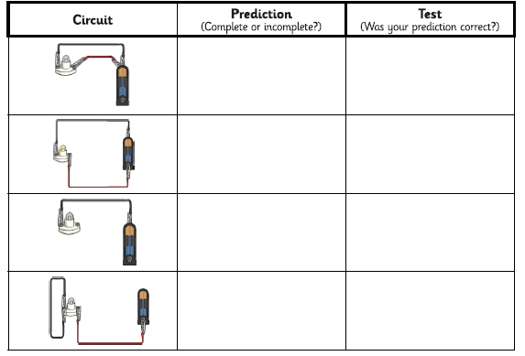
Steps to Success
Date | Monday 11th January
Subject/s | Science
Learning Objective | To construct a simple series electrical circuit.
 |  | SA | TA  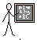
Success Criteria | I can name key parts of a circuit.
 | I can use equipment to create a working circuit.
 | I know that I need to have a complete circuit for it to work properly.
 | I can predict whether or not circuit is complete or incomplete.
Support | Independent Adult Support ( ) Group Work
Key vocabulary for the lesson:
Circuit incomplete complete simple circuit equipment wire crocodile clip cells bulbs

How many predictions did you get right?

___________________

