Lockdown
Date | Thursday 21st January
Subject/s | Science
Learning Objective | To recognise some common conductors and insulators.
 |  | SA | TA  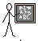
Success Criteria | 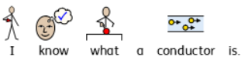
 | 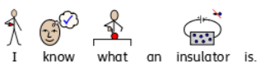
Support | Independent Adult Support ( ) Group Work
Key vocabulary for the lesson:
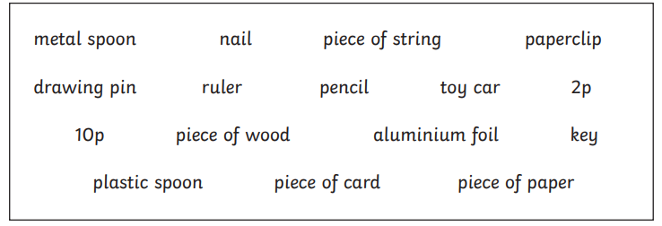
Look at these objects and sort them into the grid below deciding whether you think they are conductors or insulators.

Conductor | Insulator

