Lockdown
Date | Monday 11th January
Subject | Science
Pre- unit quiz
Area | Electricity
Look at these pictures. Circle the ones that need electricity to work.
What is a circuit?

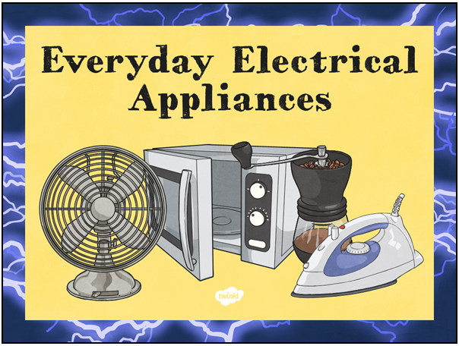
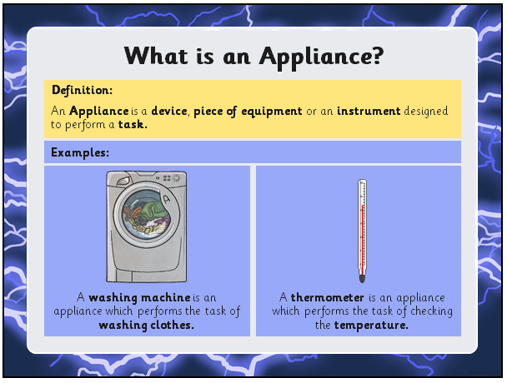
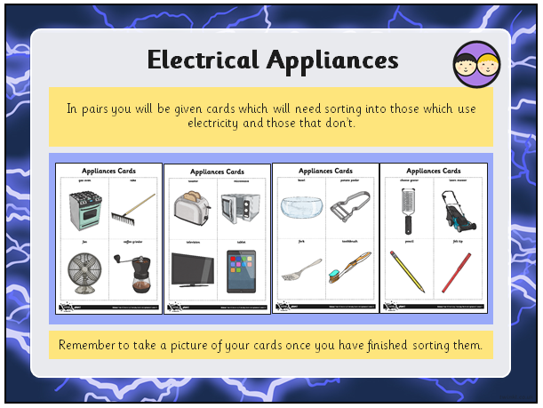
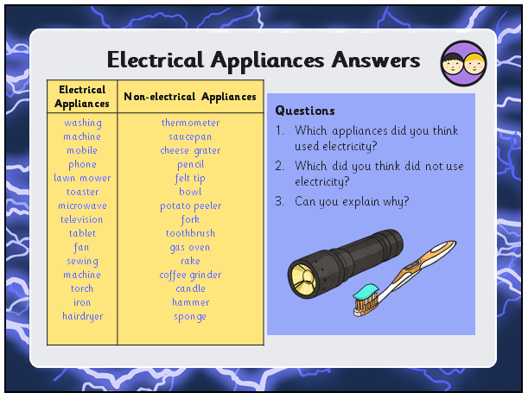
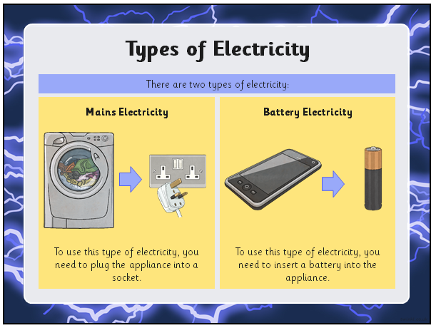
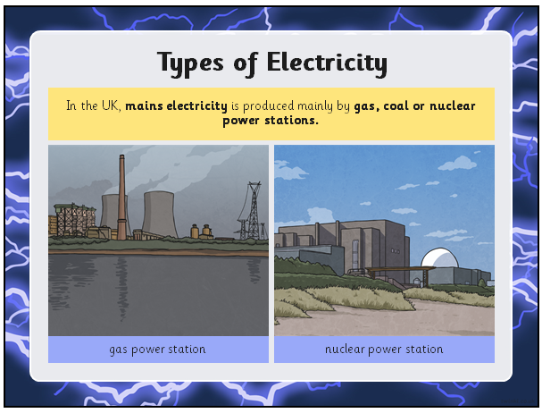
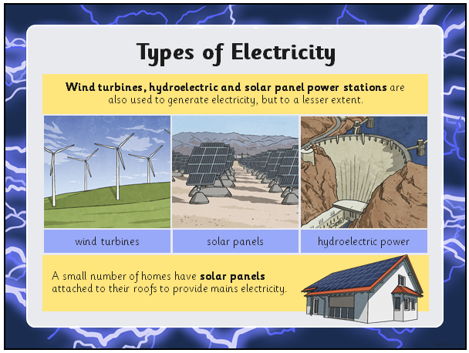
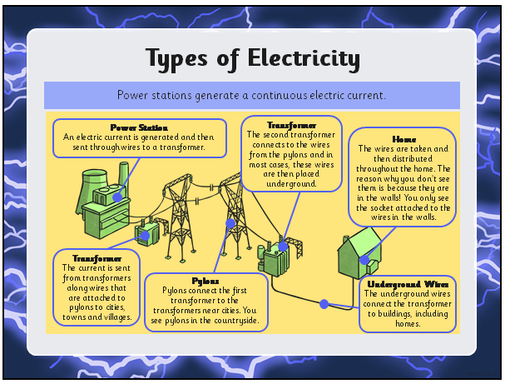
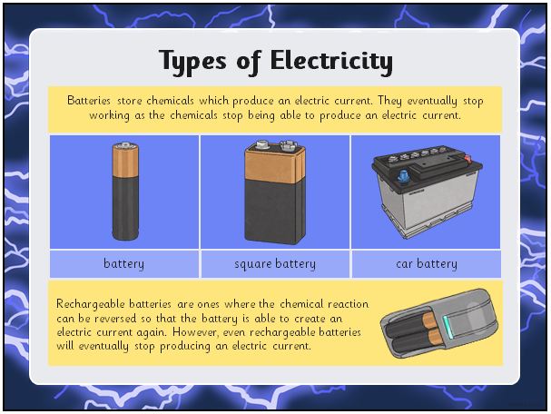
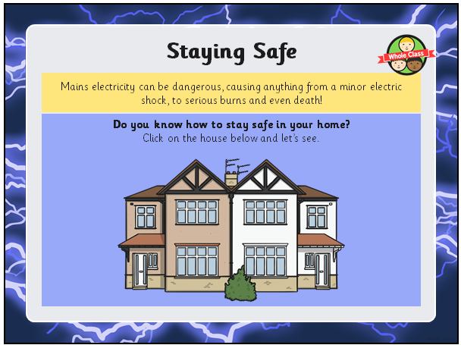

Steps to Success
Lockdown
Date | Monday 11th January
Subject/s | Science
Learning Objective | To identify common appliances that run on electricity.
 |  | SA | TA  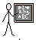
Success Criteria | I can identify objects that a powered by electricity.
 | I can identify objects that don’t need electricity to work
 | I understand what a battery is and how it works.
Support | Independent Adult Support ( ) Group Work
Key vocabulary for the lesson:
Electricity mains power battery appliance
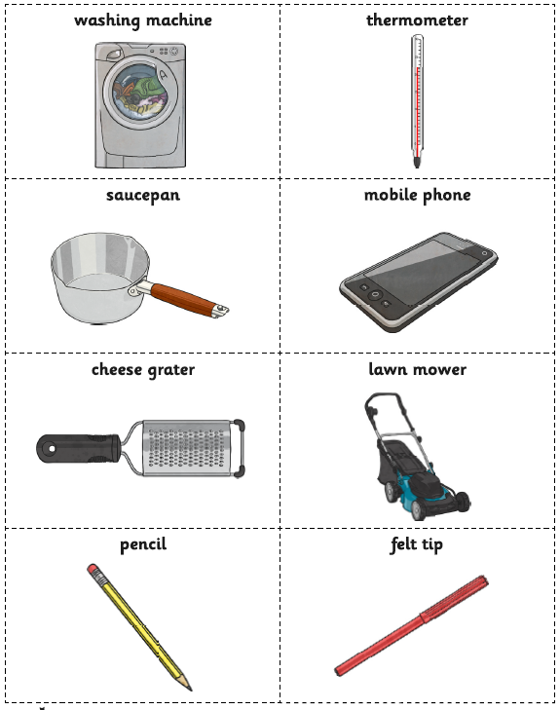
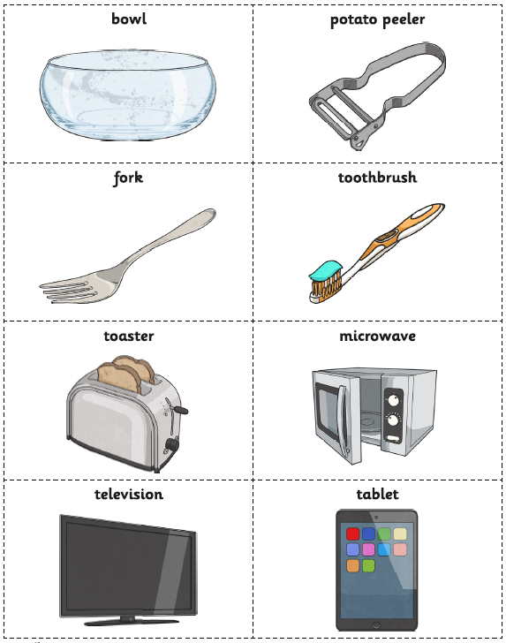

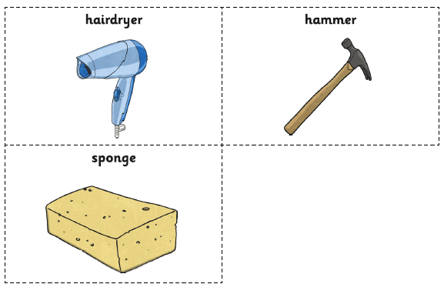
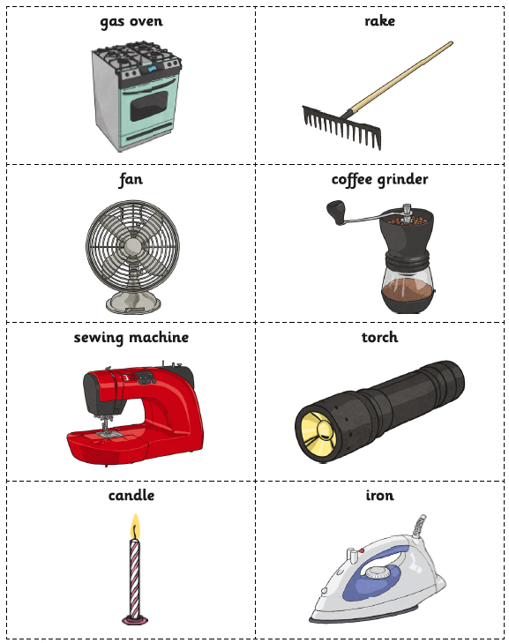
Can you sort the appliances into this venn diagram?

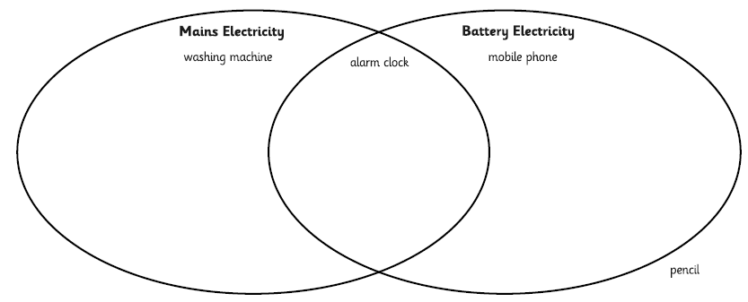

Challenge:

Can you think of your own items to put into the Venn diagram?

