Thursday 7th January 2021
Good Morning- Videos will be uploaded to Dojo too for the lessons.

RWI- Youtube Video
Miss Goodhead
https://youtu.be/qQ67lPEz6Z4
Miss Torrance
https://youtu.be/yFOvdL5DYWQ
https://youtu.be/eH4Lzw_l6-0

Miss Howards and Mrs Thackray
https://youtu.be/a5NI3Ui0R94
https://youtu.be/Frn7RO5b4ic

English-
Steps to Success
Date | Thursday 7th January 2021
Subject/s | English Short Burst
Learning Objective | To describe a setting
 |  | SA | TA  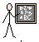
Success Criteria | I can list  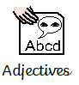
Support | Independent | Supported ( )

Write as many adjectives as you can to describe this place:

thematics- 3-D shape consolidation
Date | 07.01.2021
Subject | Maths – consolidation
L.O | To recognise and name 3D shapes
 |  |  |  | 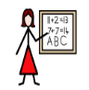
Success Criteria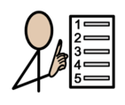 | I can name the shapes
 | I can recognise the shapes
Support | Independent Adult Support
Pre-task – Name the shapes.
__________ __________ ___________

__________ __________ ___________

Teacher led |  | Fluency

Fluency 1. Go on a shape hunt and try and find 3D shapes.
Make a tally of the shapes you find.
Cube
Sphere
Cuboid
Cylinder

Fluency 2- cut out the shapes and stick them in
Cubes | Pyramids
Cuboids | Spheres
Cylinders | Cones

Mastery glasses

- Use it
Circle the cubes
Tick the pyramids

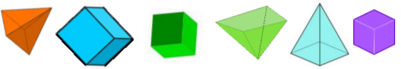

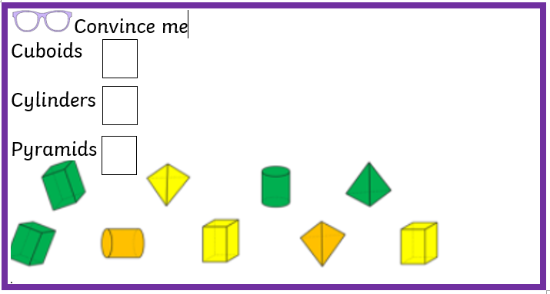

Prove it
The 3-D shape Is hidden
Explain what the shape could be?

Further challenge
Use 3-D shapes to build a tower.
Write down what shapes you have used.
In my tower I have used.
_________________________________________________________________________________________________________________________________________________________________________________________________________________________________________________________
RE- Stories from Christianity
Steps to Success
Date | Thursday 7th January
Subject/s | RE
Learning Objective | To know what stories come from Christianity
 |  | SA | TA  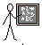
Success Criteria | I can write what ‘Holy’ and ‘Sacred’ means.
Support | Independent | Supported ( )  All  Most  Part

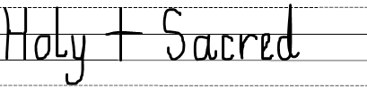
Listen to the PowerPoint to help you called ‘Week 1 RE’ on class Dojo:

