Wednesday 6th January
Phonics- RWI groups. Children should know which group they are in for RWI, the link is a YouTube video of the phonics lesson.
Miss Goodhead
https://www.youtube.com/watch?v=lC1UaB_QDY4&safe=active
https://www.youtube.com/watch?v=pi5-Om_taFs&feature=youtu.be&safe=active
Miss Torrance
https://www.youtube.com/watch?v=-anCt1oZ_K0&feature=youtu.be&safe=active
https://studio.youtube.com/video/QfeX0ivGrXc/edit
Miss Howards and Mrs Thackray groups.
https://youtu.be/VBAfIncTh3o
https://youtu.be/aBkyOOMMs1w

English

Mathematics
Date | 06.01.2021
Subject | Maths- Consolidation
L.O | To recognise and name 2D shapes
 |  |  |  | 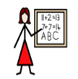
Success Criteria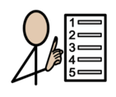 | I can name the shapes
 | I can recognise the shapes
Support | Independent Adult Support
Pre-task – Name the shapes
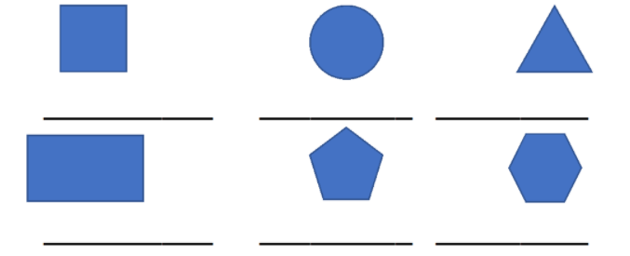
Teacher led |  | Fluency

Fluency 1- Can you find any of these shapes in your house?

Fluency 2
Mastery glasses

- Use it
Circle the triangles
Tick the rectangles
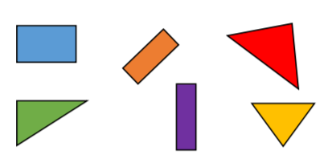

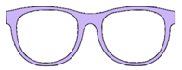Explain It
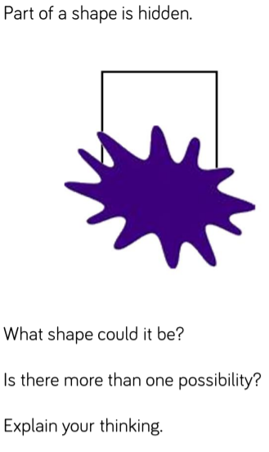

Further challenge
The answer to my question is rectangle.
What could the questions be?
Can you think of more than one?
Remember to think about the properties.

Science
Steps to Success
Date | Wednesday 6th January
Subject/s | Science
Learning Objective | To know what plants need to grow.
 |  | SA | TA  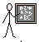
Success Criteria | I can say what a plant needs to grow.  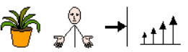
I know which part of the plant allows it to grow.
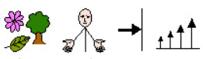
Support | Independent | Supported ( )
Can you sort the pictures of what a plant needs to grow.

Star Challenge
What does each part of the plant do to make it grow?

