Meerkat mail story.
Once upon a time there was a meerkat called Sunny. Sunny lived in the Kalahari desert where it was very dry and very hot. Sunny had a large family who did everything together. They were very close.

One day Sunny was bored of his family and wanted to visit somewhere new. He packed a big suitcase and wrote his family a note. On Monday he visited uncle Bob but he didn’t fit in, it was really rocky here. The next day he visited Scratch and Mitch but he still didn’t fit in because there were ants everywhere! After that he visited Mildred and Frank but it poured with rain all the time which made Sunny sad.

Unfortunately on his next trip to visit Madagascar and it was at night. Sunny discovered that he was afraid of the dark. Sunny was scared and worried that he would never fit in anywhere.

Fortunately, Sunny decided to visit somewhere very dry and very hot where everyone is close. He decided to go home.

Finally, Sunny is happy with all his family to play with.
Read the story Meerkat mail in your pack and answer these questions:
Steps to Success
Date | Monday 11th January
Subject/s | English ERIC
Learning Objective | To understand what we read
 |  | SA | TA  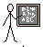
Success Criteria | I can answer retrieve questions
Support | Independent | Supported ( )  All  Most  Part
Vocabulary:
Tick the nouns

desert
beautiful
Visit

Where did sunny live? Tick the right answer.

- Rain Forest
- Kalahari desert
- Derby City
Who did he visit on Monday?
______________________________________

What was the weather like with Mildred and Frank?
___________________________________

Steps to Success
Date | Tuesday 12th January
Subject/s | English ERIC
Learning Objective | To understand what we read
 |  | SA | TA
Success Criteria | I can answer interpret questions
Support | Independent | Supported ( )  All  Most  Part

On Monday he visited uncle Bob but he didn’t fit in, it was really rocky here. The next day he visited Scratch and Mitch but he still didn’t fit in because there were ants everywhere! After that he visited Mildred and Frank but it poured with rain all the time which made Sunny sad.
Draw a picture of what Mildred and Franks home looked like.

Draw a picture of what Uncle Bobs home looked like.

Steps to Success
Date | Tuesday 12th January
Subject/s | Computing
Learning Objective | To sort objects
 |  | SA | TA
Success Criteria | I can sort objects
Support | Independent | Supported ( )  All  Most  Part

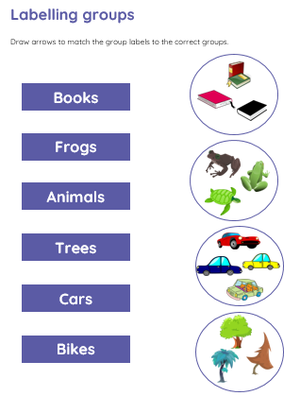

Steps to Success
Date | Wednesday 13th January
Subject/s | English Short Burst
Learning Objective | To describe a setting
 |  | SA | TA
Success Criteria | I can draw where I live.
 | I can use to describe my house.
Support | Independent | Supported ( )  All  Most  Part

Steps to Success
Date | Thursday 14th January
Subject/s | English
Learning Objective | To write a journey story
 |  | SA | TA
Success Criteria | I can write the first part of the story.
Support | Independent | Supported ( )  All  Most  Part

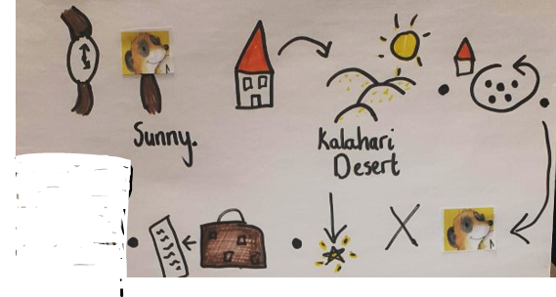

Steps to Success
Date | Thursday 14th January
Subject/s | RE
Learning Objective | To learn from Christian sacred stories
 |  | SA | TA
Success Criteria | I can answer questions about the Christian story ‘The Lost Sheep’
Support | Independent | Supported ( )  All  Most  Part

Zoom lesson with Mrs Goodhead

Steps to Success
Date | Friday 15th January
Subject/s | English
Learning Objective | To write a journey story
 |  | SA | TA
Success Criteria | I can write the final of the story.
Support | Independent | Supported ( )  All  Most  Part
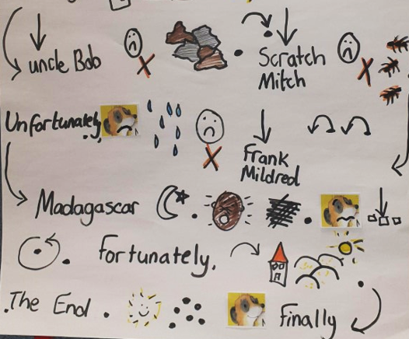

Steps to Success
Date | Friday 15th January
Subject/s | Geography
Learning Objective | To create a map.
 |  | SA | TA
Success Criteria | I can make a map of a local area using the things we saw.
Support | Independent | Supported ( )  All  Most  Part

