**Home learning pack Week commencing 22.2.21**

**AFTER HALF TERM 22.2.21 February 2021 - RETURN TO SCHOOL NO EARLIER THAN 26.2.21 Thank you.**

Have a week off after all your hard work this term - 15th to 19th February :)

When collecting next weeks work, can you bring back this pack so we can look through the work and award dojos for hard work on 26.2.21 or after. RWI and Handwriting will be posted onto Dojo and the website with the link to YouTube.

For Reading: Read one of your favourite books to you parent/carer. If you have ran out of books, log on to your myon.co.uk and find a book from there! Miss Howard will read a story to you every morning during the morning register Mon to Wed.

Ask your teacher on class dojo if you aren’t sure of your username or password.

Remember to take lots of pictures of work and upload them as portfolio on dojo so can reward you. Certificates for reaching 50 or 100 will still be awarded and send home.

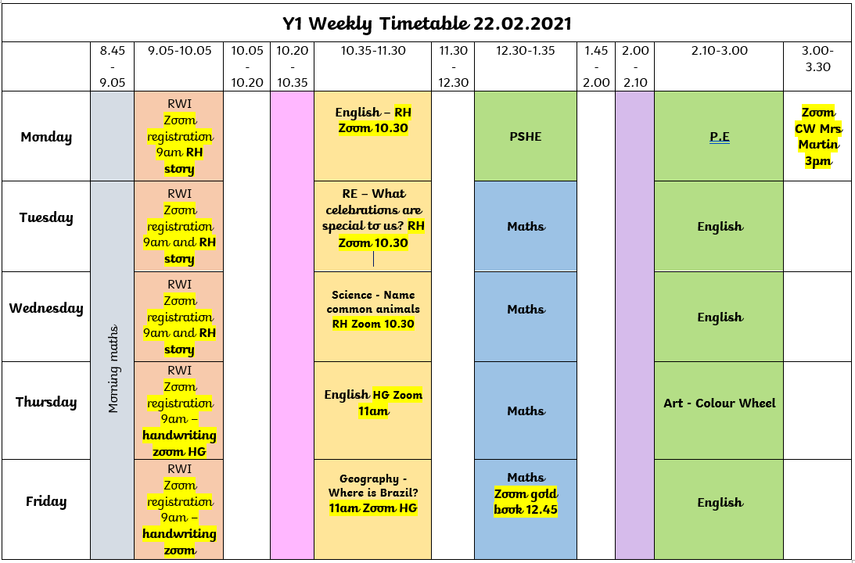Here is the timetable for the weeks work.

Mrs Martin would like you to join her on Zoom for an assembly today at 3pm.  
  
Topic: Collective Worship  
Time: 3.00pm  
  
Join Zoom Meeting  
<https://zoom.us/j/97938185173>  
  
Meeting ID: 979 3818 5173

**Sycamores and Palms Year 1 is inviting you to a scheduled Zoom meeting.**

**Topic: Gold Book Sycamores and Palms Year 1's Zoom Meeting**

**Time: This is a recurring meeting Meet anytime**

**12.45pm Every Friday**

**Join Zoom Meeting**

**https://zoom.us/j/96343632591?pwd=SkdwaXQ1TCtrVDZsckY1NHNqTjBpZz09**

**Meeting ID: 963 4363 2591**

**Passcode: K83GPW**

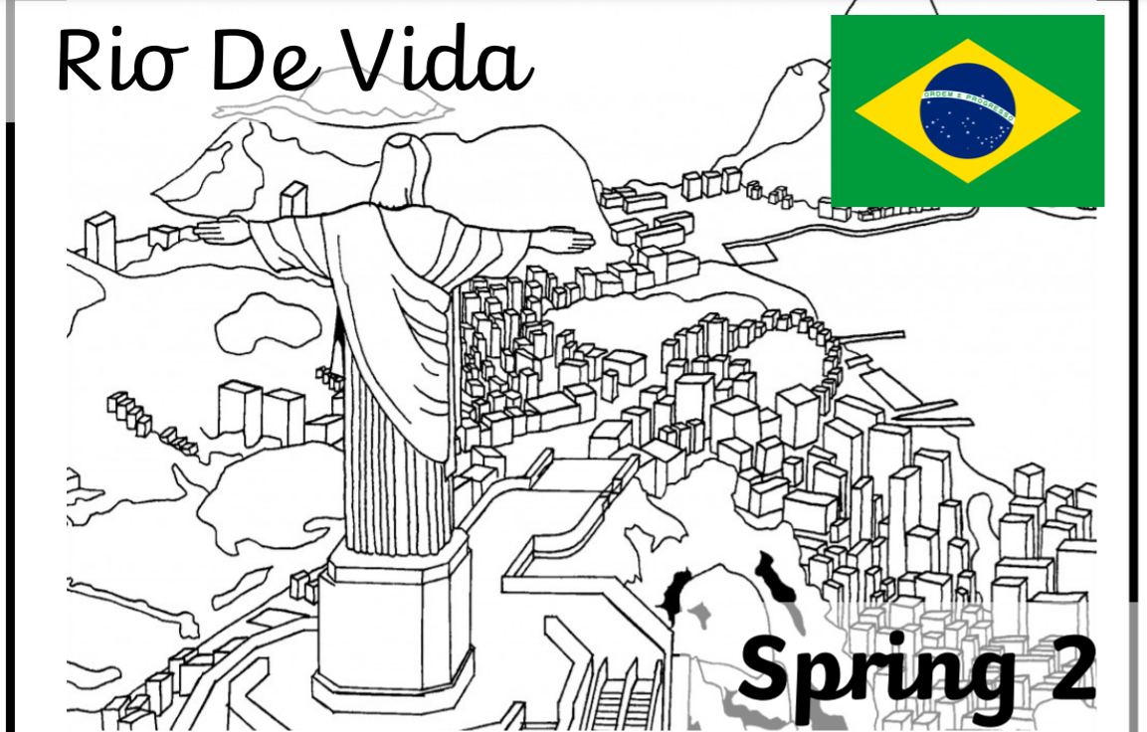

Our new topic

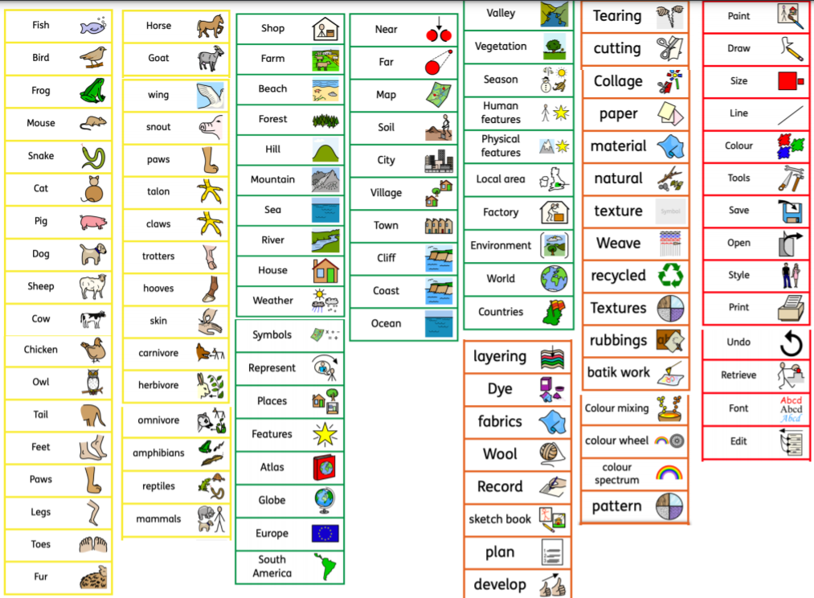

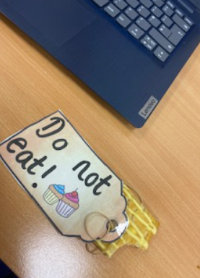

Someone has been into Miss Goodhead’s classroom and ate her cake slice. Should they have ate her cake?

Who do you think it is?

Why would they take it?

Can you write a warning story of someone coming into the classroom and eating the cake, what do you think will happen next?

**Cold Write**

|  |  |
| --- | --- |
| Date: | Monday 22nd February |
| Text Genre: | A warning story |
| Task: | Write/verbally tell a warning story about the person who has ate a muffin. |









**Steps to Success**

|  |  |  |  |
| --- | --- | --- | --- |
| Date | Monday 22nd February | | |
| Subject/s | PSHE | | |
| Learning Objective | To learn about different feelings. | | |
|  | | | |
|  | | SA | TA |
| Success Criteria | I can say what each face shows in feelings. |  |  |
| I can say when I might feel like this. |  |  |
| Support | Independent | Supported ( ) | |

Draw a face to show each emotion:

|  |  |
| --- | --- |
| Happy | Sad |
| Angry | Scared |

Choose one emotion and say when you feel that way.

I feel ____________________________________________________

**Steps to Success**

|  |  |  |  |
| --- | --- | --- | --- |
| Date | Tuesday 23rd February | | |
| Subject/s | English | | |
| Learning Objective | To make a prediction. | | |
|  | | | |
|  | | SA | TA |
| Success Criteria | I can predict who has been in the classroom |  |  |
| I can draw who I think it is. |  |  |
| I can explain who I think it is. |  |  |
| Support | Independent | Supported ( ) | |

Draw a picture of who you think has been in our classroom?

**Challenge: Explain who you think it is**



|  |  |  |  |  |
| --- | --- | --- | --- | --- |
| Date | 22.01.21 | | | |
| Subject | Maths | | | |
|  | To find one more and one less. | | | |
|  | | | | |
|  | | | 240GB SSD:Users:emmabates:Desktop:Screen Shot 2017-09-10 at 16.34.06.png | 240GB SSD:Users:emmabates:Desktop:Screen Shot 2017-09-10 at 16.34.57.png |
|  | I can use equipment to find one more and one less. | |  |  |
| I can write one more and one less. | |  |  |
| Independent Adult Support | | | |
| Support |
| Pre-task – | | | | |
| What is one more and one less than 13? | | | | |
| Teacher led | | Fluency | | |

|  |
| --- |
| Fluency 1 |
| |  |  |  | | --- | --- | --- | | One less - 1 | Number | One more +1 | |  | 9 |  | |  | 7 |  | |  | 3 |  | |  | 11 |  | |  | 10 |  | |  | 12 |  | |  | 8 |  | |

|  |
| --- |
| Fluency 2 |
| |  |  |  | | --- | --- | --- | | One less - 1 | Number | One more +1 | |  |  |  | |  |  |  | |  |  |  | |  |  |  | |  |  |  | |  |  |  | |

|  |
| --- |
| Mastery glasses |

|  |
| --- |
| Use it. |

10

|  |
| --- |
| A picture containing mirror  Description automatically generatedProve it  Tom thinks of a number.    1 more than 11.  What is his number?  = |

|  |
| --- |
| A close up of a logo  Description automatically generatedExplain it  I am one year older than my sister.  I am 13 years old.  How old am I? |

|  |
| --- |
| Further challenge |
| Use number cards 11-20  How many different ways can you complete the boxes? |

**Steps to Success**

|  |  |  |  |
| --- | --- | --- | --- |
| Date | Tuesday 23rd February | | |
| Subject/s | RE | | |
| Learning Objective | to identify special occasions | | |
|  | | | |
|  | | SA | TA |
| Success Criteria | I can draw my special occasion for a celebration |  |  |
| I can write one special occasion coming up for Christians |  |  |
| Support | Independent | Supported ( )  All  Most  Part | |

A celebration for Christians is ________________________________________.

**Steps to Success**

|  |  |  |  |
| --- | --- | --- | --- |
| Date | Wednesday 24th February | | |
| Subject/s | English | | |
| Learning Objective | To sequence the story. | | |
|  | | | |
|  | | SA | TA |
| Success Criteria | I can say the story map. |  |  |
| I can match the sentence to the story map. |  |  |
| I can sequence the story map and sentences. |  |  |
| Support | Independent | Supported ( ) | |

Can you cute out each part and match it to the story map. Once in order, practise your story map.

|  |
| --- |
| “I’m tired”, said Goldilocks.  First, she sat on the big chair- but it was too hard.  Next, she sat on the middle-sized chair- but it was too soft.  Finally, she sat on the baby-sized chair and it was just right.  CRACK! The chair broke! |
| The three bears came home. Baby bear found his empty bowl. Then he found his broken chair. |
| The three bears lived happily ever after. |
| After that she saw three beds.  “I’m sleepy”, said Goldilocks.  First, she lay on the big bed- but it was too hard.  Next, she lay on the middle-sized bed- but it was too soft.  Finally, she lay on the baby-sized bed and It was just right.  So, she fell asleep. |
| Inside she saw three bowls of sweet porridge.  “MMMM, I’m hungry”, said Goldilocks.  First, she tasted the big bowl, but it was too hot.  Next, she tasted the middle-sized bowl- but it was too cold.  Finally, she tasted the baby- sized bowl- and that was just right.  So, she ate it all up! |
| “Oh no, what are you doing in my bed”, asked Baby Bear  Goldilocks shouted, “Ahhhhh!”   Goldilocks leapt up and ran out of the cottage all the way home! |
| Once upon a time there was a little girl called Goldilocks who lived in a village.  One sunny day she went for a walk in the forest until she came to a little cottage. She knocked on the door and went in. |

|  |  |  |  |  |
| --- | --- | --- | --- | --- |
| Date | 24.02.21 | | | |
| Subject | Maths | | | |
|  | To add by counting on. | | | |
|  | | | | |
|  | | | 240GB SSD:Users:emmabates:Desktop:Screen Shot 2017-09-10 at 16.34.06.png | 240GB SSD:Users:emmabates:Desktop:Screen Shot 2017-09-10 at 16.34.57.png |
|  | I can put the first number in my head .    5  5 + = | |  |  |
| I can count on how many counters in my head.  6, 7 | |  |  |
| I can write the answer  = 7 | |  |  |
| Independent Adult Supported fluency ( ) all most part | | | |
| Support |
| Pre-task – | | | | |
|  | | | | |
| Teacher led | | Fluency | | |

|  |
| --- |
| Fluency 1 |
|  |

|  |
| --- |
| Fluency 1 |
|  |

|  |
| --- |
| Fluency 2 |
|  |

|  |
| --- |
| Problem solving 1 |
| Sam says this is the right answer:    2 +  = 5    Is he right? Convince him! |
| + = 5    4 + = 5 |

|  |
| --- |
| Problem solving 2 |
| Sam says this is the right answer:    12 +  = 16    Is he right? Convince him! |
| + = 16    12 + = 17 |
|  |

|  |
| --- |
| Further challenge |
| How many ways can you make this answer on the ten frames? |
| + = 20  + = 20  + = 20  + = 20  + = 20  + = 20  + = 20 |

**Steps to Success**

|  |  |  |  |
| --- | --- | --- | --- |
| Date | Wednesday 24th February | | |
| Subject/s | Science | | |
| Learning Objective | To name common animal groups | | |
|  | | | |
|  | | SA | TA |
| Success Criteria | I can label the groups |  |  |
| Support | Independent | Supported ( )  All  Most  Part | |

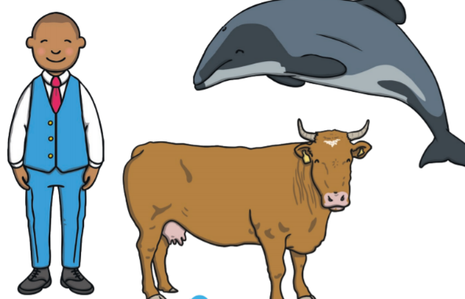

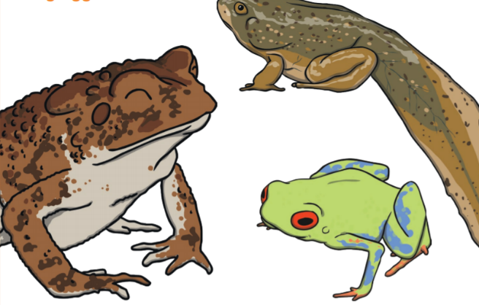

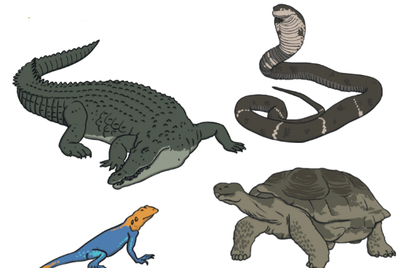

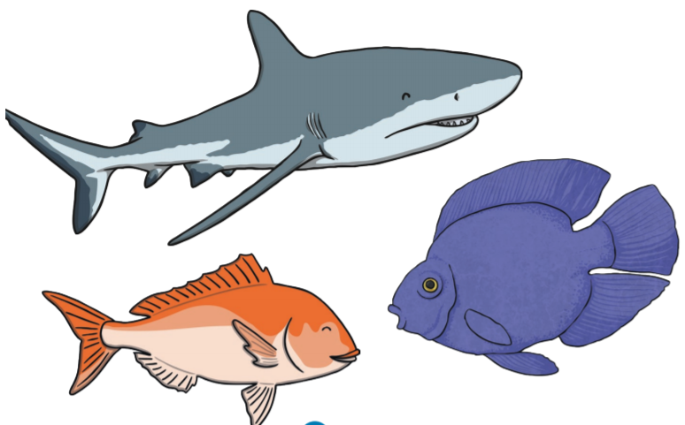

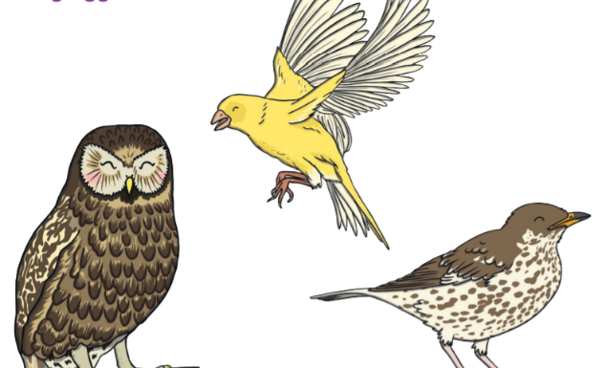

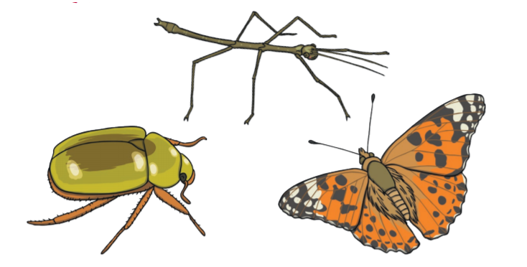

**Steps to Success**

|  |  |  |  |
| --- | --- | --- | --- |
| Date | Thursday 25th February | | |
| Subject/s | English | | |
| Learning Objective | To identify the key features in the Toolkit. | | |
|  | | | |
|  | | SA | TA |
| Success Criteria | I can name feature in a warning story. |  |  |
| I can find the key features in the Story map from the list |  |  |

Read through the story and see if you can spot any of the key features. Using different colours to find them.

|  |  |
| --- | --- |
| Using a different colour to highlight any of these key features in the story. | |
| Story opener e.g. Once upon a time ….  In a land for away…. |  |
| Description of characters e.g. Adjectives |  |
| -Good character, bad character |  |
| Fantasy/ Magic e.g. Talking animals |  |
| Often repeated phrase |  |
| Speech |  |
| Clear structure |  |
| “I’m tired”, said Goldilocks.  First, she sat on the big chair- but it was too hard.  Next, she sat on the middle-sized chair- but it was too soft.  Finally, she sat on the baby-sized chair and it was just right.  CRACK! The chair broke!  The three bears came home. Baby bear found his empty bowl. Then he found his broken chair.  The three bears lived happily ever after.  After that she saw three beds.  “I’m sleepy”, said Goldilocks.  First, she lay on the big bed- but it was too hard.  Next, she lay on the middle-sized bed- but it was too soft.  Finally, she lay on the baby-sized bed and It was just right.  So, she fell asleep.  Inside she saw three bowls of sweet porridge.  “MMMM, I’m hungry”, said Goldilocks.  First, she tasted the big bowl, but it was too hot.  Next, she tasted the middle-sized bowl- but it was too cold.  Finally, she tasted the baby- sized bowl- and that was just right.  So, she ate it all up!  “Oh no, what are you doing in my bed”, asked Baby Bear  Goldilocks shouted, “Ahhhhh!”   Goldilocks leapt up and ran out of the cottage all the way home!  Once upon a time there was a little girl called Goldilocks who lived in a village.  One sunny day she went for a walk in the forest until she came to a little cottage. She knocked on the door and went in. | |

**Steps to success**

|  |  |  |  |  |
| --- | --- | --- | --- | --- |
| Date | 25.02.21 | | | |
| Subject | Maths | | | |
|  | To add by counting on. | | | |
|  | | | | |
|  | | | 240GB SSD:Users:emmabates:Desktop:Screen Shot 2017-09-10 at 16.34.06.png | 240GB SSD:Users:emmabates:Desktop:Screen Shot 2017-09-10 at 16.34.57.png |
|  | I can circle the first number on the number line.  5 + 4 = | |  |  |
| I can count on in jumps the next number.  5 + 4 = | |  |  |
| I can write the answer I land on.  = 9 | |  |  |
| Independent Adult Supported fluency ( ) all most part | | | |
| Support |
| Pre-task – | | | | |
|  | | | | |
| Teacher led | | Fluency | | |

Fluency 1

3 + 1 =

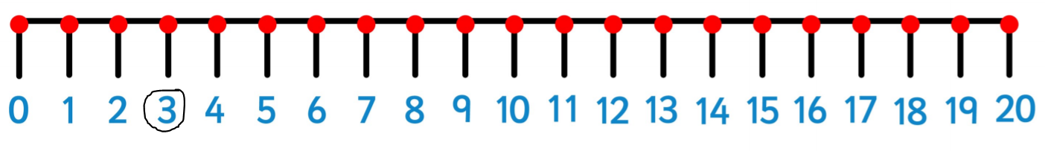

2 + 1 =

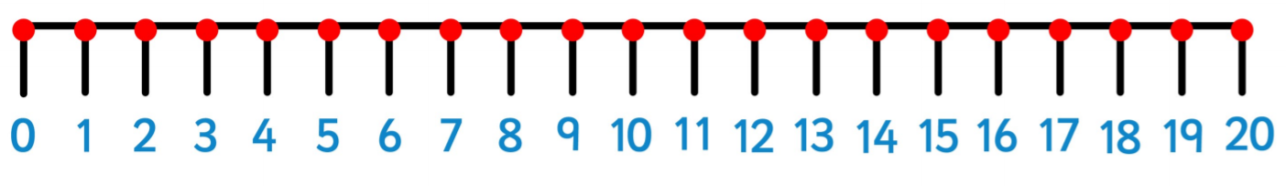

2 + 2 =



3 + 2 =



4 + 1 =



Fluency 2

9 + 1 =



6 + 8 =



4 + 6 =



9 + 5 =



8 + 6 =



Fluency 3

14 + 1 =



16 + 3 =



15 + 2 =



10 + 9 =



11 + 6 =



|  |
| --- |
| Problem solving 1 |
| Sam says this is the right answer  3 + 3 = 5    Is he right? Convince him! |
| Show this number sentence using a 10 frame and a number line.  3 + 1 = 4    + = 4 |

|  |
| --- |
| Problem solving 2 |
| Sam says this is the right answer.  11 + 4 = 15    Is he right? Convince him! |
| Show this number sentence using a 10 frame and a number line.  9 + 4 = 13    + = 13 |

|  |
| --- |
| Extra challenge |
|  |

**Steps to Success**

|  |  |  |  |
| --- | --- | --- | --- |
| Date | Thursday 25th February 2021 | | |
| Subject/s | Art | | |
| Learning Objective | To understand colour mixing. | | |
|  | | | |
|  | | SA | TA |
| Success Criteria | I can mix colours together. |  |  |
| I know how mix colour together to make different colours. |  |  |

|  |  |  |
| --- | --- | --- |
| Support | Independent | Supported ( ) |

Paint in each colour and mix them to see what colour they make.

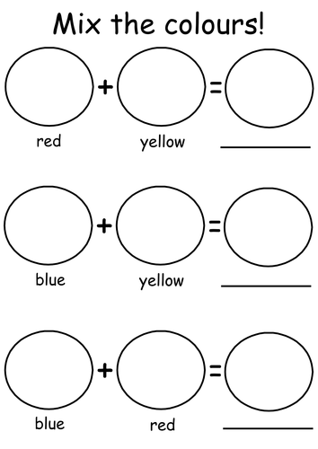

**Steps to Success**

|  |  |  |  |
| --- | --- | --- | --- |
| Date | Friday 25th February | | |
| Subject/s | English | | |
| Learning Objective | To identify speech. | | |
|  | | | |
|  | | SA | TA |
| Success Criteria | I can say where speech is in the story map. |  |  |
| I can find speech in sentences.  **“Ahhh”** said Goldilocks |  |  |
| I can act out the speech |  |  |
| Support | Independent | Supported ( ) | |
|  | | | |

Can you find the inverted commas into the sentence to show speech?

1. “Mmmm,” I’m hungry, said Goldilocks
2. “I’m tired,” said Goldilocks
3. “I’m sleepy,” said Goldilocks
4. “Oh no, what are you doing in my bed?” asked Baby Bear
5. Goldilocks shouted “AHHHHHH!”
6. “This porridge is too hot,” said Goldilocks
7. Mummy bear shouted “Get out of my house!”
8. Goldilocks said “Something smells good in here!”

**Challenge**

**Can you think of a better word then said?**

**Handwriting Paper**



|  |  |  |  |  |
| --- | --- | --- | --- | --- |
| Date | 26.02.21 | | | |
| Subject | Maths | | | |
|  | To add using number bonds | | | |
|  | | | | |
|  | | | 240GB SSD:Users:emmabates:Desktop:Screen Shot 2017-09-10 at 16.34.06.png | 240GB SSD:Users:emmabates:Desktop:Screen Shot 2017-09-10 at 16.34.57.png |
|  | I know that this means 1 ten and 2 ones  12    = 1 ten  = 2 ones | |  |  |
| I can count on how many yellow ones counters in my head.  11, 12    = 12 | |  |  |
| I can write the number | |  |  |
| Independent Adult Supported fluency ( ) all most part | | | |
| Support |
| Pre-task – | | | | |
|  | | | | |
| Teacher led | | Fluency | | |

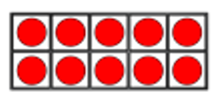Fluency 1

|  |  |
| --- | --- |
| Tens | Ones |
|  |  |

|  |  |
| --- | --- |
|  |  |

= =

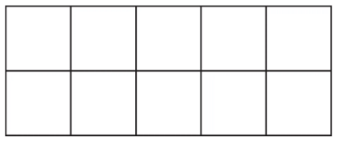



|  |  |
| --- | --- |
| Tens | Ones |
|  |  |

|  |  |
| --- | --- |
|  |  |

= =





|  |  |
| --- | --- |
| Tens | Ones |
|  |  |

|  |  |
| --- | --- |
|  |  |

= =





|  |  |
| --- | --- |
| Tens | Ones |
|  |  |

|  |  |
| --- | --- |
|  |  |

 = =

|  |
| --- |
| Problem solving 1 |
| Sam says this is the right answer:      Is he right? Convince him! |
| Show this number on the 10 frames.    = 15 |

|  |
| --- |
| Extra challenge |
|  |

**Steps to Success**

|  |  |  |  |
| --- | --- | --- | --- |
| Date | Friday 26th February | | |
| Subject/s | Geography | | |
| Learning Objective | To know where Brazil is | | |
|  | | | |
|  | | SA | TA |
| Success Criteria | I can label where Brazil is on a map. |  |  |
| I can colour in Brazils flag. |  |  |
| Support | Independent | Supported ( ) | |

