Design and technology – Tuesday 23rd February
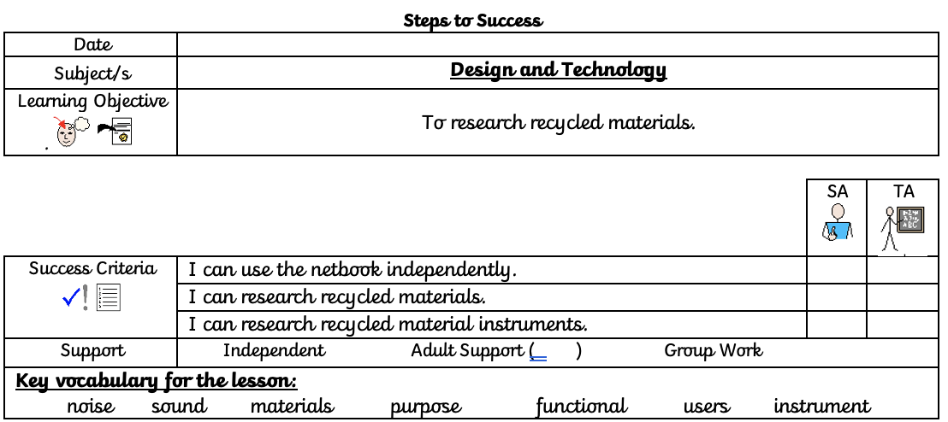
In school, we received a letter from a musician:
Dear children,
I am in a lot of trouble. I was supposed to be recording my new song this month, but some thief has robbed all of my instruments.
I need your help to build me some instruments, so that I can release my album on time. There is an issue though, I don’t have any money.
I need at least, a guitar and a shaker. If you can think of any other instruments I will need, then that will make my music so much better.
I hope that you guys can help me, otherwise I am going to be in soooo much trouble!
Kind Regards,
Drake.
You need to think about what materials are recyclable and would be good to make an instrument with. Using the internet, research different materials that you may have in your house and think about how you could turn these into an instrument. Make notes below.

