English – Tuesday 23rd February
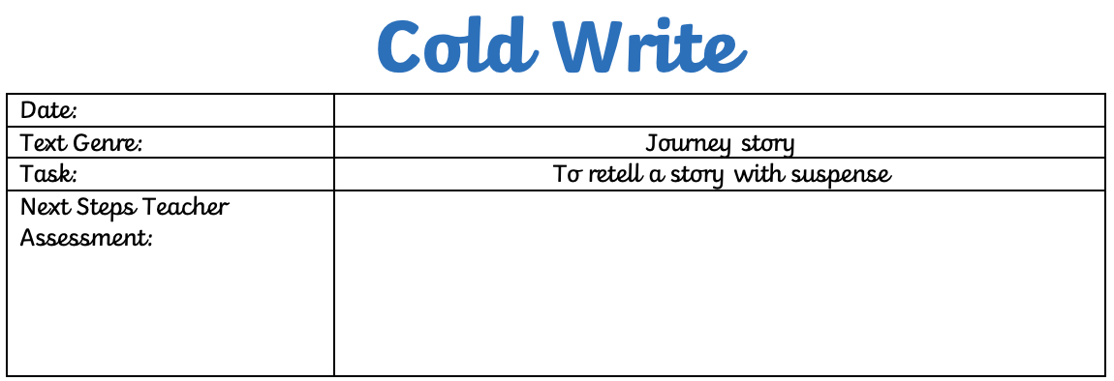
Watch the video: https://www.literacyshed.com/roads-end.html
Write the story with suspense, making sure to make the reader wanting to read more.

