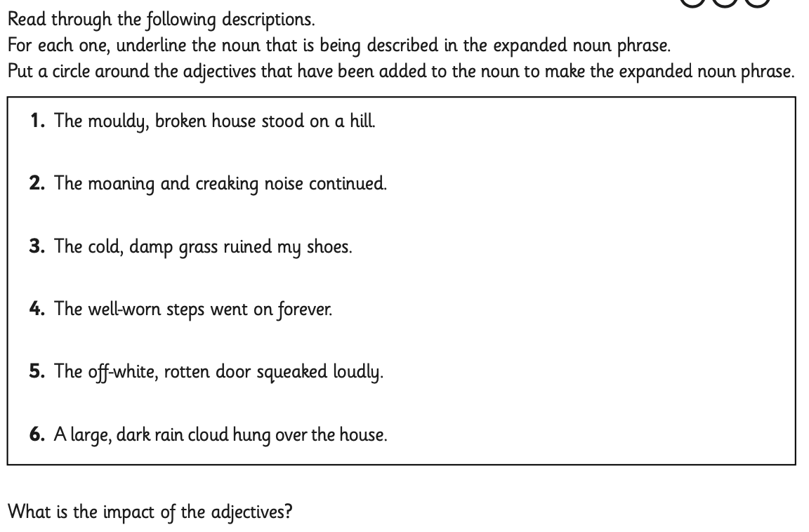
Steps to Success
Subject/s | English
 | Innovate
Learning Objective  . | To use expanded noun phrases.
 |  | SA | TA
Success Criteria | I can explain what an expanded noun phrase is.
 | I can identify the different parts of an expanded noun phrase.
 | I can explain the impact of the adjectives in an expanded noun phrase.
Support | Independent Adult Support ( ) Group Work

