English – Thursday 4th March
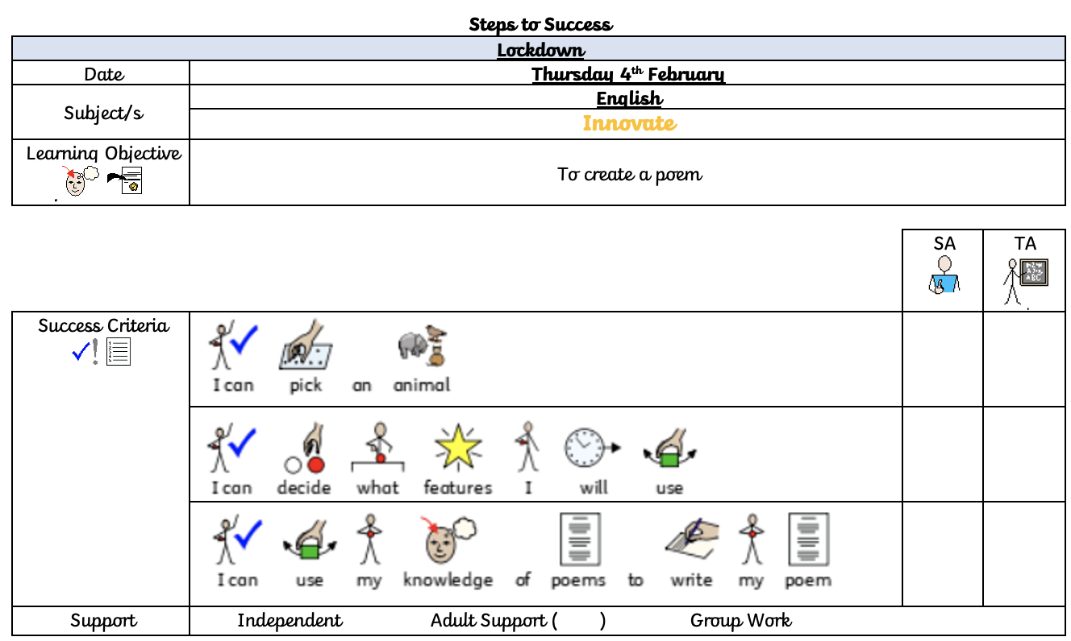
Now is your chance to write your new and improved poem. Use the handwriting lines below and don’t forget:
- Title
- Capital letters
- Finger spaces
- Spelling
- Neatest handwriting

- Rhyming
- Any features from Tuesday’s lesson
- New line, new sentence
- Write at the bottom who it is by

