English – Wednesday 3rd March
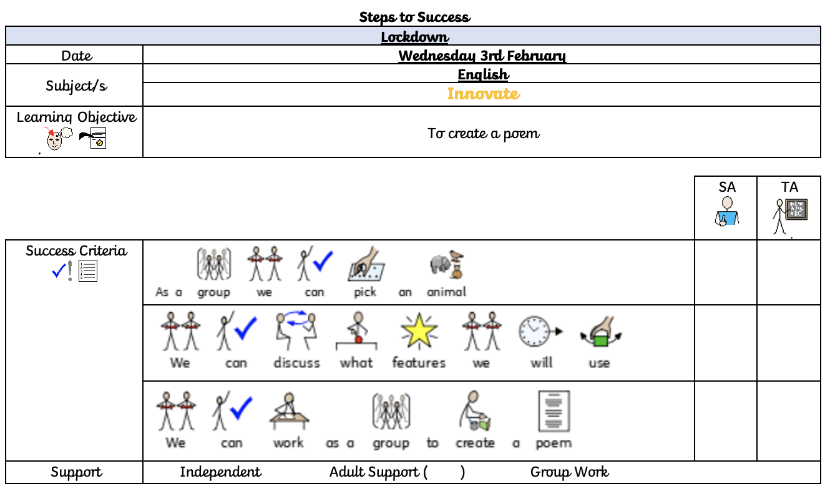
For today’s lesson we are going to be thinking about creating our own poem. What you need to do to start is to think of an animal and think of some words that you can use in your poem to write about that animal.

Now use our poem to add your ideas of your animal to innovate the text map:
