English – Monday 1st March
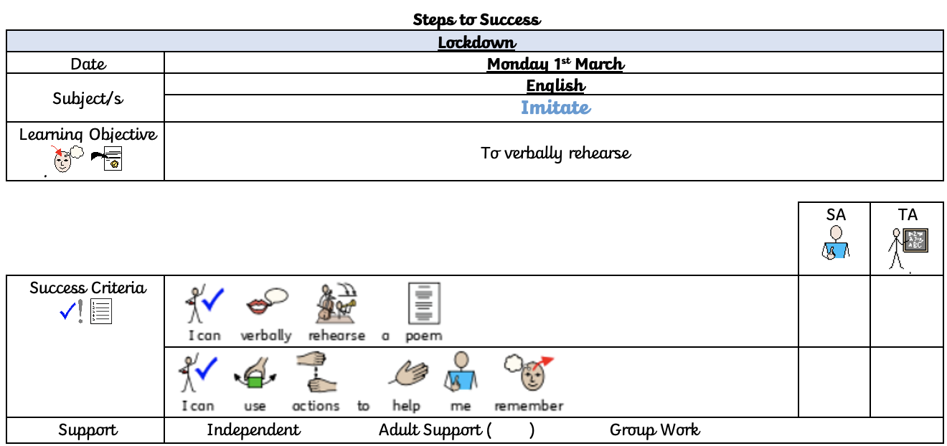
For this week, we are going to be having a look at poetry. What you are going to do it learn this poem and see if you can add your own actions to it to help you remember – just like we do in school.
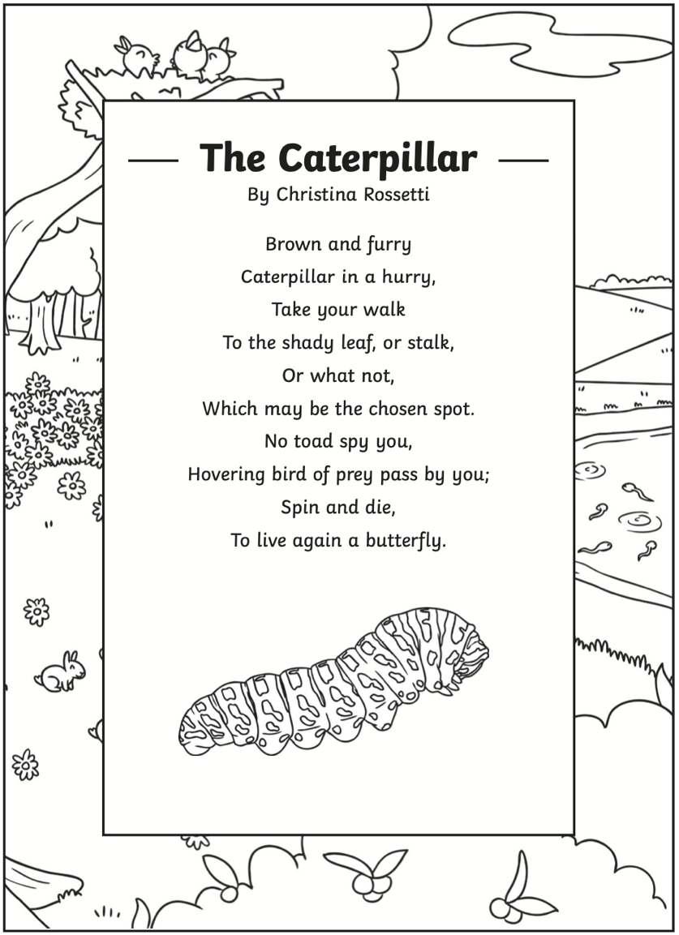
Then, once that you have learnt the poem, you need to create your own text map, using pictures to help you.

