English – Monday 22nd February
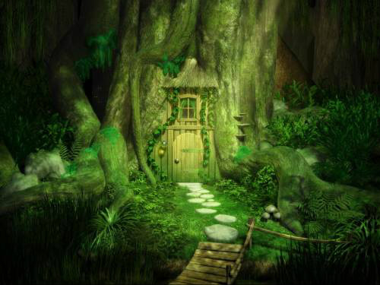
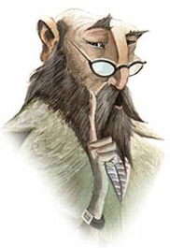

This term we are going to be looking at stories that have suspense in them – when something happens that makes us want to read more. For this lesson, I would like you to look at these photos and think of some questions that makes you want to read more. For example: Who is that?

