Lockdown
Subject/s | Maths
Learning Objective | Equal groups
 |  | SA | 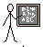  TA
Success Criteria | I can describe equal groups
 | I can write the multiplication for equal groups
 | I can write the addition for equal groups
Support | Independent Adult Support ( )
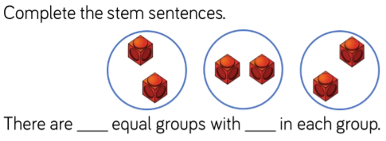
Pre- task:

3 x 4 =

Draw it | Add it
Say it  There are ______ equal groups with ______in each group.  There are ______ altogether. | Multiply it

Draw it | Add it
Say it  There are ______ equal groups with ______in each group.  There are ______ altogether. | Multiply it
6 x 4 =

Draw it | Add it
Say it  There are ______ equal groups with ______in each group.  There are ______ altogether. | Multiply it
5 x 2 =

Draw it | Add it
Say it  There are ______ equal groups with ______in each group.  There are ______ altogether. | Multiply it

7 x 5 =

