Maths – Friday 26th February
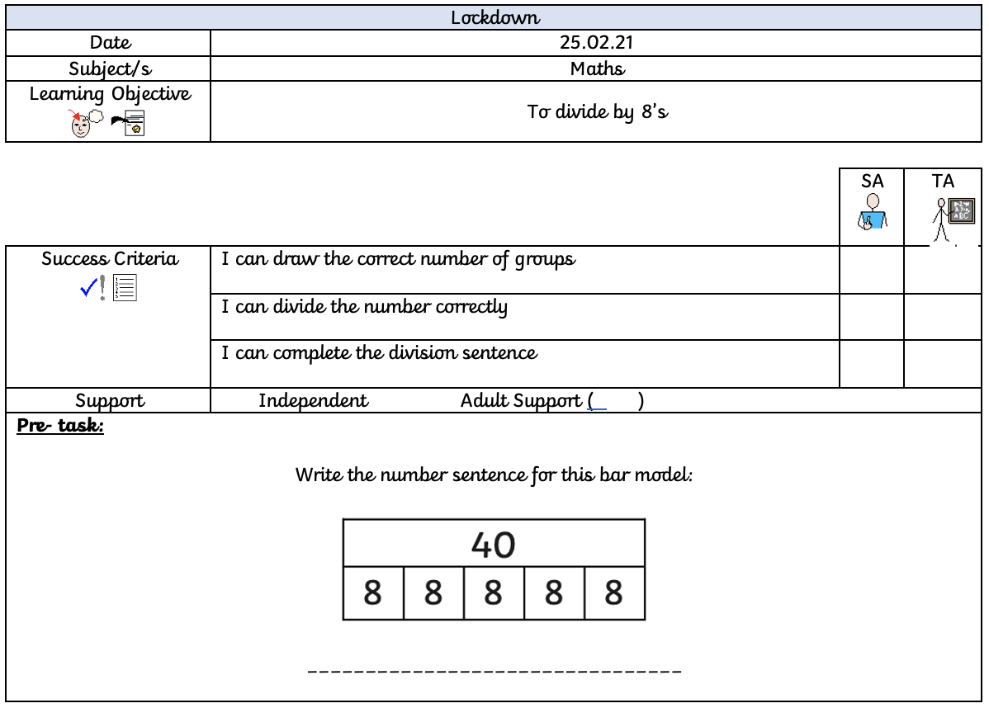

Use your knowledge that you have gained over the week and answer the below questions, remembering how to equally divide the number given.

56 ÷ 8 =

16 ÷ 8 =

24 ÷ 8 =

40 ÷ 8 =

