Maths – Tuesday 23rd February
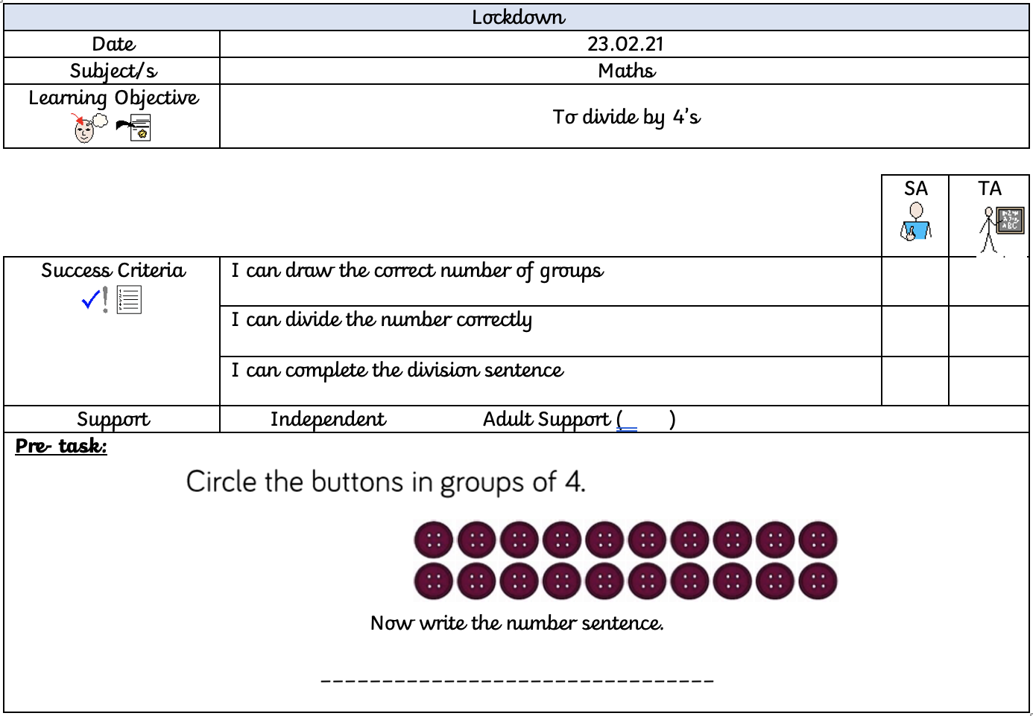
When dividing by 4, we share the given number into equal groups of four. For example:
Here is my group of four, and I have divided the number 8 into the circles by placing one cube into a group at a time.

This has then given me the answer of:
8 ÷ 4 = 2

Now have a go at drawing 4 big circles for each of these number sentences. Don’t forget to write the division next to it to show your answer.
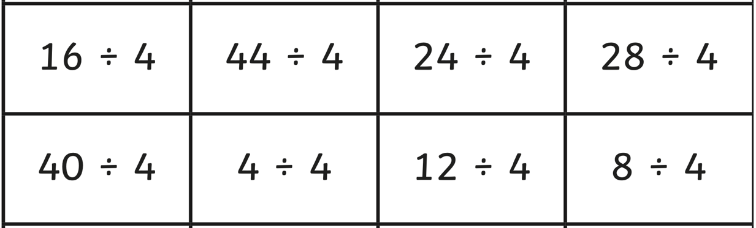

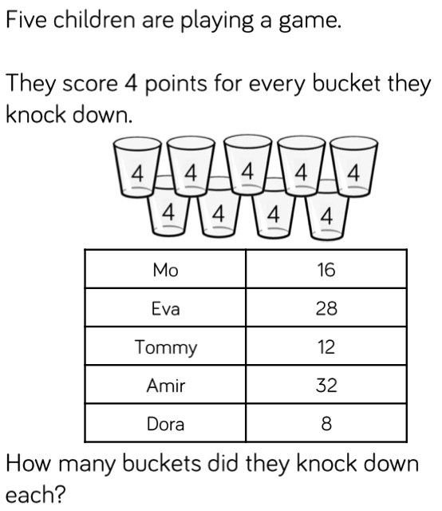
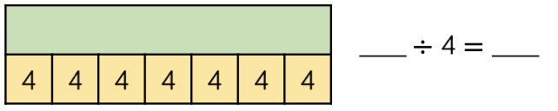
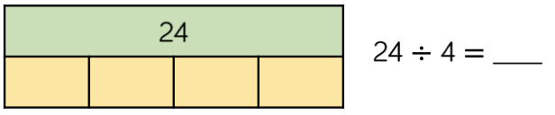
Show your working out.
Complete the bar models.

