Maths – Wednesday 24th February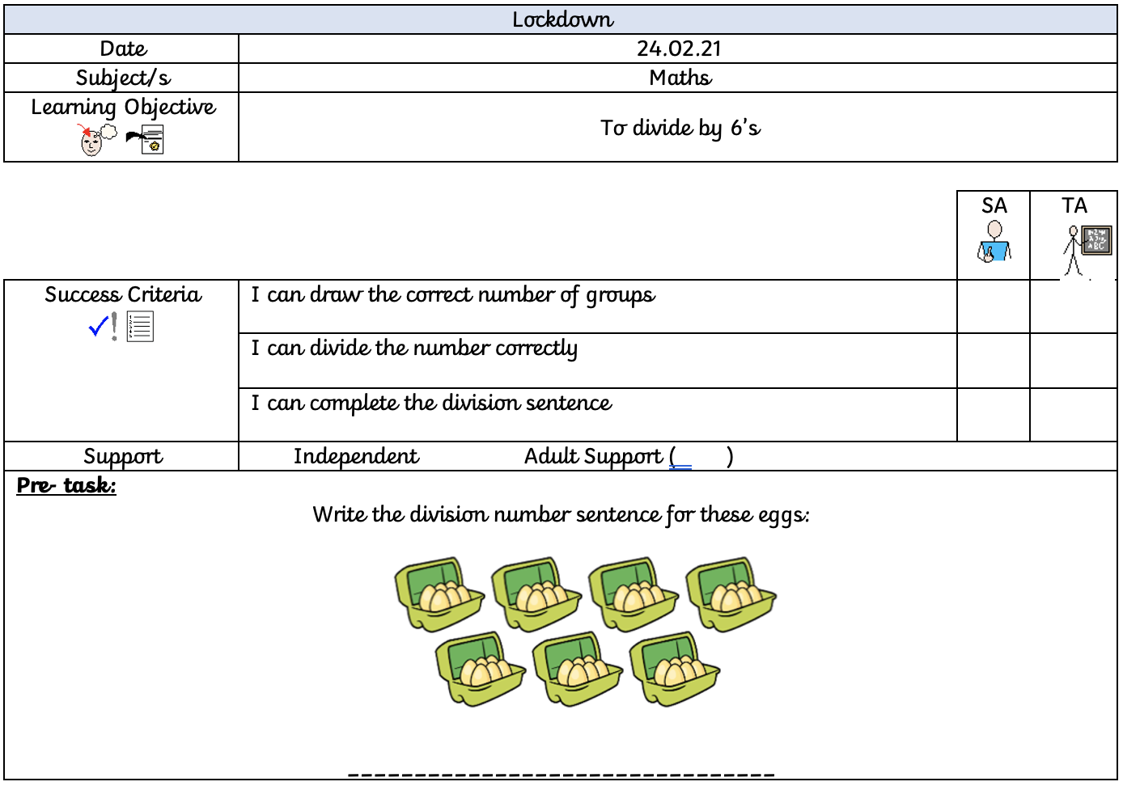
When dividing by 6, we share the given number into equal groups of six. For example:
Here is my group of six, and I have divided the number 18 into the circles by placing one cube into a group at a time.
This has then given me the answer of:
18 ÷ 6 = 3
Now have a go at drawing 6 big circles for each of these number sentences. Don’t forget to write the division next to it to show your answer.

12 ÷ 6 = | 36 ÷ 6 = | 54 ÷ 6 =
6 ÷ 6 = | 60 ÷6 = | 24 ÷ 6 =

Convince me I am wrong
66 ÷ 6 = 9

What is the number sentence for this picture?
What other number sentence could we write if we divided it by 4?

